Cloud Security Posture Management

CSPM is a continuous process of monitoring a cloud environment identifying, alerting on mitigating Cloud vulnerabilities, and improving cloud Security. The whole idea is to enhance an organization's Cloud Security posture.

One of the major problems in cloud security are around *security misconfigurations*.

OWASP site. OWASP - for Open Web Application Security Project. It's a non-profit foundation which works towards enhancing the security within software. Your software might be missing appropriate security hardening across not just software, but any of your applications stack. Your software might be out of date or vulnerable, and so on and so forth.

All right so as we talked earlier, CSPM, Cloud Security Posture Management, is a continuous process of monitoring a cloud environment with the goal to improve security. What are some of the capabilities which are involved? Well, the first capability is any CSPM quantifies your security environment. It looks at all the resources and gives it a score.

It also gives a risk score. So there is a security and risk assessment just to figure out where do you stand as far as your security posture is concerned. Then as we saw in the description, it involves continuous monitoring and alerting. Many times many of these solutions are AI and machine learning based because the kind of data volume you get, you need these capabilities to remove the noise and give you the relevant security alerts.

There is this whole DevSecOps integration where security sits between your development and operations. And the idea is security is a shared responsibility that is part of the entire development and operations cycle to produce applications and security. So there's this whole DevSecOps integration.

And then finally, one of the most important capabilities of CSV is automated remediation. So if you have a storage bucket which is public and open due to the web traffic, and you have a CSPM enabled for automated remediation, it can go ahead and remediate that problem. It could change the visibility from public to private. So you could do that.

What are some of the outcomes? Well, the number one outcome is to enhance an organization's security posture, as we discussed. Lots of things are relevant here. So you-- it gives you compliance with standards and policies, helps protect the data. It helps protect applications and infrastructure, helps in faster incident response and recovery.

One thing I'd like to draw your attention to is this whole notion of zero trust security. With zero trust security, no one is trusted by default from inside or outside your environment. Zero trust operates from the start by requiring verification from every user trying to gain access to resources, thereby authenticating users, regulating access to systems, networks and data. And there are many capabilities which have to be enabled when you talk about zero trust security. But remember that using a CSPM, one of the main outcomes is to give you a zero trust security environment.

What are some of the benefits of a CSPM? Well, the first benefit, as we talked about, is protection against cloud security breaches due to security misconfigurations. And you saw how important some of these misconfigurations can be. And you really need to be protected against them. It does continuous visibility of cloud environments to identify these misconfiguration and vulnerabilities.

And then finally, as we saw, it provides you automated detection and remediation so you can make changes on an ongoing basis. It gives you that enhanced security posture. So hopefully, this was a quick lesson on what a CSPM is. Remember CSPM is a continuous process of monitoring a Cloud environment and improving the overall cloud security.

Cloud Guard.

Cloud Guard is an OCI service that helps customers monitor, identify, achieve, and maintain a strong security posture on Oracle Cloud. In the previous lesson, we looked at what a Cloud Security Posture Management Service is, and Cloud Guard is Oracle Cloud's Security Posture Management Service also referred to as CSPM service.

Now, there are three main components, which you will deal with as you're working with Cloud Guard. The first thing is, Cloud Guard examines specific targets. Think about targets as your whole environment, your tenancy, your account, or it could be specific parts of your tenancies-- your specific compartments. And targets basically define the scope of what Cloud Guard is to check, and the idea here is to quantify the security stance and assess the risk posture.

So you end up with a security score and a risk score, and it basically gives you a baseline of where you stand as far as your environment is concerned. Then you detect problems-- I mean, that's the whole idea behind a Cloud Security Posture Management Service. And are two kinds of problems which Cloud Guard detects. These are problems related to security misconfigurations, we saw earlier in the lesson, how these are really important. So it looks at any kind of security weakness related to configuration or misconfiguration for OCI resources, and then it also looks monitor activities.

And activities could be related to your operator's and user's risky activities. So for example, it alerts you when a user logs in from a suspicious IP address or it could be just monitoring your regular activity. So if a user gets created, you want to be alerted on that because you want to see who are the users within your account. So the whole idea is to check your configurations and monitor activities. And then finally, Cloud Guard applies a response if it figures out that there are security misconfigurations or there are risky kind of activities.

Then upon detection, Cloud Guard can suggest-- it can suggest that you can take action. It can assist you, help you with a workflow on how to solve these, or it could even take corrective action on your behalf if you have configured your Cloud Guard like that for what we refer to as automated remediation, right? So remember these three things, is define the scope, then Cloud Guard goes and looks at your environment, detects problems, and then it can also apply a response or it could alert you so you could apply a response on your own.

What does Cloud Guard looks like? We'll look into this in a demo shortly. But you can see different components here, and we'll look into what each of these component means. Some of the services which Cloud Guard supports today are shown on this slide here**. So compute, networking, load balancer, identity access management, object storage, block volume, database, wallet, and then other services like scanning, and bastion.**

It's likely when you're watching this lesson, we would have supported a few more services, which always a good idea to go to the documentation and see what kind of services are supported by Cloud Guard, but these are the services which are supported today. One other thing to keep in mind as you're setting up a Cloud Guard is this notion of a reporting region. The first region defined when you enable Cloud Guard in your tenancy is called reporting region, it doesn't have to be your default region.

Where your default region is where you're billing, et cetera takes place, right? But choose reporting region wisely because it might have compliance and regulatory implications depending on which region you choose. Irrespective of what your reporting region is, you can monitor every region through Cloud Gaurd. But this is where you have to set up your notification and events in case you want to send notifications, so that only happens in your reporting region. So keep this in mind, this might be important when you want to be notified, for example, right and in your setting guard.

Last thing I'll talk here is Cloud Guard also helps with compliance with Center for Internet Security Benchmarks. We have OCI CIS benchmark, and think about these benchmarks as a step-by-step checklist to secure OCI, right? To secure this kind of best practices and things you have to follow. Cloud Guard provides visibility into specific CIS security configuration practices that your tenancy might not be compliant with. So as you can see here, these are some of the areas where Cloud Guard checks the compliance, whether it's around identity, whether it's around monitoring, networking, object storage, et cetera.

And I have visited a couple of screenshots here. You can see here that there is kind of this issue around Object Storage buckets having encryption-- server-side encryption, but with Oracle Managed Keys. And it's a best practice for customers to use their own keys or what we refer to as Customer Managed Keys. So if you have your object storage buckets which don't use Customer Managed Keys, Cloud Guard would flag that as a problem and it would give you kind of details on how to resolve it.

But right here, you can see, I took the screenshot from the CIS OCI Foundations Benchmark, and there is a section 4.2 where it talks about this particular issue. And it's kind of a guidance, which it says that-- ensure that objects storage buckets are encrypted with a Customer Managed Keys, right? Then gives you all the details. It also actually talks about Cloud Guard, and how you could ensure that this thing is met using the steps to follow using Cloud Guard here, right?

So keep in mind that these benchmarks, one of the outcomes of a CSPM, is to have compliance with standards and policies. And a Cloud card today does that with the CIS OCI Foundations Benchmark Configurations. With that, let me quickly switch to a demo and show you some of the key pieces of Cloud Guard. All right, I'm logged into my account here. And if I click on the menu on the left hand side and click on Identity and Security, Cloud Guard is available as part of Identity and Security Portfolio of Services.

And as you can see here, I get my Cloud Guard home screen. Now, a few things are available here-- as you start for the first time, it gives you this guided tour. And the first thing you can see here is it gives me a Security Score. And you can read the description, it says, security score measures the number of resources examined across all the regions and compare it with the number of problems detected.

And the score can be from poor to excellent. Right here, my score is 97, which is a pretty good score. So if I move to the next one, it gives me a Risk Score. And again, like security score, it examines the number and importance of resources, criticality of problems, and available resources for Cloud Guard check. Lower score is better. So you can see that I have a score here, which is not quite low, but still, it's not bad, right? If it was any lower, it's actually better.

Then the next section is around Security Recommendations. And these are the places where things which you need to do to improve your security and risk score. The reason this is higher is because I have certain problems, right? You can see there's kind of 90 problems here. Once this starts going down, this number will go down and this number will go up, right.

And you can see here, right? Things like your recent security list allows traffic to restricted ports, or your bucket is public, right? So those kind of recommendations are shown there. Now, the fourth kind of widget in the dashboard is around the Problems Snapshot. And you can see, I have a lot of problems kind of throughout my account-- kind of 90 problems. Some of these are critical, some of them are eye level, some are medium, low, and so on and so forth, right?

And I can drill down here and I can see which are minor problems, which are critical problems, et cetera. And then on the next one, is it gives me the specific problems broken down by compartments, or by regions, or by resources, right? So if right now, you could see, if I click on Compartments, I can see-- let me just removed this view here. --I can see that these are some of the compartments we have, right? If I scroll by region, I can see that I have resources in Germany, Canada, Australia, US West, so some of these resources are shown here.

If I click by Resource Type, you can see our compute instances, and you can see some of the critical problems, also shows kind of a breakdown by critical, or minor, or high kind of problems, right? And I can see VCN and Buckets have kind of between them, we have all the major critical problems. There is one, I think on load balancer. Right, so it gives you kind of this easy snapshot. Then it also shows you user activity problems.

So malicious activity, users logging in from suspicious IP addresses, et cetera, which are super critical are shown here, right? So kind of increases the visibility issues widget here, right? Right now, you can see there is no problem, so all that looks good. And then the final one here is the Responder Status. And we haven't talked about detectors, responders, et cetera, but think about responders as to how Cloud Guard takes action to fix problems.

And it shows how many responders are in queue and the ones which have recently been executed. There is nothing here because I just set up Cloud Guard in this account and we have not done any kind of responder execution. And down below, you can see how my security score changed over time, kind of the new problems which came up. Remediation which happened, nothing has happened yet, right? So this is just a quick kind of a dashboard, which Cloud Guard has.

And if I click on Problems here. You can see a long list of problems because remember I had close to 90 problems. And as you could scroll down, you can see 50 here. And if I scroll to the next page, you see some other here, right? So it's a bunch of problems being shown here. There are recommendations, which are shown, right? And we'll talk about all these and targets, and et cetera, et cetera, right? Last thing I want to show here are the settings-- you can disable Cloud Guard here.

So if you want to disable it for your account for whatever reason, you could do that. You can see that reporting region right now is US East, you cannot change this reporting region. Once you have set up your Cloud Guard, you could disable it and you could change it again. But for right now, it is as what you set up initially. So hopefully, this gives you a good overview on what Cloud Guard is and what all kind of some of the things it can do. In the next few lessons, we are going to dive deeper into many of these components.

Demo enabling Cloud Guard.

If you have a tenancy where Cloud Guard is not already enabled and you access it for the first time, you would see this kind of a dialog box when you click on Cloud Guard that says enable Cloud Guard. And we'll actually see this in a demo.

What actually this does is for Cloud Guard to work, it requires certain IAM policies, Identity and Access Management policies. And these policies are required to allow the Cloud Guard service to read or use various resources in the tenancy. And what do these policies look like? If you see on the right hand side, these are the IAM policies that are automatically added to the Cloud Guard policies policy group. That's the name of the group, which automatically gets created when you click on this enable Cloud Guard.

And if you parse these IAM policies, I have sort of grouped them like this so you can read them better. You can see that the first few policies are regarding IAM, Identity and Access Management. So things like users, groups, dynamic groups, policies, compartments, et cetera, are here. Then you have some policies which are around compute service. There are policies around virtual Cloud network, load balancer, volume family, block volumes, object storage, database, key management service, the vault service, KMS, and then something around audit events.

And you can see these services listed here. No surprise, these are the services, some of the services, that Cloud Guard supports. And possible at the time you are watching this lesson, there might be a few more services that Cloud Guard has support for. So you should always check the documentation. But this is what happens behind the scene when you click on Enable Cloud Guard, these policies get created.

And if you recall from the Identity and Access Management service, different services within OCI also need access if they are working on your behalf to do certain things on other services. You need to write these kind of policies, where instead of saying allow group and group of users, you say allow this particular service to do something. And this is basically what is happening behind the scenes.

So when you do that, the next step is, of course, you configure IAM group, which would be handling Cloud Guard related privileges. And next slide, I'll show you what some of these groups might look like. Now you add users to those groups. And then you write certain policies to those users, as part of that group, to grant privileges, certain kind of privileges on Cloud Guard. Because you don't want everyone to have all kind of access on Cloud Guard. You want to limit it to security admin, security specialists, operators, root users, et cetera. So you could do that. And we'll see that in the next slide.

So how does this work? And we'll see a demo as well. In the OCI Console, you click on Security, you bring up Cloud Guard. And then you click Enable Cloud Guard there. And as you do that, basically you have to do a few more things when you configure and enable Cloud Guard. The first thing is you need to select a reporting region. And give careful consideration to your reporting region selection, because once you select a reporting region, it commits your organization to comply with all legal requirements of the country, or the region, where the reporting region is hosted. So keep that in mind.

And once Cloud Guard is enabled, you cannot change the reporting region without disabling and reenabling Cloud Guard. So keep that in mind. And reporting region has a significance where notifications and Cloud events have to be set up in a reporting region. And we cover that in another lesson. Then once you select your reporting region, then you have to specify compartments. If you want to monitor every compartment, you could choose the tenancy itself.

And then you set up your detector recipes. The two recipes which are Oracle managed, detector recipes, one on configuration, one on activity. Optionally, you can also set up responder recipes. And as a best practice, as an ongoing activity, you should customize the Cloud Guard configuration as your requirements change, or as required to enhance the security posture within your organization.

Now, what are some of the typical security roles which you could set up with Cloud Guard? Well, there could be a service owner. And this particular-- the users within this particular group, or this particular role, can manage the entire Cloud Guard. So you can see that the policy here is manage Cloud Guard family in your entire tenancy. So these can be your administrators for the account.

And then you can have Security Architect and Security Ops Admin, SecOps, as we call it, Admins, who have different kind of roles. So your Security Architect might be somebody who is managing, inspecting, reading resources in the tenancy or compartments. So they might be setting up your Cloud Guard detectors. They might be setting up the targets, responder recipes, and so on, and so forth. So these are the architects who are responsible for managing the security posture.

And then you have SecOps people who are managing things on a day-to-day basis. So they are not necessarily the ones who set up targets, or detector recipes, or responder recipes. They don't have access for that. But they-- because they're SecOps, they need to know and be alerted on the Cloud Guard problems. So as you can see here, they can manage, inspect, and read Cloud Guard problems. But they don't have any other access permissions beyond those.

So this is just a sample kind of a setup. Your setup could look completely different. But this is one of the setups. Now, let me quickly switch over to the console and show you how to enable Cloud Guard in your own account.

All right, as you can see here, I'm logged into my account here, logged in as an administrator. And this is my tenancy here. Now, Cloud Guard is available as part of identity and security set of services. So I click on Identity and Security here. And then it brings up all the available services as part of Identity and Security. So I'll click on Cloud Guard.

And you can see here, right now, I'm logged in to the US East Ashburn region. And you can see Cloud Guard is not enabled in my account. It gives me this kind of a nice view. Talks about the core components of Cloud Guard, targets, detectors, problems, responders. Links to-- it has links to documentation. And there's this box here, which says Enable Cloud Guard. So let me just click on it.

And then it says, it basically gives me all these policies which you saw earlier. We went over this. It says it's going to create this policy name, which we saw. And these are the policies which are going to get created. So I click on Create Policy. And it says all statements have been successfully added to the policy, Cloud Guard policies. And then I click Next.

And as you can see here, these are some of the steps we have to follow. So it says reporting region. And I can pick a reporting region here. Now, I'm still in US East Ashburn, so I'm going to pick Ashburn. And then say it's compartments to monitor. Do I want to monitor all compartments? Or I could select specific compartments here. I have many compartments here. I could select a specific compartments.

I want to monitor everything in this account. So I'll click All. And then it asks me to configure the detector recipe and the activity recipe. Now, this is optional. I could skip it. But I'm going to do this anyways. I picked the Oracle managed defaults. And then I'll click on Enable.

And as you can see here, that took some time. And it says, Cloud Guard is enabled. And if I go to Cloud Guard, you can see that I get this kind of a view. So hopefully this was a quick demo which showed you how to enable Cloud Guard in your own tenancy. And if I go to Settings here, I just want to show this really quickly, if I can go to the Settings, you can see that this is my reporting region, the one we picked out.

And right now I don't have anything else available. There is no problem, because I just set it up. There is no recommendations. There are no targets. Well, the target is the root compartment I set up. And the detector recipes are the ones I set up as default. There is the responder recipe, which is Oracle managed.

But there are no problems which are available right now, because it hasn't started scanning my account. And you can see my security score is excellent.

Cloud Guard Concepts.

So what are some of the Cloud Guard components? The first component we are posting which you need to keep in mind are what is called as targets. *Targets* basically set the scope of resources to be examined for OCI Compartments, and their descendent structures, your subcompartments can be targets, as you can see in the graphic here.

The second thing to keep in mind, what is called detectors. *Detectors* are Cloud Guard components that identify issues with resources or user actions and alert you when an issue is found. So you can see some representative detectors here. So it can, Cloud Guard can detect if your instance is in a public subnet, if your storage buckets are public, or if there is log in from a suspicious IP. Each of these are kind of detectors within Cloud Guard.

And then there are what are referred to as problems. *Problems* are, think of problems as notifications that a configuration or activity is a potential security threat or a potential security issue. So in each of these cases, you could decide a public instance is a problem or not right. And it could notify you if you have an instance which has, let's say, a public IP address.

And then you have these things as *responders*, which basically provide notifications and corrective actions for security problems. When you set up your Cloud Guard upon detection, Cloud Guard recipes, responders can suggest, assist, or even take corrective actions based on your configuration. So you could automate this whole process. So these are the four major components; targets, detectors, problems, and responders. And let's look at each of them in a little bit more detail.

So our targets and detectors, well, targets we talk about as what sets the scope of resources to be examined. In case of OCI, when a set of Cloud Guard targets basically are compartments, you could set it up at your root compartment so you can monitor your entire tenancy, or you could set it up at specific compartments and subcompartments. And there are rules around that.

We have lesson on detectors where we will talk about this in greater details. Now detectors themselves identify issue with resources or user actions and alert you when an issue is found. There are two kinds of detectors which are available in Cloud Guard. These are around configurations. You'll think about them as sort of detecting security misconfigurations, and detectors around activity, which are basically monitoring activity. For example, let's say there is kind of a suspicious log in from a suspicious IP or something.

And then there are what we refer to as detector recipes. Now recipes is, kind of think about them as collection of rules. So there are two recipes. One configuration recipe and second one, activity recipe. And within these, you have many rules. Each of these rules have kind of a different scope and a different resource which they examine. And we will look into these in greater details in the next lesson.

As we said, detector rules provide a specific definition of a class of resource with specific actions or configurations that cause a detector to report a problem. And these recipes, the two recipes, configuration recipe and activity recipe, are basically collection of these detector rules. And think about these as providing a baseline for examining the resources and activities in the target.

So as you can see here, these are your configuration detector rules. And these could be things like your API key is too old. It's a best practice to rotate your keys every 90 days. Your block volume is encrypted with Oracle manage key. The best practice is to encrypt them with customer managed keys. You create a block volume, but it's not attached to an instance. You have a storage bucket, but that is public. And as you can see, each of these detector rules have a different risk level. And they are different kinds of settings. There are things like conditional settings, et cetera, you could do. So the different kinds of definitions. Class of resources with specific actions or configurations.

OK, so having looked at targets and detectors, let's look at the other two key components; problems and responders. Problem is any action or setting on a resource that could potentially cause a security threat. So problem could be a bucket is public, or a problem could be as shown here, database is not backed up automatically. So that's a problem. It flags that problem so you could take a corrective action on that. And how do you take that corrective action? With these things what are called responders. So responder is nothing but a corrective action that Cloud Guard can take when a detector has identified a problem.

And again, these responder recipes are a collection of responder rules. And one thing with Cloud Guard is, you could do a manual response. So a Cloud Guard operator could respond, or you could even automate this whole process and let Cloud Guard handle it for you. So as we talked about responder rules and recipes, like detective rules, responder rules define the specific actions to take. If any one responder rule is triggered, it triggers the whole responders. Kind of class called a responder, just different rules within them.

And responder recipes is basically a collection of these responder rules. So if any responder rule is triggered, it triggers the whole responder recipe. And basically, responder recipe defines the action or set of actions to take in response to a problem that a detector has identified. And you can see some of these things here. It could be things like just do a notification, or it could be things like delete a policy or delete in internet gateway if it's like kind of a public subnet and you want to avoid having a public subnet and public compute instances.

So hopefully, this was a quick theoretical lesson on the main Cloud Guard components. Again, keep in mind the four main components. Targets set the scope of resources. Detectors basically identify issues. The two kinds of issues, security misconfigurations or user actions. And it basically alerts on them. Problems are nothing but notifications that there has been a security misconfiguration or an activity which can be a potential security issue.

And then responders provide notification and corrective actions. And you could even do it and have manual response, or you could automate the whole response.

Cloud Guard problems.

As we discussed earlier, Cloud Guard problems are notification that a configuration or activity is a potential security issue. But let's dive deeper.

So the best way to dive deeper is to look at a practical example. Let's say you have a public bucket. And a user makes a bucket visibility public. And you are using the default Oracle managed detector recipe, where this kind of behavior is given kind of a critical risk rating. And so the critical risk is the bucket is public. And the resolution here is you want to make the bucket private. So that's what you see in kind of the end state.

Now let us see how Cloud Guard handles this kind of scenario. So the first thing is you have, as I said, you are-- let's say you are using the Oracle managed configuration detector. And the rule bucket is public is triggered. And a problem is created. And the severity is flagged as critical. So it's the critical level severity.

Next thing is, as I said, problem gets created. And problems are these notification, which says that the bucket is public. And again, the security is critical. As you have set up your configuration detectors, assume you responder recipes are also enabled. So there is a responder recipe, which is, again, Oracle provided, managed, which says make bucket private enabled. And if you have enabled in your account, as it shows here, it says yes, then there are steps to follow to remediate this issue. So Cloud Guard operator here can-- in this case, it looks like it's a manual remediation.

So there's a person, who is the Cloud Guard operator, says remediate the problem, yes. And then he goes-- he or she goes and does the remediation. In this case, it's a manual process. And then he makes the bucket, he or she makes the bucket visibility private. So this is kind of a workflow on the problem lifecycle with the detector detecting a problem, problem getting flagged, responder recipe being enabled, and then a Cloud Guard operator going and remediating that problem manually.

Now, you could also automate this whole thing. And what is shown there at the top is if you have Cloud Event enabled, you could, using the OCI event service, you could get notification, number one. And you could have something like an OCI function written, which could remediate this automatically. In this particular case of a public bucket, Cloud Guard actually does this automated remediation also. So you don't need to write function, serverless function.

But in other cases, you might actually want to remediate this whole thing, right? So there is this whole automated remediation workflow which you could follow where you get notification. And then you write the serverless function. And then you could act upon and change certain configurations.

Let's look at some other things here. As we looked earlier, we looked at a problem. But there are different kinds of problems. Problems can be remediated, as we saw in the previous example. It could be fixed by using a Cloud Guard Responder, either it could be manual, or it could be automated. You could resolve a problem by other process. You could say mark as resolved. Or maybe there's a manual process you follow. Or it's a much bigger issue, you have multiple teams to do that. So you could mark as resolved. Or you could dismiss it. You could say that, just dismiss this problem.

But one thing to keep in mind with Cloud Guard is it's a continuously monitoring process or a service. So the whole idea with our Cloud security posture management service is it's continuously monitoring your environment and flagging things. So what happens if you resolve something, or you dismiss something, and Cloud Guard flags it again? So let's look at how Cloud Guard handles this.

So if Cloud Guard detects an issue again for an open, or what we call as unresolved problem, it will update the problem history, but it will not create a new problem. So as you can see on the right, if Cloud Guard detects an issue for a previously resolved configuration problem, resolved configuration problem, it will reopen the issue and update the history. If Cloud Guard detects an issue for a previously dismissed configuration problem, it will just update the history. It will not create a new problem.

But if Cloud Guard detects an issue for a previously dismissed activity or a previously resolved activity problem, it will create a new problem. This again, you can read on the documentation. The whole idea is you can either fix the problem by doing this remediation here. Or do you fix the baseline? Baseline, meaning your detector recipe. So you make change to that, either that, or you remediate the problem.

Otherwise, you might run into issues, where Cloud Guard, because it's continuously monitoring your environment, it could reopen these issues, or it could even create a new problem. But in most of the cases, as you can see here, it will update the problem history. It will not create a new problem. Otherwise, your account will have too many problems if, suppose you don't resolve these, you don't remediate in the first place. So the software is intelligent. It takes care of that. But you should check out documentation on different scenarios which are possible.

So as you can see here, well, the whole idea of processing reported problems is this is the core of Cloud Guard functionality. You have detectors. You have responders. But the whole idea is to flag problems. I mean, that's what it does around security misconfigurations or user activities. And it involves prioritizing problems to focus on the highest risk. And that's why you have the risk level here, critical, and high, and so on, and so forth, low, et cetera. So you can focus on the ones which might be the highest risk level.

And to do that, Cloud Guard has a dedicated problem page. And it examines problem details to-- it has the problem details to determine what's happening. So as you can see here, the problem could be database is not backed up automatically. So it gives you that kind of-- those problems, as you saw in the previous slide, it gives you these-- a list of all the problems, but then your problem, your database is not backed up automatically. And you click on that. And it will basically give you all the details on what the problem entails.

So you can go and resolve it. And then along with this, there is also a responder activity page. And I know we have not gone into details of responder recipes and et cetera. But there is a responder activity page where you could see, if you apply your responder to a problem, you could see how the resolution has happened. And the whole idea is to ensure that risks are counted. And false alarms do not continue in the future. So you can see kind of the steps taken here in this part of the responder activity. So you can see it.

And again, we will touch on a bunch of these as we go and do a Cloud Guard demo. So hopefully this was a quick theoretical lesson talking about problems, the problem lifecycle, how problems are surfaced. And that's one of the core ideas behind Cloud Guard, and then how you could apply responder recipes to the problem and get all the visibility using a problem detail page and a responder activity page.

Cloud Guard Detector Recipes

Detector is a Cloud Guard component that identifies potential security problems based on either resource configuration or resource misconfiguration or user or operator activity. These rules are combined into what is called as a Detector Recipe. So recipe is nothing but a collection of these rules, and rules are tied to specific resources and they have different kind of severity level, and different kind of action, et cetera, depending on the resource.

Now Cloud Guard supports two types of Detector Recipes. The first one is Oracle-Managed Recipes, these are provided by Oracle by default and you cannot modify them, you have to use them as is.

The second way to use these, the second kind of Detector Recipe is User-Managed recipes. These are created by cloning an Oracle-Managed Recipe, and the advantage here is you can modify User-Managed recipes as needed because your security requirements and needs might be different than some other customer. So you could change them, modify them, and then you can use them.

So let's look at some examples. First, we'll look at Configuration Detector Recipes and Rules and then we'll look at Activity Detector Rules. So Configuration Detector Rules, as you can imagine, are related to configuration.

So for compute instance, these can be things like the compute instance has a public IP address is available in a public subnet. It doesn't have the required tags, so you have this concept of forced tagging, you could enforce that. Or it could be things on the database side, the database is not backed up automatically. Its patch is not applied, it has a public IP address.

Similarly on the networking side, it could be things like your SSL certificate is expiring, you have an internet gateway on a VCN, you have a VCN has a security list allows traffic to restricted ports, and so on and so forth. And this is again a snapshot for the entire list. You should always go and refer to the OCI public documentation.

Now on the Activity Detector Rules, again remember this last slide and this slide is all Oracle-Managed. You have Identity Access Management resources, so things like your user getting created, Cloud Guard Detectors will actually look at it and flag it, so you can capture this information. Or things like you creating an Auth token or you're creating a group, and so on and so forth. Or you're modifying a security policy because very few people should have access to policies and only a few people should be able to modify them.

Similarly on the networking side, it would be things like you're creating a DRG or you are creating a VCN, and so on and so forth, something that's getting created or something getting terminated would be flagged as activity.

And you can see the same thing for compute and database, instances getting terminated, that's an important event for a Cloud Guard to monitor and flag. So these are some examples of what kind of Detector Rules are supported by the Oracle-Managed Recipes.

As we saw in the demo, you apply these detectors to a particular target, and target is basically what defines the scope of Cloud Guard. So in OCI, when you define the target, you define the target at a compartment level. You can either define it at the root level, which applies to all the compartments in that particular tenancy, because your tenancy is nothing but a root compartment, or you could apply them at specific subcompartments.

So when you do that, how does Cloud Guard resolve any kind of conflicts? So if you look in this example, as we discussed, you apply your detector recipes to compartments. As you see here, Detector A, when you apply these detector recipes here, it applies to all the compartments in the hierarchies, the ones which are shaded in yellow and the ones which are not shaded. It applies to everything, because you are applying Detector A recipe right here at the root compartment or at the highest level hierarchy compartment.

Now when compartment hierarchy has detector recipes applied to a compartment at a different level-- let's say it is applied at this particular level, then in that case, whenever the rules conflict, the rules from the detector recipes applied at a lower level override the rules from any applied at a higher level. So what that means is all the compartments which have Detector B applied, detector rules applied, recipes applied, they will override any kind of rules which are applied here.

So Detector B applies to these shaded compartments. And the rules here, whatever the rules might be, will override the rules which are put at Detector A. And as we saw, you can always create User-Managed recipes and they might be two different User-Managed recipes here, right in two different hierarchies. So keep this in mind. This would come up as you create targets and you apply detector rules.

Before we finish this lesson, let's quickly jump to the console and I'll show you quickly how you can change some of these Oracle-Managed recipes to a User-Managed recipe.

All right, so right here I'm in the console, I can see this Cloud Guard. If I click on Targets, I can see I have applied Target to a specific compartment. You can see this is my compartment, it doesn't have any subcompartments, so this is just right here. And if I click on Detector Recipes, I'm using Oracle-Managed, both Activity Detector and Configuration Detector. So I have not created my own User-Managed recipes.

And the thing with this is we saw this in the demo, if I come here, and if I want to edit some of these, there is not much I can do. If I want to click-- and for example, Bucket is public, I want to change this, I want to change the risk level, I want to change the status, maybe disable it, or change the labels. I cannot do any of these right now, because these are Oracle-Managed, I cannot modify them.

Now if I go back and I go back to my Cloud Guard, you can see under Detector Recipes, nothing is available, right. There is no recipe available. This one shows all the User-Managed recipes.

So what I can do is I can click Clone here and it gives me what do I want to clone, either Activity Detector or Configuration Detector, I would say Configuration Detector is fine, and I could say this is My-configuration-detector-recipe. And I could put this in a particular compartment, I would say this particular compartment is fine, and I click Clone here.

And now what gets done is I have my own recipe and set of rules, which are the same as Oracle-Managed, but now I can do certain things here. For example, in my environment, let us say I'm going to have public buckets. So that shouldn't be flagged as critical, because I will have public buckets whatever my use case is.

So I'll come here, I'll disable this, and I could just Save. And now basically what it means is Cloud Guard is not going to look into this particular rule and flag this when it scans my account.

Now there are some other ones here like Scanned host has open ports, if I want to change it, let me just Edit it and I can change Status from Enabled to Disabled, I could do that. I could change my Critical Level, so High Risk Level, so I could say let's make it High. I could put my own Labels here, I could say this is my VSS-V1.

And now the thing which you can see here is the Input Setting, so I could give my own ports here. So for example, if I want on TCP, if I want port 10, I could just specify that and I could Save it. So this way, now what happens is I have customized my detector rule here and I can use that in my own scanning, when I scan my own targets here. So this is how you would use a bunch of these detector rules and recipes. You would clone them and then once you clone them, then you can use them in your own environment.

Now one last thing I want to show here is if I go back to-- let me pick something, Instance is publicly available for this one, for example. If I click here, you can see there is something called Conditional Group. And as the hover shows, Conditional Group establishes certain parameters around the rule. All statement in a Conditional Group are bound together with the AND property.

So what I can do here is, for example, this particular rule is identifying all the instances that have a public IP address. Suppose I'm going to have a few instances, which always will have public IP, these are web servers, for example in a DMZ, and I don't want them to be flagged. I could come here, I could provide my Instance OCID here, I could say either in or not in, so exclude or include, I could do that.

And right here you see something called a Custom List or a Managed List. Think about Managed List as a reusable list of parameters that make it easier to set the scope. And this is true for detector as well as responder rules.

So for example, suppose I want to exempt a couple of instances from all detectors related to identified public configuration, I could create my own managed list here and I could just use this in when I define this condition here. Or if my list is too small, I could create a custom list here. So I could provide values.

So remember Custom Lists for small configurations, if you have a big configuration, you want to use a Managed List. I don't have a Managed List here, but Oracle provides a pre-defined trusted Oracle IP address space which contains all the Oracle IP addresses that you want to record as trusted, when you define rules for either detectors and responders. So that's an example of having a Managed List if you have a long list of things for Cloud Guard to either exclude or include, you could create a Managed List like that.

So hopefully this was a quick demo. We looked at Oracle-provided, Oracle-Managed detector recipes, we cloned our Oracle-Managed recipe, created our own User-Managed recipe, and then using that, you could change status, you could change risk level, you could change labels, you can specify conditions, and you can also do things like change the input settings.

And the whole idea is you can customize your environment, your rules and recipes to suit your own environment.

Cloud Guard Responder Recipes.

We did take a look at responder recipes when we were doing a demo, but in this particular lesson let's dive deeper. A responder is an action that Cloud Guard can take when a detector has identified a problem as you recall from the Cloud Guard Concepts lesson. The available actions, as you can imagine, are resource specific. Each responder uses a responder recipe, so they're grouped under this recipe, that defines the action or set of actions to take in response to a problem that a detector has identified.

So vice versa, think about responder recipe is made up of multiple responder rules. Now, these rules, as you can see here, they kind of form the responder recipe. As you can see here, you can use them as is so that's basically shown here. You could take these Oracle managed responder recipes and you can clone them to make them user managed. And you can fine-tune the recipes as we saw in the detector recipe lesson. You could do the same thing with the responder recipes.

And you can modify them to suit your specific needs. So if you think about all the different use cases, you could use the responders as is. You can clone any of the default responders and modify the rules to meet your specific requirements and needs. You can enable and disable responder rules individually. And then you can limit the scope for applying individual rules by specifying conditions that must be met. This is the same as what we saw in the conditional group in the detector recipe lesson.

So if you look at the screen and we'll do a quick demo, we'll take a look at some of this in the console. You can see those here. A responder recipe here. This is Oracle managed. And you can see a bunch of these responder rules which make up that responder recipe. Now there's one important thing we want to talk about, that's managed list. Manage list is a reusable list of parameters that make it easier to set the scope for detectors and responder rules.

And then these configuration basically applies to the detector. Now there is a trusted Oracle IP address space which is nothing but all Oracle IP addresses that you want to regard as trusted when you define rules for detectors and responders. So this is basically things like your object storage, IP range, et cetera, et cetera across different regions. You want to not get flagged on these. But you could create your own managed list as well. So Cloud Guard lets you define your own managed list as needed under different categories. And we saw this again in the detector recipe lesson.

So what does the managed list look like? For example, this is a screenshot where we have created a managed list here. You can see the total number of entries are hundred-plus. And these are CIDR blocks. But you're not just limited to CIDR blocks. For example, you can create list of states or provinces, zip codes, postal codes, OCID, or whatever else you may need. You can create, modify and delete your own managed list as needed to meet your specific security needs. As we saw, one example of managed list would be trusted IP addresses. These can be used to exempt listed IP address from triggering alerts that should be triggered from IP addresses that are not trusted.

So you could kind of list these addresses, denote them as trusted and then Cloud Guard would not trigger alerts on those. For example, if you have a few resources which should always be public, you can exempt them from all detectors rules related to identifying public configurations. So these are a couple of examples where you can create managed lists. And remember, there is a managed list and there's a custom list. Managed list is always when you are managing many more things. So you have for this example, you have 100 plus or 200, close to 200, CIDR blocks.

So you don't want to create a custom list. There's whole manageability so you define it once, then you can use in different conditions. If you don't have a requirement like that, you have one off conditions, you could create your own custom list. You don't need to create a managed list in that case. So with that quick lesson on responder rules, rules and recipes, let's go into the console and look at some of this in action.

I'm here in the console as you can see. This is my Cloud Guard home page, landing page. And I have a target here, which is nothing but my compartment. It doesn't have any sub-compartment. We talked about detector recipes in one of the previous lessons. Let's look at responder recipe. And if I click here, I can see that this particular target is using the OCI responder recipes which are Oracle managed. So I can click here and I can see a few of the responder rules which make up this recipe. And as you can imagine, these are things like if you have a public bucket make it private. Rotate your vault key or disable a particular IM user if you suspect the user is logging in from a suspicious IP address or enable your DB backup et cetera.

Now if you want to change these, for example make bucket private, I want to disable that. So if I click Edit here, you can see that the status is enabled. I cannot change it. To disable it you'll have to clone it and then you can disable that. But a couple of things I want to show here really quickly is on the setting you have kind of two settings. One is, when you trigger this rule you could do it a manual trigger. So this is as it looks here. It says ask me before executing rule. And the second one is, execute automatically.

So what that means is, if Cloud Guard detects that a bucket is public, it will not ask you or there will be not manual remediation. Rather it would do it in an automated fashion without you being involved as a person. And of course, you can set up things like notifications so you get notified on when that happens. But you could actually execute certain rules automatically.

And as we saw earlier, you can specify your conditions and you can specify your managed list here or a custom list here and you have various options to kind of specify your parameters. This is the same behavior as we saw in the detector recipe lesson. So these are some of the things. Let me just cancel here. And you can see, it's a rather short list of things which responder rules apply to and recipes apply to. If I go back to my Cloud Guard home page and click on responder recipes, you can see that there is nothing available here.

So if I want to clone my own responder recipe, I could say this is my responder recipe and my compartment assignment is fine and I can clone it now. Now when I clone it, now I can go ahead and make changes here. So for example, if I want to disable this bucket private thing because I will always have buckets which are going to be public for example my use case. I could click disabled here and I could save it. And now this particular responder rule is disabled. And even if Cloud Guard is flagging this, detecting it, there is no responder activity going to happen because I've disabled it.

So that's how you can customize depending on your own needs and requirements. Last thing I want to show you is this responder activity. So whatever kind of activities the responder recipe goes through or applies, they're all shown here. For example, in one of the previous lessons, we were trying to create a public bucket and then Cloud Guard manually or automatically was trying to remediate that to make it private. And you can see the kind of a log here.

So some operations failed, some operations succeeded and so on and so forth. So this basically shows you actions which are taken or could be taken by Cloud Guard for identified problems.

Cloud Guard notification.

So with Cloud Guard notification, you can use other OCI services like events and notifications to send notifications whenever Cloud Guard detects a problem for which you want to be notified. See, one of the core principles of a cloud security posture management service is it's continuously monitoring your environment. And it's alerting you on if it finds any kind of security misconfigurations or user or activity operator issues. It has to send you-- alert you, right? And so for that to work, you can use events and notification.

How does it work? There is a notification responder Cloud Event, which can emit problem details to the events service. And as it does that, this Cloud Event responder rule is part of the responder recipes, which you can disable if you want to. But it's enabled if you're using Oracle managed recipe. But you must attach to the corresponding target for which you want to get alerted on.

And the couple of things to keep in mind is when you set up events and notifications, very important, it has to be set up from your Cloud Guard reporting region. Now this reporting region doesn't have to be your default region for your tenancy. But when you set up Cloud Guard for the first time, the region which you set up is your reporting region. You can change it, but in flight, you have to disable Cloud Guard and then you can change it. Otherwise, it stays whatever region you specified in the first place.

Now you can monitor every region, as we discussed earlier. But the events and notification have to be set up in the reporting region. And the notification comes from this reporting region.

Second thing to keep in mind that in the event service, you specify what these things are referred to as Event rule. The compartment you select for the Event rule must be either the one where the resource exists or a parent of that compartment. So this is again very important thing to keep in mind.

It's not a major configuration thing, but it's definitely something to keep in mind as you set up Cloud Guard notifications. So these two things, where you set the reporting region and then the compartment you select for the Event rules, the Event rule itself, must be either the one where the resource exists, or it can be a parent of that compartment. If you are processing problems entirely within Cloud Guard, you don't need to configure notifications. Because in that case, you have in Cloud Guard operator a human being who is going and managing this from within the Cloud Guard console.

So all that we discussed, if you see it in a visual manner, you have these targets, these resources existing in specific compartments. You have detected recipes, which are nothing but a collection of rules. So they're looking at the target, and then they are flagging certain things right there, alerting on some problems.

And they can provide different risk levels, critical or minor, or low or medium or high. And then you have responder recipes, which are basically a collection of rules. And these can be things like if you find a public bucket, make the bucket private.

And then as you see on the top, there is the Cloud event service and notification service working in tandem. These can basically send you alerts and notifications. And you could also trigger Oracle functions, for example.

And you can write serverless code to do certain things to do this automated remediation. So this is in a nutshell how it works. Again, keep in mind very important functionality, particularly as you set up a CSPM, Cloud Security Posture Management Service, it's imperative that you set up notification and events so that you constantly continuously get alerted on any kind of security misconfiguration or user or operator activity.

**Security zones and security advisor.**

Both these services help you maintain a strong security posture in Oracle Cloud Infrastructure. Let's dive deeper. Security zones let you be confident that your resources in Oracle Cloud Infrastructure comply with Oracle security principles.

As you can see here, this is an account with multiple compartments. And security zone is associated with a compartment. So that is being shown here with this dotted line, which means that this particular compartment is a security zone. It has these strong security policies applied.

Now how does this work in reality? As we just discussed, a security zone is associated with compartment and a security zone recipe. So you can see here, there is a region. And we have a couple of compartments shown here. And these compartments have multiple resources.

Now we designate compartment B as a security zone. And we do that by assigning it a security zone recipe. A security zone recipe is nothing but a collection of policies as we saw in the Cloud Guard lessons. And policies are these security rules. So it's the same kind of a concept. So you have these security zone recipes, a are nothing but a collection of security zone policies.

When you create an update resources in a security zone as you are doing there-- shown on the slide, OCI validates these operations against the list of policies defined in the security zone recipe here. So this has a list of rules. It validates these operations against those rules.

And if any kind of security zone policy is violated, the policies which you are written here-- which are written here, then the operation is denied. So that's been shown here. If there is any kind of policy violation, that operation is denied.

Now which services are supported to be created inside a security zone? Currently there are four services which are supported-- networking, storage-- actually object storage, compute and database. And these resources-- again, keep in mind, these are the four resources-- are supported to be created within a security zone.

And what these policies might look like-- well, it might be that you need to create your compute instances in private subnets or when you create storage buckets, you have to use customer-managed master encryption key rather than using Oracle-managed keys. So these are some of the policies. And these four resources or services support security zone today.

Now some of the other concepts-- as we just said, security zone is an association between a compartment and a security zone recipe. Recipe itself is a collection of security zone policies. So think about this as similar to Cloud Guard. These are security rules in this nomenclature. It's called policies because they look like kind of policies and what they specify rather than actually any kind of configuration rules, but it's the same kind of concept.

And then a policy is a security requirement for resources in a security zone. So it's kind of a rule, right, in a policy format. And what security zone does is it does validation for-- it goes through a validation for resource tasks. So if any kind of policy in which are defined here is violated, then that operation is denied.

What's the idea here? The idea here is to give you a strong Cloud security posture. And that's basically what security zone helps with. And you can see here, this is the recipe and these are the policies. And today there is a recipe which Oracle provides you.

And as you can see here, it says this recipe is Oracle-managed. It's called maximum security recipe, and it cannot be changed. It cannot be modified. Today custom recipes are not supported. So you have to go and use this particular recipe and the policies which are defined within that particular recipe.

Now what are these security zone policies? What do they look like? Well, these can be things like restrict resource movements. You cannot take resources from a security zone compartment to a standard compartment.

It could be things like deny public access as we just saw. You cannot have public subnets. It could be that you require encryption. And you have to enforce encryption using customer-managed keys. It could be that you have to ensure data security. You have to restrict resource association.

So if you create a compute instance in a security zone, your block volume cannot be in a standard compartment, right? So this kind of association-- it ensures data durability. And then it also has things like-- you have to use Oracle-approved configuration for certain thing site.

So these are just some of the categories or the categories which are covered by security zone policies. And again, keep in mind too that these cannot be modified. So you cannot pick a particular area and customize it and say that you don't want deny public access to be there. This cannot be modified. And the idea again here is these are best practices from Oracle. And we want you to enforce this in your environments because this is kind of consistent best practices across customers.

So this is all about security zones. And we will go and take a look at a demo on security zones and security advisors, so we'll look into some of these things. Now security advisor is kind of, again, a service which helps you maintain strong Cloud security posture. And the idea is it kind of gives you a workflow to do certain activities and maintain that security posture.

Again, these are the four services which are supported, and you can see its compute and kind of storage services. And the idea is if you look at the storage bucket example, the idea is you can create a bucket and you encrypt it with a key that you manage, so customer-managed keys. And it gives you kind of a workflow to do that.

So rather than doing these things in isolation, you create a world and you create a key. And then you create a bucket and you associate it. You make sure that you start with this kind of a workflow.

One thing to keep in mind is to use security advisor, it is not mandatory to use a security zone. You could use security advisor for resources in kind of a standard compartment. You could use them together, but you could use them separately also.

1. You want to monitor and detect issues across a global OCI tenancy of compartments and resources and also want to check security weakness related to the configuration.  
  
What would help you in this scenario?

Web Application Firewall

Security Advisor

Cloud Guard (*)

Data Safe

Correct. OCI Cloud Guard provides continuous monitoring of OCI resources and workloads, and helps customers identify misconfigurations, vulnerabilities, and other security risks. It uses predefined security policies and best practices to evaluate the security posture of customer environments and to provide recommendations for improving security and compliance.

2. Which two statements about Oracle Cloud Infrastructure (OCI) Object Storage server-side encryption are true?

Encryption is enabled by default but it can be turned off.

All the traffic to and from Object Storage is encrypted using Transport Layer Security. (*)

Customer-provided encryption keys are always stored in OCI Vault. (*)

All objects should use the same encryption key assigned to the bucket.

Incorrect. Object Storage are encrypted at-rest and on-transit (using TLS). At rest they are encrypted using Oracle-managed keys or using customer-provided keys stored in the OCI Vault service.

3. Which three are the customer's responsibilities in the shared responsibility model for security?

VCN configuration (*)

Storage isolation

Key management (*)

IAM policies (*)

IAM framework

Physical security

Correct. OCI uses a shared responsibility model. Part of the customer's responsibilities are, but not limited to, configuration of IAM policies, key management, VCN configuration. IAM framework/platform, storage isolation, and physical security are part of Oracle's responsibility.

4. You want to restrict users from creating public buckets in Object Storage; if some user tries to do so, they should receive an error message.  
  
What would you use to configure this?

Data Safe

Cloud Advisor

Security Advisor

Cloud Guard

Security Zone (*)

Correct. Security Zones allow customers to apply a consistent set of security controls and policies across their cloud resources and applications, making it easier to manage and enforce security across their environments. One of its features is to apply strict security controls avoiding misconfigurations.

5. What would you use as a unified control center for securing your data in Oracle Database?

Oracle Data Safe (*)

Oracle Data Guard

Cloud Guard

Oracle Vault

Audit Service

Incorrect. Oracle Data Safe is a cloud-based service that provides a unified control center for securing Oracle databases in the cloud or on-premises. It is designed to help customers with data protection and compliance requirements by simplifying the management of security for their Oracle databases.

**Billing and Licensing**

Calculating costs, setting budgets, analyzing costs, as well as best practices for cost optimization.

Let's start with budgets. Naturally, all OCI services emit to a database of usage, which in turn is used to maintain a database of cost. Budgets, then, are thresholds that you can set on cost per billing cycle that OCI will evaluate every hour or so and send email alerts if the actual or forecasted costs cross the threshold. For example, I can get an email alert if a specific compartment is forecasted to pass $1,000 this month.

But compartments aren't the only thing we can set budgets for. Budgets can be set on four different kinds of targets. These are compartments, cost tracking tags, subscriptions, and child tenancies. Of these, the two main ones that we are concerned with are compartments and cost tracking tags. We should be familiar with compartments.

But cost tracking tags are key value pairs that you can attach to any infrastructure, usually provision time, that are flagged as cost tracking tags. Note that you can only have up to 10 keys flagged as cost tracking tags. While this can sound limiting, it's actually not, because your keys should be very broad, like department or project, and the values should do most of the fine differentiation.

Going back to our data flow, something that's important to note is that there's no feedback from budgets to services. That is, budgets don't actually limit what is spent. They're reactive rather than proactive.

The way you'd actually prevent overspending is through quotas. Quotas are customizable limits that can be set on compartments, but we'll save the details around it for another video. The important things to get out of this video are that budgets are thresholds that can be set on various targets such that if the actual or forecasted spend crosses them, they will send out email alerts.

Cost Analysis.

In this video, we'll be going over generating reports that visually break down your cost and usage.

Recall that OCI maintains usage and cost databases for your tenancy. Cost analysis is a service that lets you query these databases to generate visualizations. These reports can answer questions like, what is my monthly spend for each service? Or what is my projected daily spend for each compartment? Or even more specific questions like, how much compute is each compartment using?

These reports will generally look something like this. Let's break down each part of this and how to make it. The x-axis is always time. While the y-axis can either be cost or usage. The graph can either be a bar or line graph. But the meaning won't change.

Reports do have lots of settings, however, that are more than just superficial. The first three are fairly straightforward. The first setting is granularity. This will just select whether each bar represents a day or a month.

Second, we have start and end date. These just set the time bounds of the graph. And third, we have the range, which would be called show in the UI. And this just selects whether to show cost or usage.

Next, we have a setting that's a little less straightforward but very powerful. This is grouping dimension. To explain grouping dimension, let's zoom in on one bar. For each bar, the grouping dimension breaks it up into pieces based on a category that we select. For example, we can break it up by compartment or service. This way, you can understand where your money's going.

The next big setting is filter. Filters let you only include specific data. For example, I can graph the cost from specifically my compartment named dev. Filters are combineable. So within the compartment dev, I could graph just the cost of compute and block storage.

The last thing that we will address is whether you want to show a forecast. Whereas budgets use linear extrapolation, cost analysis forecasts use exponential smoothing to predict the next few days or months of data. Now if we take a look at the console, we can see that this is everything we need to set up a report. Once you've done so, make sure to save the report, so that you can return to it. And OCI will refresh it with the latest data.

Now if you need to perform really specific analysis or visualization that can be performed here, the raw data is always available for download. And the schemas are described in the OCI documentation. For most cases, though, the built-in analyzer should be sufficient. So we have that the OCI cost analyzer lets us graft cost or usage over time grouped by various categories, filtered for specific values, and forecasted based on exponential smoothing.

Compute pricing

as well as how to use autoscaling to save money. When it comes to compute costs, there are four main considerations-- shape, size, time, and capacity type. Technically, we should also consider OS licenses, like Windows if we use that, but we'll save that for a later video. Let's talk about shape first. Shape refers to the overarching configuration of the machine, including processor type, virtualization, optimization, generation, or features. These are a little outside the scope of operations, but to learn more about how to select these, feel free to head over to our Architect Associate or Architect Professional courses. In addition to shape, let's consider the size of the machine. Size is measured in OCPUs and memory.

Memory is straightforward enough, but OCPUs require quick view of hyper threading to understand. Every rack has many CPUs. Each CPU in turn has multiple cores. On an ARM CPU, each core corresponds to one logical core, meaning that it can execute one thread. In contrast, each x86 CPU, which includes Intel and AMD, each physical core is mapped to two logical cores, meaning that it can execute two threads simultaneously. So we get this distinction between physical cores and logical cores.

An OCPU then always refers to a physical core. This measurement differs from the vCPU measurement that you'll see elsewhere in that vCPUs refer to logical cores. The reason for this distinction is that OCI fundamentally virtualizes CPUs at the physical core level for performance and security advantages, while other clouds tend to virtualize at the logical core level for flexibility advantages. So when comparing cloud environments, you'll have to take note that, for Intel and AMD shapes, one OCPU means two vCPUs, while for ARM shapes, one OCPU means one vCPU.

Our next consideration is a simple one-- time. The only thing to note here is that billing is metered at a per-second granularity with a one-minute minimum. The next thing we need to consider is capacity type. The first capacity type is on-demand. This is the default, and probably what you're familiar with. The second is preemptible. Preemptible instances are the same as regular compute instances, but OCI is allowed to terminate the instance at any time. This is intended as a way to save money on workloads that can withstand interruptions.

As of Summer 2022, these run at a 50% rate compared to the on-demand instances.

Reserved instances are the same as normal compute instances, except their capacity is guaranteed when you launch them. They're billed at 85% of on-demand instances while they're unclaimed and then 100% when they are claimed. Dedicated host VMs are a way of reserving an entire host machine such that you can provision VMs on them. These bill you for all of the OCPUs on the machine rather than just what you have provisioned, so you want to only use this if you can't share a machine with other tenants.

So that's about everything you need to understand the pricing charts or cost estimator. So let's move on to some cost optimization. Aside from the obvious things, like choosing the right shape and capacity type and monitoring to know where to downsize, the best thing to think about is usually autoscaling. When it comes to scaling, there are generally two types of scaling that we can refer to-- horizontal scaling and vertical scaling. Horizontal scaling refers to provisioning more machines, but vertical scaling refers to increasing the size of existing machines.

Autoscaling, in the context of OCI Compute, refers to horizontal scaling. So it means it will automatically provision or deprovision machines. Now, it can do so based on two types of rules-- schedule-based and metric-based. Schedule-based autoscaling scales based on time and can either be one time or recurring events. This is best for when demand is predictable. For example, suppose I have an ERP application that's busiest during working hours, from 9:00 to 5:00. Then I can scale out during that time and scale in outside of that, saving money.

Metric-based autoscaling is a little more on the reactive side. Recall that, like all services, Compute constantly broadcasts to a database of metrics. These metrics include CPU utilization and memory utilization. This means that OCI can use these to define scale-out rules and scale-in rules. Let's look at how you define these in the console.

The first thing you have to define is cool down. This is just how long it'll wait before applying any scale-in or scale-out rules. This is just so it doesn't go wild provisioning and deprovisioning machines. Next, we select the metric to use. These can either be CPU utilization or memory utilization. Then you can define a scale-out rule. Here you can define a threshold percentage and how many instances to add when average utilization passes it. Scale-in rules operate analogously. And lastly, you define the limits for the maximum and minimum number of compute instances. So you always know your costs are bounded.

And that's an overview of cost for Compute instances. Compute size is measured in OCPUs, which refers to physical cores. On x86 processors, like Intel and AMD, one physical core corresponds to two logical cores, often referred to as vCPUs. An ARM processors, physical cores and logical cores, thus OCPUs and vCPUs have a one-to-one correspondence instead. In addition, there are four capacity types that bring about some different cost considerations. These are on-demand, preemptible, reserved, and dedicated host. And finally, to save costs, one of the best things you can do is implement schedule-based and/or metric-based autoscaling.

Block storage cost

cost associated with block volumes, including capacity and performance, as well as touch on auto-tuning volumes to save money. There are two components to the cost of every block volume-- the size and the performance. Size is simple to price out. As of June 2022, it's 0.0255 per gigabyte per month. On a more relatable scale, it's $12.75 per 500 gigabytes per month.

For a block volume though, its total cost is its size plus its performance cost. Performance is measured in Volume Performance Units, or VPUs. These quantify for different aspects of block volume performance-- IOPS per gigabyte of capacity, max IOPS per volume, kilobytes per second throughput per gigabyte of capacity, and max megabytes per second throughput per volume.

Starting at 10 VPUs, every 10 more VPUs adds 15 IOPS per gigabyte, 25,000 max IOPS per volume, 120 kilobytes per second per gigabyte of capacity, and 200 max megabytes per second throughput per volume. If we take this rule and apply it given these numbers for 10 VPUs, we can construct this chart up to a maximum of 120 VPUs. The reason that I had to phrase this in terms of increments rather than just saying what one VPU is is that 0 VPUs doesn't quite fit the rule.

This chart then gives the full spectrum of block volume performance. We often refer to zero VPUs as lower cost, 10 VPUs as balanced, 20 VPUs as higher performance, and everything higher as ultra high performance. Given that 10 VPUs costs $0.017 per gigabyte, we can work out the following examples for 500 gigabytes and 1 terabyte. To get the actual cost of the volume, we'd then have to add these performance costs to their respective storage costs.

If we stare at this chart long enough, we'd notice that performance costs are comparable, if not more significant, than storage costs. This brings us to one of our easiest cost-saving tactics. And that's to lower performance to lower cost on block volumes that are detached. This comes up a lot in cases where compute instances themselves are often provisioned and deprovisioned as demand grows and shrinks, but their volumes are used as persistent storage.

Luckily, we can automate this to an extent with the auto-tuning feature of block volumes. This will automatically swap volumes between their target performance and lower performance based on whether the volume is attached. **If a volume spends 14 days detached, it will swap to lower cost.** **If it gets attached, it will swap back to the target performance.** This can be enabled in the console with the toggle switch either when you provision a block volume or when you edit it.

So, to sum up block storage costs, we have that there are two components to costs of every volume-- size and performance. Performance is billed in terms of VPUs, which determines IOPS and throughput. And finally, auto-tuning swaps volumes to and from lower cost based on whether or not they're attached.

File Storage cost

the costs associated with file storage as well as explain how utilization is calculated for clones and snapshots at the surface level file storage costs are really simple. It costs $0.30 per gigabyte per month, and capacity scales automatically to fit whatever you're storing. So if you're storing 1 terabyte, then it'll cost $300 a month. Simple enough, but there are two ways in which it can get more complicated. The first is metadata, and the second is clones and snapshots.

Let's address metadata first. Metadata includes 512 bytes for each directory entry and 8,192 bytes for each symlink. Note though that hard links are more or less equivalent to directory entries. All in all, metadata tends not to be a huge contributor to cost.

Clones and snapshots are a little more complicated, however. To understand how they use space, we need to review a bit about how they work. First, note that clones and snapshots are not for hardware failure resiliency. This is because file storage already uses five-way replication under the hood. Instead, clones and snapshots are for versioning. This means that they can be space efficient by using the Copy-on-Write technique. Let's go for a simple example to build some intuition.

Suppose we create a file system with three files in it. Then we create a snapshot of the file system. All the snapshot's going to contain is references to the original files. Now, as a sanity check, suppose we add another file. As we'd expect, this file would have no effect on the snapshot. Great.

Now, suppose we delete File C. Then the snapshot would have to preserve it. Now, suppose we edited some of the blocks of File B. Like before, the snapshot would only preserve the blocks that were overwritten. Clones tell somewhat of a similar story, except you can write to a clone as well. Also, because you can have entire hierarchies of clones, our rudimentary version of Copy-on-Write would need to be beefed up a little bit to handle the complexities that can arise.

But getting into the full implementation would be way too much for right now, as it's only important to get the intuition behind it. The takeaway is that only differentiated data contributes to utilization. And that sums up the two additional ways to add utilization.

So wrapping up, we have that file storage costs $0.30 per gigabyte of storage per month plus metadata. Snapshots and clones also add to utilization but only for differentiated data, since they use Copy-on-Write.

Object Storage cost.

the costs associated with object storage, including storage tiers and lifecycle management. First, let's quickly review the three tiers of object storage. First is standard.

This is intended for immediate, frequent access. So it would be good for use cases like content repositories, accessible backups, and data lakes. The second is infrequent access. This is intended for immediate but infrequent access. So it's good for things like backups that are rarely accessed or data that's replicated from another region.

As you'll see in a bit, infrequent access is priced to have lower storage fees but higher access fees than standard tier. The last is archive storage. This is intended for data that you rarely, if ever, need to access. And when you do, speed isn't important.

The most common use cases here tend to center around compliance and audit mandates or historical data. Just access archive storage, you have to temporarily restore the data to standard here, which can take hours depending on the size of the object. Now, with these in mind, let's look at the cost considerations for object storage in general.

First is the actual size of the storage. Second is what I'm going to call transactions. And third is network egress fees. The only thing I'll say right now about egress is that the first 10 terabytes each month is free. So many, if not most, don't actually end up paying anything here. I'll save details regarding networking for another video.

So that leaves us with storage and transactions. Storage is simple enough. For all three tiers, it's billed per gigabyte per month. Transactions are a little trickier.

For standard here, they're billed based on every 10,000 requests per month with the first $50,000 every month free. It's also not uncommon to stay within $50,000 most months. As opposed to standard tier, infrequent access tier bills based on gigabytes retrieved per month.

Archive storage doesn't have any, but you are billed standard tier during the download window. With these in mind, we can make our chart of prices for each tier. First up, a standard tier.

Storage cost about $0.3 per gigabyte per month. Additionally, every 10,000 requests after the first $50,000 costs about $0.3 per month. Infrequent access storage is cheaper at $0.01 per gigabyte per month. However, its access costs can scale much faster than standard tier at $0.01 per gigabyte retrieved per month.

So we can do a fun little algebra problem to figure out exactly which is more effective when. Or we can use auto-tiering. More on that later.

To do an intuitive comparison, however, we can assume that the request costs of standard tier won't really matter. Then if we assume that we access our objects once per month, we can sum the infrequent access storage and retrieval costs to get $0.02 per gigabyte per month. Then we can see that it's just slightly cheaper than standard tier.

So a rough rule of thumb is to prefer infrequent access when data is accessed less than monthly. Meanwhile, archive storage costs about a 1/3 of a cent per gigabyte per month and has no direct access costs. Let's compare just the storage costs of each tier.

If we assume at 1,000 gigs, standard costs $25.50 and frequent access costs $10 and archive costs $2.60, we can round these to $25, $10 and $3 respectively. To calculate these exactly and with their transaction costs, I highly recommend trying out the OCI cost estimator.

If you play around with some of the numbers, you'll see how much infrequent access in archive tiers can actually save. However, for these to be economical as products, OCI has minimum retention periods for infrequent access and archive storage. For infrequent access, it has to remain there for at least 31 days. For archive storage, it has to remain for at least 90 days.

If you delete the data prior to these periods, you're prorated for the full retention period. However, if versioning is enabled, then deletes don't actually remove the data so you aren't penalized. OK, so that's how we calculate object storage costs.

So how do we now optimize them? There are two main ways that we'll address-- lifecycle management and auto tiering. Lifecycle management allows you to automate movement between tiers based on time past. So you can automatically cascade objects from standard tier to deletion.

In fact, any flow from left to right is allowed, although you need to be careful about respecting minimum retention periods. Let's dig into the details a little bit.

If we were to go into the console, view buckets details and click Create a Lifecycle Rule, we'd get this menu. Just after where we input the name, we can see where we select our target.

This can either be the latest version of objects, old version of objects, or uncommitted multi-part uploads. Then we can select the action we want to take. For objects, these will be to move to archive, move to infrequent access, or to delete. For uncommitted multi-part uploads, the only option will be to delete.

Then we select the number of days until the action is taken. And finally, we can add filters based on object names. Here, we can use simple prefixes or pattern match based on a Unix like syntax that we can find in the documentation.

These come in handy often. For example, I can prefix my logs with the word log so that they're moved into infrequent access after only one day. Or I can prefix machine generated temporary files with temp so that they're deleted after a week.

The other big cost optimization opportunity is auto-tiering. Auto-tiering essentially moves objects between standard and infrequent access based on their access patterns. So OCL will move objects into whichever it thinks will be more effective for each object.

Note that as you'd hope, auto steering can ignore the minimum retention periods for infrequent access. The way you enable auto-tiering is just with the checkbox that's available on Buckets Details page. Note that auto-tiering can't be enabled if you have any lifecycle management rules that move objects to infrequent access. The converse is also true in that you can't create any lifecycle management rules that move objects to infrequent access if auto-tiering is enabled. And that's it.

Object storage has three tiers, each with their own price considerations. Standard tier is built on storage and on API requests. Infrequent access has cheaper storage but comes with retrieval fees. Archive storage has the cheapest storage by far, but access can take hours. Lifecycle management policies can automate movement between tiers and deletion. And finally, auto-tiering can automate movement between standard and infrequent access to save money.

Networking cost

the costs associated with core networking as well as on-premises connectivity. Core networking charges are very straightforward. All traffic within a region is free. So we only need to consider ingress and egress.

All ingress is free. And that refers to traffic that's entering an OCI region. Egress, on the other hand, is only free up to 10 terabytes a month. This is any traffic leaving an OCI region, including going to another region. So a packet flowing from Phoenix to Ashburn can incur a charge while leaving Phoenix but not while entering Ashburn.

The charge for excess egress depends on the region that it is egressing from. We can build a simple chart for this. Traffic from OCI regions in North America, Europe, or the United Kingdom is a little less than a cent per gigabyte per month. Traffic from OCI regions in the Asia-Pacific region, Japan, or South America costs $0.025 per gigabyte per month. And finally, egress from OCI regions in the Middle East or Africa cost $0.05 per gigabyte per month.

Aside from the core networking costs, let's touch on VPNs and FastConnect. OCI's IPSec VPN service itself is free, but you still have to consider the egress fees that we just discussed. On the other hand, FastConnect is charged by the port. And since you're reserving the entire port, unlike before you aren't metered for any egress. If you connect through a partner though, you still have to consider their fees separately.

There are three port speeds-- 1, 10, and 100 gigabits per second. These are charged by the port hour. If we multiply by the hours in a month, we can get these in terms of port months-- $158 for 1 gigabit per second, $949 for 10 gigabits per second, and $7,998 for 100 gigabits per second.

So all traffic within an OCI region, like within or between ADs is free. Likewise, all ingress into a region is free. Egress from a region, on the other hand, is only free up to 10 terabytes per month. OCI's VPN service is free, but you still need to consider egress charges. And finally, FastConnect is billed by the port, but you don't have to consider any data transfer charges like egress fees.

Software licensing on OCI,

including Oracle, Microsoft, and other third-party software. When it comes to software and OCI, there are two main licensing models, license included and bring your own license, often abbreviated BYOL. For license included, the license is issued on demand, meaning when you provision the infrastructure that it runs on.

For BYOL, you just use your existing licenses. So license included will bill you for the license and the infrastructure as opposed to BYOL, which will just bill for the infrastructure. The first place where this comes up is the OCI Marketplace.

Here, you can one-click provision preconfigured stacks or images from Oracle or partners. Some of the items are listed as free. This doesn't mean that the stack is free. It just means that the software is. In other words, it will only bill you for the infrastructure that it provisions.

Other items are listed as BYOL. This means that it assumes that you have a license that is eligible to be moved. So like before, it only bills you for the infrastructure that it provisions. Lastly, some of the items are listed as paid. These are license included. So they will bill you for the license for the lifetime of the stack in addition to the normal infrastructure costs.

Another place where licensing comes up is with Oracle Database. Here, we can say a little more. With license included for Oracle Database, you can use any of the database options. BYOL assumes that your license has provisions for any of the options that you select.

Additionally, license included comes with support for no additional fees. In contrast, if you BYOL, you have to continue paying for your support stream. You can select which one of these to use in the console when you provision a database instance. You just click the option you want here.

For Windows licensing, it's a little more complicated. For license included, there are three options. For the first two, you can either use a platform image or a custom image on a VM. Both of these are available to be selected when you provision a VM. Remember that this means that Oracle will bill you for a Windows license based on per OCPU per second usage. A key takeaway here is that it only bills while the instance is running. So if you were to write a cron job that calls the OCI CLI to pause the instance when it's not needed, you could save a lot of money on licensing.

The third option is to launch a bare-metal instance using the Windows Server data center platform image. Windows Server data center includes unlimited VMs. So you can just copy your guest OS to Hyper-V on the bare-metal instance.

So those are the three options to procure Windows licenses through OCI. If you have an eligible Windows license that you want to move to OCI, the only option is to launch a bare-metal instance with the KVM image in the marketplace. Then copy your Windows guest OS to the Hypervisor and activate it with Microsoft.

Note though that you can only do this if you enroll in license mobility with active software assurance. To do that, you have to go through Microsoft volume licensing. And they will verify your eligibility.

License mobility through software assurance, though, can work with a lot more than just Windows. There's potential eligibility with SQL Server, System Center, Exchange Server, MS Dynamics, and SharePoint. But like with Windows, it's your responsibility to respect the terms of your particular license agreements with Microsoft. I'll refer you to Microsoft for more info here.

So we have a lot to sum up. So here we go. There are two licensing models on OCI, bring your own license and license included. Marketplace images that are BYOL assume that you have eligible licenses and will only bill you for the underlying infrastructure. Ones that are listed as paid will also bill you for a license.

When provisioning Oracle databases on OCI, selecting BYOL assumes that you have an eligible license to move. Selecting license included will bill you for a new license on top of the cost of the underlying infrastructure. Oracle can issue Microsoft software licenses through platform images or marketplace images. But you can only BYOL onto bare-metal machines after having enrolled in license mobility through software assurance with Microsoft.

Finally, just due to the nature of software licenses, there are a lot of if, ands, or buts around all of this. So at least for Oracle and Microsoft licenses, OCI's documentation has a lot more information here. So I definitely recommend checking it out.

1. Which two network services are chargeable?

Inbound network transfer

FastConnect (*)

Outbound network transfer (*)

VPN

Correct. Inbound network transfer and the VPN services are free, while the outbound network transfer (after 10Tb) and FastConnect (per port) are chargeable.

2. How long does it take for meteredBytes to update the metered utilization for a file system?

24 hours

1 minute

1 week

1 hour (*)

Correct. Changes in meteredBytes can take up to 1 hour to reflect in the utilization.

3. At which three port speeds is FastConnect available?

1000 Gbps

100 Gbps (*)

500 Mbps

1 Gbps (*)

10 Gbps (*)

Incorrect. FastConnect is offered at 1Gbps, 10 Gbps, and 100 Gbps. Those values represent the maximum bandwidth of the circuit that can be used. There is no problem if the circuit uses less.

4. Which consideration regarding block volume autotuning is NOT correct?

If the Target Performance is changed for a detached volume with autotuning enabled, the volume performance will remain Lower Cost until it is reattached.

If autotuning is enabled for an attached volume, performance is adjusted to Lower Cost 14 days after detaching from the volume.

If autotuning is disabled while a volume is detached, performance is adjusted to Target Performance after 14 days. (*)

If autotuning is enabled for a detached volume, performance is adjusted to Lower Cost after 14 days.

Incorrect. When autotuning is enabled for an attached volume, performance is adjusted to Target Performance after 14 days. All other three statements are correct.

5. Which move can Object Lifecycle Management NOT perform?

Archive to Infrequent Access (*)

Infrequent Access to Archive

Standard to Archive

Standard to Infrequent Access

Correct. Object Lifecycle Management can move objects between different storage tiers: Standard to Infrequent or Archive; Infrequent to Archive. There is no rule possible to move objects from Archive to the other tiers.

6. Which statement about file system clones is FALSE?

Clones duplicate the parent file system. (*)

Clones reference the parent file system.

Metered data includes metadata and differential data.

Initial metered cost includes only metadata.

Correct. A clone is a new file system that is created based on a snapshot of an existing file system. Because of that it does not need to duplicate the parent file system.

7. Which service cost differs based on region?

Object Storage

Inbound network transfer

Outbound network transfer (*)

File Storage

Incorrect. Outbound network traffic is charged differently based on the region.

8. Which two object deletion scenarios will incur a penalty?

Deleting a versioned object from Infrequent Access before 90 days

Deleting an object from Standard Tier before 90 days

Deleting an object from Archive before 90 days (*)

Deleting an object from Infrequent Access before 31 days (*)

Incorrect. Object Storage Infrequent and Archive tiers have a minimum retention period of 31 and 90 days respectively.

9. While using Standard Tier Object Storage, which three factors contribute to metered usage?

Object delete requests

User-defined encryption keys

Outbound data transfer beyond 10 TB per month (*)

Storage used per month (*)

Total number of access requests per month (*)

Incorrect. The Object Storage service has the following billing metrics: Storage (the used space) and the number of requests made. If the traffic is leaving the region, the outbound network transfer beyond 10 TB should be accounted.

10. Which statement about file system snapshots is FALSE?

Snapshots duplicate the parent file system. (*)

Only differential data is metered.

Snapshots reference the parent file system.

In case the parent file system is unaltered, new snapshots do not consume more storage.

Incorrect. Snapshots are a consistent, point-in-time view of your file systems. This means that they store just the changes that happen in the parent file system and do not duplicate it.

**Service Limits and Compartment Quotas**

In this video, we'll be going over service limits. Service limits are Oracle-set allowances on resources. For example, one of them could say your tenancy is allowed 15,000 OCPUs of E4 Flex in AD-1 of Phoenix. Or you could be allowed 50 VCNs in Ashburn. These are essentially to protect both you and Oracle from any accidental or malicious service usage.

They're set when you provision your tenancy, but you can easily request raises. The easiest way to view your limits are in the console. If we look at the top, we can see the three parts of a service limit. You can ignore compartment to the right for now, as that's for quotas, which we'll talk about in the next video. The two fields, Service and Resource, are pretty straightforward. These are just the things that service limits limit. The other one, Scope, is also easy, but people tend to forget about it.

Some resource limits, like number of VCNs, are regional in scope. Others, like core count, are availability domain-specific. So depending on which limit you want to view, you have to think about the scope of the resource itself and which it would make sense to be in. So if you go to this page and you don't see the service limit you're interested in, you probably forgot to set this or have it wrong.

For many of the services, the default limits are fairly generous and you won't have to worry about them. Others, like for large bare metal instances, have default limits of zero. In any case, if one of yours is too prohibitive or you get an error while bumping up against one, there's a dedicated button in the Help menu, which you can open by clicking the question mark at the top right of the console or the little buoy that's always in the lower right-hand of the screen. It'll take you to this form, which basically just asks you what you want to raise and why.

And that's it for service limits. They're Oracle-set limits on your resource usage. But you can easily raise them in the console. In the next video, we'll go over quotas, which are like service limits, except you can set them.

Quotas

As discussed in the last video, service limits are Oracle-set allowances on service usage. Quotas, then, are administrator-set allowances on service usage. This way, you can do things like limit consumption per resource per compartment.

Quotas use a simple syntax that's reminiscent of IAM policies. Let's go over how to set a quota. These statements begin with the keyword "set." Then you have to define the resource family that you want to set a quota on. These are keywords, like compute-core, filesystem, or load-balancer. As always, the documentation is your friend here. For our purposes, let's select compute-core.

Next, we use the keyword "quota." After that, we specify the name of the quota we want to set. These can be things like standard-e4-core-count, gpu4-count, or optimized3-count. These vary based on the resource family we chose earlier. Let's pick standard-e4-core-count for now.

Then we use the keyword "to" and put a numerical value, like 110 or 50. Let's do 50. And finally, we use the keyword "in" and specify a location. This can be the tenancy or a compartment. Let's fill in a compartment. And this is now a valid quota that limits e4 cores to 50 in the compartment named MyCompartment.

We could pop this into the console under Governance and it would take it as valid. Now, what's not obvious is that this quota is AD-specific. That's because standard-e4-core-count is an AD-specific limit. Like with service limits, different limits have different innate scopes. In the documentation for each resource family, there's a column that tells you the scope of each limit.

Set statements aren't the only statements though as there are three total. Set statements set quotas. Unset statements reset quotas. And zero statements basically set the limit to zero.

The confusing ones here are unset statements. They are more or less for creating exceptions. For example, this combination of statements sets the standard-e4-core-count to 10 everywhere in the tenancy except for in the compartment named productionApp. As you can see, the syntax for unset is similar to the syntax for set except it doesn't need to give a value.

We can represent this with railroad diagrams. If you don't know how to read these, you go from left to right following as a train would follow a rail. The words in ovals are key words and the words in boxes are values that you fill in.

That's basically all there is to quotas. So quotas are administrator-set resource caps to control usage across your tenancy. And they're set with a simple language that mimics the IAM policies.

Cloud Advisor.

Cloud Advisor is a free service that uses Oracle-designed recipes to scan your tenancy daily and generate recommendations. These recommendations fall into three categories-- cost management, performance, and high availability. The front page of Cloud Advisor gives a nice dashboard that summarizes all of the current recommendations.

The reason that I said there's three categories, but there's obviously four listed here, is that the security widget in the bottom right actually just links to Cloud Guard, which is a similar but separate service specifically for security. In any case, to give an example of each of these recommendations, if Cloud Guard detects single OCPU E3 Flex instances with utilization that's usually low with occasional spikes, then it will recommend that you change those instances to burstable.

On the other side, if it detects compute instances with utilization that's consistently too high, then it will recommend rightsizing those compute instances. Or if it detects that all of the compute instances in a compartment are clustered in the same fault domain, it will recommend spreading them out. If you go to the documentation, you can view the complete list of recommendations as well as the precise logic. Some, but not all, of the recommendations are customizable.

For example, one customizable recommendation is downsize underutilized compute instances. You can choose whether it uses average utilizations or P95 utilization. You can also choose between conservative, standard, or aggressive profiles. Each of these has different thresholds that it looks for. For example, the conservative profile looks for CPU utilization less than 5%, while the aggressive profile looks for CPU utilization less than 15%.

When you get one of these recommendations in the console, there are three buttons you can press-- Implement, Postpone, and Dismiss . Of these, the interesting one is Implement because, for some of the recommendations, Cloud Advisor can automatically implement it. This would include things like enabling block volume auto tuning, but not things like distributing instances across fault domains.

For the most part, Cloud Advisor is intended to reduce the amount that you have to do and look at manually. However, do note that it's not enabled by default. This is essentially because OCI needs your consent to let Cloud Advisor look at your tenancy. So be sure to go into the Cloud Advisor settings and enable it if you can.

So Cloud Advisor is a free service that scans your tenancy daily using preconfigured but customizable logic to generate recommendations. These recommendations can either be for cost optimization, performance, or high availability. And for many of them, Cloud Advisor can implement them with just one click.

Managing multiple tenancies with Organization Management

Organization Management allows you to take multiple tenancies and map them to a common parent tenancy. This way, the parent tenancy can centrally manage subscriptions and map them back onto child tenancies for consumption.

So for example, you could have one company that operates the parent tenancy and has one large OCI subscription. Then they have different tenancies for disparate branches of their company. This way, the branches could operate almost completely independently but still consume from the same rate card. As opposed to just separating everything out by compartments, the multi-tenancy approach has a few other advantages, including data isolation, ease of consolidated billing, separation of governance and security, and centralized cost management and monitoring.

But it's worth being careful here, because there's quite a bit of management overhead when breaking things up into multiple tenancies. Every tenancy gets its own distinct set of IAM users, IAM policies, service limits, isolated VCNs, and security and governance settings. So if compartments can provide sufficient isolation, then new tenancies probably isn't worth it. Though supposing you do want to use multiple tenancies, how do you go about that?

The first thing to do is make a tenancy. This will be the parent tenancy. Then go to the Organization Management page under Governance. Next, you can either create a child tenancy or invite an existing tenancy. Then you can map subscriptions to the child tenancies and they will begin consuming from those subscriptions. Finally, you can revoke and remove children or invited children as needed.

So multiple tenancies allow you stronger isolation than compartments can provide but at the cost of management overhead. Organization Management then allows you to consolidate your tenancies under a parent tenancy so that they consume from a centralized subscription.

1. Which metric is used by Cloud Advisor to generate rightsize/downsize load balancer recommendations?

HandledConnections

PeakBandwidth (*)

AcceptedConnections

ActiveConnections

Incorrect. Load balancer's sizing is based on the allocated bandwidth. Cloud Advisor recommendation will be based on the PeakBandwidth.

2. Suppose you receive a performance recommendation to rightsize an instance when the average of P95 CPU utilization goes beyond 80%. Which recommendation profile is active?

Conservative

Extreme

Standard (*)

Aggressive

Correct. The profile options for the Rightsize compute instances profile are:

* Conservative: CPU and memory utilization: 95%
* Standard: CPU and memory utilization: 80%
* Aggressive: CPU and memory utilization: 60%

3. To use Cloud Advisor, which family resource-type do we need access to?

datasafe-family-resources

compute-management-family

all-resources

optimizer-api-family (*)

Incorrect. Cloud Advisor is part of the optimizer-api-family.

4. Which three of the following are valid types of quota statements?

Alter

Set (*)

Reset

Unset (*)

Zero (*)

Incorrect. When writing quotas statements, you can use set, zero, or unset as the directives. There is no alter directive. When you change a quota policy the statements are recalculated, not requiring an alter statement

5. Suppose you receive a performance recommendation to downsize an instance when the average of P95 CPU utilization goes beyond 15%. Which recommendation profile is active?

Extreme

Aggressive (*)

Conservative

Standard

Incorrect. The profile options for the Rightsize compute instances profile are:

* Conservative: P95 CPU utilization < 5%, memory utilization <10% and net utilization < 3%
* Standard: P95 CPU utilization < 10%, memory utilization <10% and net utilization < 3%
* Aggressive: P95 CPU utilization < 15%, memory utilization <10% and net utilization < 3%

**Day 1 Ops: OCI Command Line Interface (CLI) and Software Development Kit (SDK)**

In this video, we'll touch on some of the main ways of interacting with OCI, including the Console, CLI, SDK, and REST API. Starting from the top, our goal is to connect to OCI from our local machine and manage infrastructure. The tool we're likely familiar with for that is the Console. But it's important that we dig a little deeper.

Under the hood every interaction with OCI is through a REST API endpoint. So for example, whenever we want to create a VCN, we have to hit the endpoint with a request that looks something like this. Obviously working with the API directly is rather unwieldy. Writing these comes up in specific use cases, like in application integration. But more often than not, it's easier to work with high level tools that generate these calls for you.

The important thing is to be loosely familiar with the API for two main reasons. First, permissions are granted at approximately the API level. So to implement the principle of least privilege, we need to understand which API calls we grant to each actor. Second, when things go wrong, figuring out exactly which API call failed is often a great first step in debugging. But for the most part, we'll generate these calls through other tools.

The first and most familiar way is with the Cloud Console. This is the web application where you can click around to manage your environments. It's the easiest tool to use and is great for prototyping or for small environments. But when it comes to more complicated actions, like say, provisioning 100 compute instances, it becomes labor intensive and error prone.

The appropriate tool for automating repetitive tasks is the Command Line Interface, or CLI. This is a simple text-based utility that can be installed on most operating system's terminals, including Mac OS, Windows, and Linux and Unix-like systems. This way we can leverage shell scripts to manage infrastructure. If we want to provision 100 compute instances, we could write a quick Bash script that loops 100 times.

Or for example, if we wanted to change the shape of every compute instance in a compartment, we could write a script that queries for all of the compute instances and then iterates over them, changing their shape. But just like the console, when use cases get even more complex, the CLI can also become unwieldy. Suppose we want to automatically provision a new server and decommission an old one if certain health checks fail. Or suppose we want a pilot light DR environment that automatically replicates prod but scaled down.

For these, the appropriate tool would be the SDK. The Software Development Kit, abbreviated SDK, consists of libraries for various programming languages that will generate API calls for you. This way we can leverage the full generality of languages like Python, Ruby, or Go, just to name a few.

As opposed to the CLI, the SDK becomes the most natural tool when complex logic is involved. Additionally, the SDK can be used for serverless functions that are executed based on custom API calls or infrastructure made at events. Just to show a quick example, here's a Python script that creates VCN. It loads settings, establishes the connection to OCI, packages up details for the VCN, then sends the request to OCI.

Summing up, we have that OCI is fundamentally REST API-based. But we generally use higher level tools to generate those calls. The Console is best for simple use cases, experimenting, and prototyping. The CLI is best for simple but repetitive tasks and automation. And the SDK is best for complex automation.

Throughout this course, we'll stick mostly with the Console and the CLI and two other methods we haven't mentioned yet. But it'll be helpful to keep the API in the back of your mind as a way of unifying the different methods. In the next few videos we'll go into a little more detail on the CLI, starting with the authentication methods.

CLI authentication

Before you can actually do anything in the OCI CLI, you'll have to set up authentication that lets OCI know who you are. So in this video, we'll go over the different methods of CLI authentication. Recall that all interaction with OCI is through a REST endpoint and that all the CLI does is generate and sends requests to that endpoint. But before the endpoint passes that request onto any other service, it asks the identity and access management service to verify that you are who you say you are, also known as authentication, and that you are allowed to perform the action that you're requesting, also known as authorization.

To facilitate this, your CLI client attaches some sort of identification to its API requests. Just to get a little more concrete, in the API call example we showed earlier for creating a VCN, that just means adding some headers right here that function kind of like a username and password. But again, knowing the details of the API isn't that important.

In any case, the two types of identification that we'll be going over our API keys and security tokens. API keys are the easier but less secure method. To use one, you generate it in OCI, usually through the console, download it onto your machine, and then point your CLI to it. Then your CLI can attach it to all of the API requests it makes.

There are two main reasons it's not particularly secure. First, the key does not automatically expire. It's valid until you specifically deactivate it with OCI.

Second, the key isn't bound to any particular machine. So any machine that has the key can authenticate with it. While API keys are nice for use cases that don't require tight security, we generally recommend the other method, security tokens.

To use a security token, you first tell your CLI that you want to use one. Then it sends a request to OCI, which in turn redirects you to a browser where you can sign in. Then OCI gives you a machine a session-based token that automatically expires after an hour unless refreshed. During this session, your CLI can attach the token to your API requests authenticating as you. So while you do have to sign in every time that you sit down to use the CLI, security tokens are much more secure than API tokens.

So far we've talked about using the CLI from local machines. But you can also use the CLI from machines within OCI like compute instances and functions. Because these machines have OCI-managed metadata like OC IDs, instead of authenticating as you, they can just attach their own identities.

For compute instances, this is called instance principle authentication. And for functions, it's called resource principal authentication. Of course, just authentication isn't enough. So there have to be policies within OCI that authorize these principles. But we'll talk about that in a later module.

The last thing I'll mention is the Cloud Shell. The Cloud Shell is a web application within the Cloud Console that streamlines CLI usage. It works by automatically provisioning a small compute instance with preconfigured security tokens and connects to it through your browser. Then the CLI client itself runs from the compute instance so it can attach its security tokens to your API requests.

For the most part, this is where we'll be doing all of our CLI work. And that's it. So we have that the two basic ways of authenticating from the CLI are API keys and security tokens. Machines within OCI can use their metadata for instance principal and resource principal authentication.

And finally, the Cloud Shell is a mini app within the Cloud Console that connects you to an OCI-managed VM with preconfigured security tokens. Next up, we'll take a look at some of these in action and then begin discussing the basic syntax of CLI commands.

CLI syntax

Every command starts with the word oci. Then you have to tell it what service you want to talk to. For example, you could choose compute, network, or database, to name just a few. To figure out what keyword to use for which service, you have to either look at the documentation or use the command oci dash h

Once you specify the service, you need to tell it what resource type you want to interact with. For compute, an example would be instance. For network, an example would be vcn. And for db, an example would be database. For each service, you can again use the dash h option to view the possible resource types.

Then you have to specify the action you want to execute for that resource type. Some examples that are common among different resource types are create, delete, and list. Just like before, we can get the reference for each resource with the dash h option. And finally, each command takes a list of options, some mandatory and some optional. These will vary widely between different resources and actions. But again, you can use the dash h option for help here. We'll talk more about options in a second, but let's walk through a concrete example first.

Starting from the left, we have oci as the base command as always. Then we're selecting object storage as the service. The fact that it's abbreviated as os is just something you'll have to use the reference for. Then, we select bucket as our resource type within object storage. And finally, we say that we want to create one. If we use the Help option, we get an output that looks something like this. You can usually scroll through these documents with the Arrow keys.

If we look at the required parameters, we can see that we have two required parameters-- compartment id and name. For us to specify those and an optional parameter looks a little bit like this. We give the namespace, the bucket name, and the compartment ocid. To figure out how to do this in general, let's look back at the CLI Help command.

If we look at any of these parameters, we'll see that it gives a type for the option. In this example, all of them have text. Let's dig into these a little bit. Options have four basic types. The first is text. This is just a string of characters. The gotchas here are to use quotes if there are spaces and to escape any special characters based on the shell.

Second, we have integers. That just means a number. Third, we have booleans. For these you have to just enter true or false. And the last and most difficult one is complex type. These are JSON strings. In general, you have to generate a JSON template to fill in to figure these out.

To do this for a single parameter, we can use the generate-param-json-input option and pass it the parameter name. An example output of this would look like this. Here we can see how to format the JSON for CIDR blocks of a VCN. Each string would specify a single CIDR block. If instead of generating the template for a single parameter we wanted to generate the template for all parameters, we could use the parameter generate-full-command-json-input.

An example of that would look like this. Here, we get a template that we can fill in for any of the possible parameters for generating a VCN. Just to show a couple of examples of complex types, this first example uses a JSON string to specify the CIDR blocks of a new VCN. The second example uses a JSON string to specify key value pairs for metadata while uploading a file to object storage.

1. Which three of the following are authentication methods of the OCI CLI?

RSA key

Instance principal (*)

API key (*)

Auth token/security token (*)

Passphrase

Incorrect. The OCI CLI can authenticate using API signing keys, auth/security token, or instance principal. Password authentication is only used in the OCI web Console.

2. Which of the following call the OCI API?

All the options make API calls (*)

Terraform

Cloud Console

OCI CLI

OCI SDK

Correct. All OCI control methods rely on the API.

3. Which two of the following are advantages of auth token-based authentication over API key-based authentication?

Security (*)

Ease-of-use

Flexibility (*)

Performance

Correct. Tokens are more secure because are typically short-lived and can be revoked if they are compromised.  
Tokens are more flexible because can be used for a variety of purposes, such as authentication, authorization, and auditing.

4. Suppose you want to provision 100 identical compute instances. Which would be the simpler tool to use?

Cloud Console

OCI API

OCI SDK

OCI CLI (*)

Correct. Although you could program and repeat the task using the SDK or the API, the OCI CLI offers one-liners that are easier to use in this case.

5. Which two statements about Cloud Shell are true?

Cloud Shell automates OCI CLI authentication for your user. (*)

Cloud Shell can automatically ssh into any VCN in your tenancy.

Cloud Shell has the OCI CLI, as well as other development tools, pre-installed. (*)

Cloud Shell deletes your home directory each time you close it.

Incorrect. Cloud Shell comes with OCI CLI and several other tools pre-installed. The OCI CLI authentication is also pre-configured for you.

Resource and Configuration Management

start by going back to our big picture of OCI Operations. In the last module, we talked about using the Console, the CLI, or the SDK to generate REST API calls to manage infrastructure and platform services. In this module, we want to transition from thinking about and managing individual resources to thinking about and managing stacks of resources.

To give an analogy, suppose we coach a basketball team. We could design a strategy for each player individually, or we could design a strategy for the team as a whole. While the first would work on the scale of a basketball team, it would become impossible if the game was scaled to have hundreds or thousands of players. Going back to infrastructure, we're going to make this transition in two ways.

First, we're going to implement Infrastructure as Code, often abbreviated IAC. This means that instead of ever using the Console, the CLI, or SDK to provision or deprovision infrastructure, we write declarative code that simply specifies our desired end state. An engine will then determine the steps it needs to take to make this happen and generates the API calls accordingly.

This has myriad advantages. For example, it facilitates repeatability by allowing us to use the same code to provision the exact same environment multiple times, like for prod, dev test, or DR. For another example, it facilitates flexibility in that we could modify the parameters of our infrastructure, like the amount of compute instances, by just changing a variable in the code. The particular tool we're going to use for Infrastructure as Code is Terraform by HashiCorp. We'll go into a lot more detail in later videos.

Second, we're going to implement Configuration Management. Configuration Management, abbreviated CM, can usually refer to a broad range of things, all targeted at maintaining consistency of an engineered system. We're going to use the term in a more specific way, referring to the systematic configuration of existing resources. So using code to roll out OS or package updates across various machines would be an example of CM. Another example would be to ensure that a set of machines have a particular application running in a particular state.

The tool we're going to use for CRM is Ansible by Red Hat. It's worth noting that Ansible can do a lot more than CM, including Infrastructure as Code. But in this course, we're going to stick to this portion of Ansible just to keep things simple. So let's look at our workflow so far.

We have Terraform for provisioning and deprovisioning resources and then Ansible for configuring them. Now strictly speaking, there's a huge overlap in what each of these tools can accomplish. For example, you can use Terraform with initialization scripts to install software on machines. Or you can use Ansible to provision infrastructure. But the way we're going to stick to in this course is to use Terraform for provisioning and deprovisioning and Ansible for configuration, patching, deployment, and maintenance.

To keep these tools straight, it'll be helpful to contrast their approaches with one another. First, Ansible is all about mutable infrastructure, while Terraform is all about immutable infrastructure. This means that Ansible likes to make changes to resources once they're provisioned, while Terraform prefers to destroy and reposition instead. For example, suppose you have a VM with an old version of Docker installed and you want to update it. Ansible would be able to update Docker within that machine, while Terraform would just destroy it and reprovision with an image with the newer Docker.

Mutable infrastructure gives more flexibility, while immutable infrastructure gives more consistency. This reflects that Ansible works via SSH, while Terraform works via API calls. So in that previous example, where we want to update Docker, Ansible would SSH into the machine to execute the commands, while Terraform would hit the infrastructure provider with API calls to destroy and reprovision.

Finally, Ansible uses a procedural language, while Terraform uses a declarative one. This means that, for Ansible, you define a series of steps you want to take, while for Terraform, you just define what the infrastructure should look like, and it'll figure out how to get there. And just as a final side note, both of these tools are open sourced on GitHub.

So in this video, we introduce Terraform and Ansible as two higher level ways of managing OCI environments.

Configuration management.

Recall that DevOps is all about continuous changes and continuous improvements. Configuration Management, often abbreviated CM, supports this kind of high-velocity workflow by automating several key aspects of infrastructure. These include testing, documenting, versioning, and deployment.

So if you want to migrate Docker versions, it'll unit-test the application with the new version, it'll document that change, it'll publish it as a new version of the infrastructure, and it'll roll out that change to the target environment. This way, we not only minimize time in manual labor, but we also ensure consistency in performance, function, design, and implementation. For software developers, this should sound familiar. It echoes how DevOps will approach software development in later modules.

The key idea here is that we want to do this with hardware. We want to treat the infrastructure with exactly as much rigor and automation as we would treat an application. We're not quite there yet, but know how this foreshadows infrastructure as code in later lessons. In fact, we can implement configuration management within a CI/CD pipeline. But that's getting ahead of ourselves. Let's slow down and take a look at the tools available for CM.

While there are many, two that stand out for official OCI support are Ansible and Chef. Puppet is another good one to be aware of, but as of right now, winter 2022, OCI doesn't have an official plugin, so integration would be a little more manual. I encourage you to look into all of them. But for this course, we'll dive into Ansible.

To call Ansible a configuration management tool is a little unfair, as it aims to be a general purpose IT automation platform. It handles tasks from configuration management to infrastructure provisioning to container orchestration, et cetera. But we're only going to look at its configuration management abilities and use other tools for the other tasks. OK, so how exactly does Ansible work its magic?

Ansible follows an agentless architecture, meaning that it doesn't need an agent running on every target machine. Instead, it just has one control machine that SSHes into all of the target servers to manage them. By default, Ansible will try to use native OpenSSH for remote communication. This enables ControlPersist, a performance feature, Kerberos, and SSH options, such as jump host setup.

However, when using Enterprise Linux 6 operating systems as the control machine, like Red Hat Enterprise Linux and derivatives, such as CentOS. The version of OpenSSH may be too old to support ControlPersist. On these operating systems, Ansible will fall back into using a high-quality Python implementation of OpenSSH called Paramiko.

If you want to use features like Kerberized SSH, then OSs like Fedora, Mac OS, or Ubuntu would be better choices. Through this connection, you can run an ad-hoc command on this machine, and it will roll that out to every target machine. For example, you could run one command to update HTTPD, and the control machine will execute it on every node. These commands can be grouped into plays, which are, in turn, grouped into play books that are used to define consistent configuration sets for deployment, management, and orchestration.

For example, if you had 50 Apache servers and wanted to ensure a consistent set of configuration parameters within http.conf, you could generate a playbook with all the requisite values defined. When executing the playbook against the group of web servers, Ansible would connect to each server and apply the same set of configurations. These nodes that the playbooks or commands or run against are called the inventory and are defined in a simple text file.

OK, so let's review Ansible's vocabulary. An inventory defines different groups of nodes to be managed. A task is a call to an Ansible module. It's an atomic command to execute. Plays are a series of Ansible tasks or roles mapped to groups of hosts in the inventory, executed in order. Playbooks are a series of plays that explain what to run and are written in YAML. And a role is a standard directory structure for specifying tasks and variables. Playbooks can be broken up into roles for modularity and reuse.

Let's take a look at a couple of examples of ad-hoc commands. First, you can run basic shell commands, like touch, in this case. Second, you can perform package management like with yum. And for our third example, you can manage the running surfaces like the HTTP daemon. As always, memorizing the syntax here isn't that important, but knowing what you can and cannot do is.

Ad-hoc commands are great for one-off tasks. But for reusability, let's look at an example Ansible playbook. You can see that these are written and YAML for human readability and are essentially a list of tasks. This one does two simple tasks, installing and starting an Apache server on a host of a web servers.

All right, so that's a basic overview of configuration management with Ansible. In the next video, we'll run through some demo examples of Ansible on OCI.

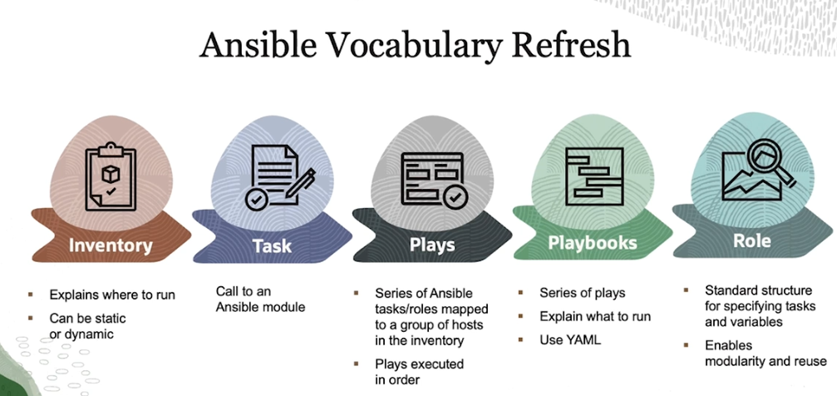

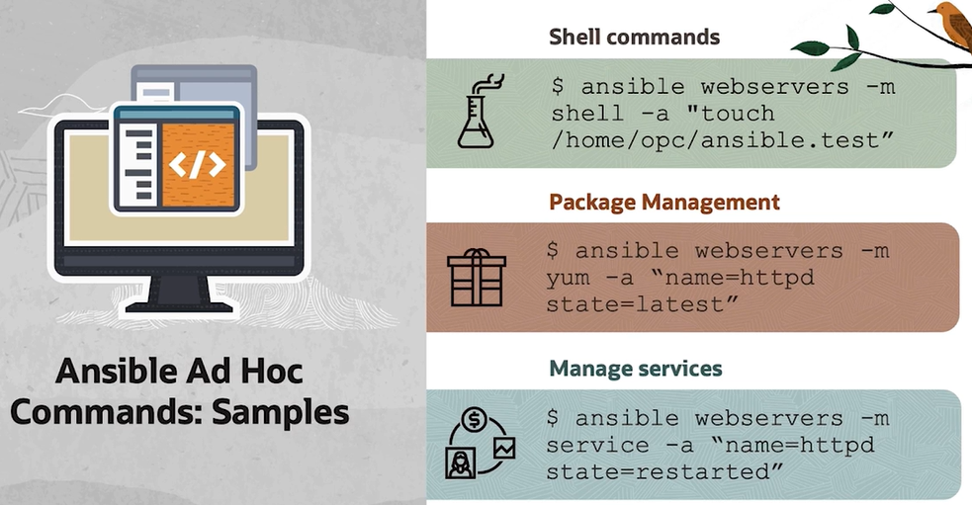

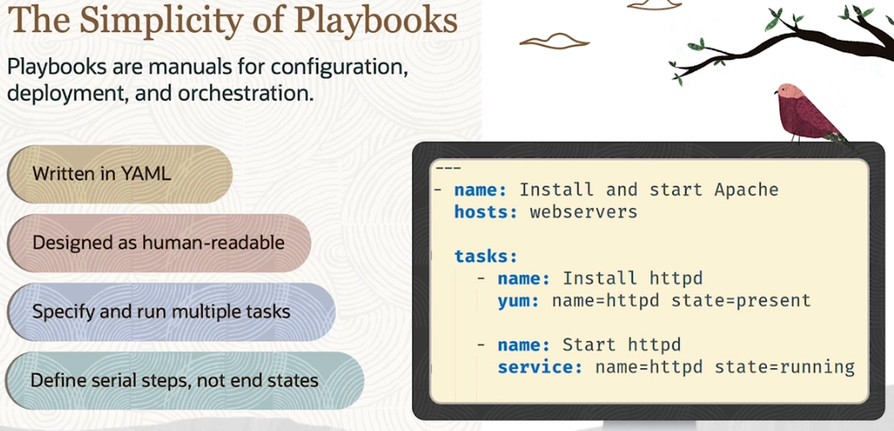

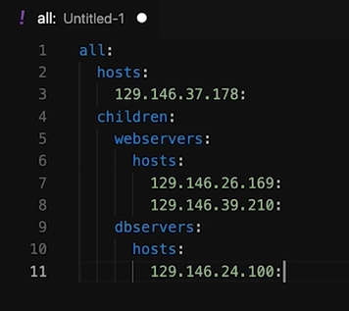

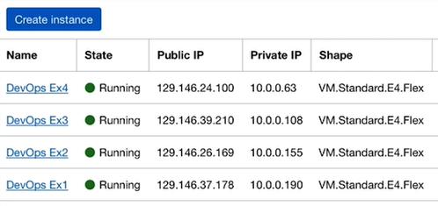

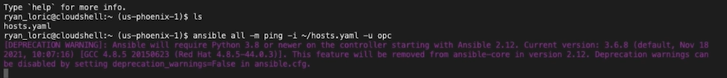

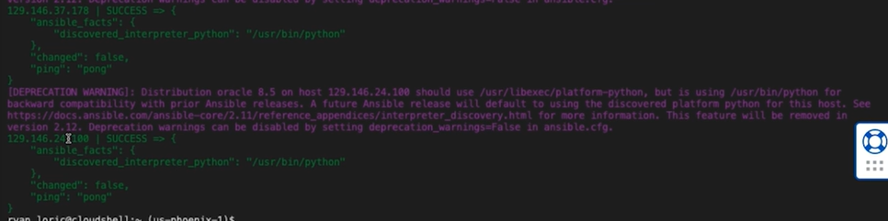

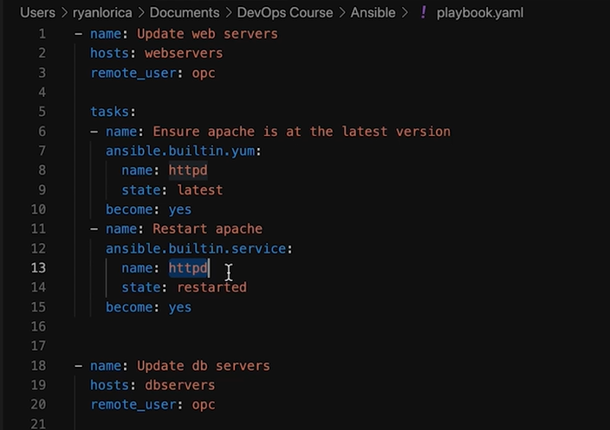

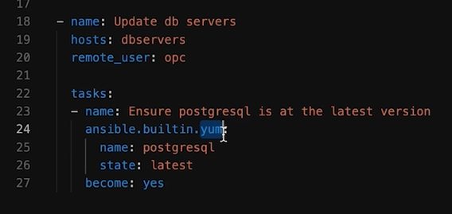

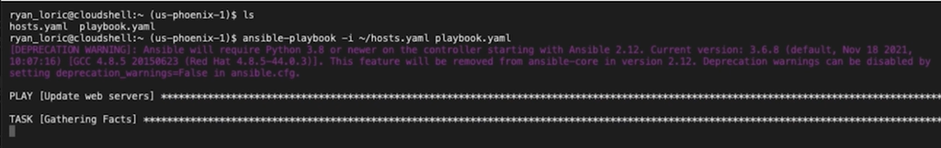

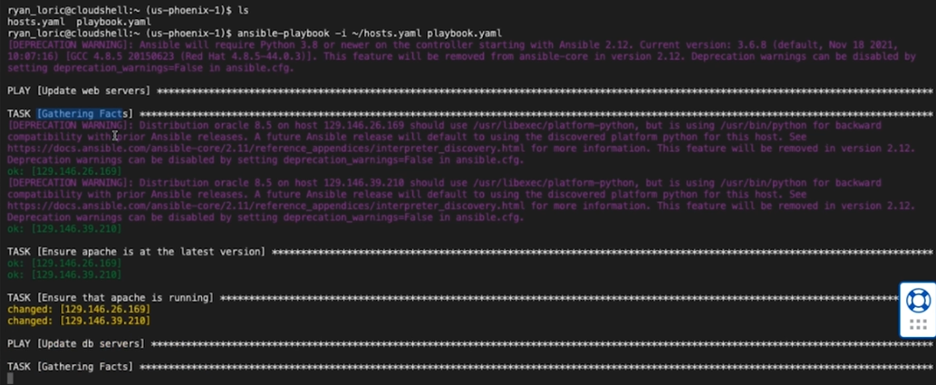

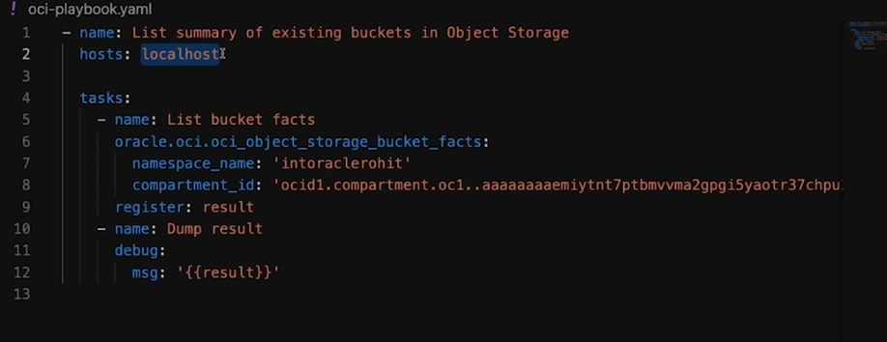

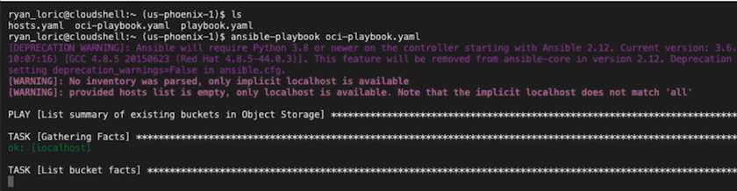

So we used Ansible to ping several machines, to perform package and service management, and to interact with OCI's REST APIs. Now, with a general sense of how to manage the machines that we have, we can turn our attention to managing what resources we have in the first place with infrastructure as code.

Intro to Terraform

Now, we're going to turn our attention to managing what resources are even provisioned using Terraform. Terraform is composed of two main parts. The first is a declarative language that lets you codify infrastructure stacks. Don't worry about the details quite yet, but here we can see a portion of Terraform code that declares a compute instance in OCI.

The second main part of Terraform is an engine that uses Terraform configurations to create a plan for making real-world infrastructure look like what is specified in the code. Again, don't worry about the details. But for example, if we give Terraform the config from before, it generates this plan to create a compute instance.

It can then take this plan and convert it into API calls to any infrastructure provider. This includes not only IaaS like OCI, but also PaaS like Kubernetes and custom on-premise solutions. When using Terraform, we can think of infrastructure management in three parts-- initial provisioning, maintenance and evolution, and eventual decommissioning.

At the start, you write your Terraform code, feed it to the Terraform engine, and it provisions the infrastructure. Then as your needs change over time, you can modify the Terraform code, and the Terraform engine will compare it to the existing infrastructure to then reconcile the two.

Once it comes time to decommission the environment, one command allows Terraform to clean up all of the resources that it's provisioned. This workflow is what infrastructure as code is all about. And it has myriad advantages.

You can reproduce stacks across environments, parameterize and version control infrastructure, create reusable hardware modules, and basically get all of the tools and techniques currently available for software development for hardware.

Easing into the details, Terraform does this through a very simple CLI. There are three main commands that you'll ever need to execute. Plan, apply, and destroy. We're already kind of familiar with Terraform apply. It takes a configuration file and provisions the infrastructure.

However, it also writes a file called the state that represents Terraform's view of the world. After thinking about this for a while, you might ask, what about if the infrastructure changes without Terraform? Perhaps someone logs into the OCI console and provisions a new machine.

For this, Terraform has an action called refresh that looks at the real-world infrastructure and refreshes the state file based on it. By default, this command is implicitly executed before any of the core actions. But in more complex implementations, it might be turned off.

Before you run apply, however, it's best to run a Terraform plan. This compares the configuration to the state and generates a plan for getting the state to match the configuration, often called the diff. You can look at the diff to confirm that your Terraform code does what you think it will.

By default, Terraform apply runs a Terraform plan and asks for your confirmation. But again in more complex implementations, this might be turned off, and Terraform apply will require an explicit Terraform plan. The last command is Terraform destroy which, as the name suggests, destroys all of the infrastructure that was under Terraform's purview.

Before we get too much into the weeds, let's go through a quick example of using Terraform to provision a VCN and a compute instance. First, we'll head over to VCNs. We'll click the menu, Networking, Virtual Cloud Networks, and select our compartment.

We can see that there's nothing here. So let's take a look at some Terraform code that will add a VCN with one subnet. Don't get caught up in any of this in text just yet. We'll discuss that later. All we want to note is that we have one block that configures a VCN named Terraform VCN, and one block that configures a subnet named example subnet. We can head to the terminal and run Terraform plan.

You can see that it outputs a list of changes that it'll make. Now let's go ahead and run Terraform apply. It outputs the same list of changes, and asks us whether we want to proceed. We'll say yes, and it'll go ahead and start creating the networking resources. Now if we head back over to the OCI console, we can see that we have our VCN. We'll click on its details. And it has that subnet.

Now let's see if we can modify the Terraform code to include a compute instance. First, let's navigate to compute instances just to see what I have. We can see that I just have a terminated instance from a test I ran earlier. Now let's head back over to the Terraform code where I've added two blocks.

The first one just selects an availability domain. But the second one configures an instance in the network we just provisioned. Now if we run Terraform apply, it creates a plan, promises as before, and goes ahead with creating the instance. You might want to take a second and stand up and stretch your legs here.

OK, it's done. And we can see that the console now shows our new instance in the running state. To wrap up, let's run Terraform destroy. It'll ask for confirmation, and it'll destroy the subnet, the compute instance, and the VCN.

Now that it's done, it'll show the instances terminated, and the VCN that we created will be gone. So that wraps up our intro to Terraform. In the next video, we'll talk about how it integrates with different platforms, and we'll dig a little bit deeper into the language.

Terraform configurations.

In order for Terraform to do anything, it has a key concept called Providers.

Recall that we have this model of Terraform being all about the interplay between configuration, state, and diff, and the real world infrastructure. And as mentioned before, Terraform can manage infrastructure across multiple platforms, including custom ones.

But this brings up the question, how can Terraform actually be platform-agnostic? To figure that out, we have to take a closer look at the internals of the Terraform engine. There are two main parts of the engine, the Terraform core and plug-ins called Providers.

The core figures out everything in a platform-agnostic way. Then, the providers translate that into the platform's language. To be a little more specific, Providers are Go language executables that translate between Terraform's diff, refresh, and apply functions, and the target platforms' CRUD API. HashiCorp maintains a registry of official, verified, and community providers that you can install. The official ones will install automatically if they're specified in the Terraform configuration.

OK. Now we can get into the real meat and potatoes of Terraform, the language itself. The big thing to know is that Terraform is declarative. That means that, for the most part, it consists only of blocks that declare resources, labels for those resources, and parameters that can figure that resource. To get a sense of the language, let's read over a very simple example together.

First, we have a block that configures Terraform itself. In that block, we have another block that lists the providers that are used. In this example we only listed OCI, but we could specify more as needed here. Next, we have one configuration block for each provider, in this case one for OCI. Any of the official or verified providers will have docs on the Terraform registry for what arguments are needed. So here we can see that we chose a region, method of authorization, and a user profile.

Finally, we have a resource block. This one declares that we have a VCN named Example. When you write these, you basically search the docs for the resource you want to create and fill in the attributes that it asks for. In this example, we fill in a DNS label, a CIDR block, a compartment OCID, and a display name.

If we wanted to improve this configuration, we would first notice that we have some hardcoded values like region and compartment OCID. We can factor these out by declaring them as variables and defining them all together. This way we can parameterize the Terraform configuration to be reusable in many different forms.

So if you look at this example Terraform code available on GitHub, you can see that they wrote it using a bunch of variables. A couple of interesting ones include num_instances, where you can change the amount of instances that you provisioned with just a number, and changing the instance shape, as well as the OCUPs and the memory. These kinds of variables are very useful in creating configurable reusable chunks of code.

To improve our code even further, Terraform has a concept of code reuse called modules. To illustrate that, suppose we have a Terraform configuration for a VCN and related resources. You could then use that VCN configuration as what's called a module and embed it inside of another configuration.

So in this example, we're calling the VCN module twice to provision it twice. This way, you could reuse the VCN module in different configurations to construct a Hub and Spoke network topology for example. You could then use the Hub and Spoke configuration as a module in an even larger application, and so on.

HashiCorp maintains a registry of modules and examples. In practice when writing Terraform you want to use these as much as possible. Admittedly, Terraform goes way deeper than is within the scope of this course. For that, HashiCorp maintains very well done tutorials and documentation that I highly recommend perusing.

For this course, like with Ansible, we're only looking to get a sense of the workflow so that when you decide you want to implement infrastructure automation, you know where to start. So that's all we have for general Terraform knowledge. In the next video, we'll talk about the tools available in OCI to facilitate Terraform usage.

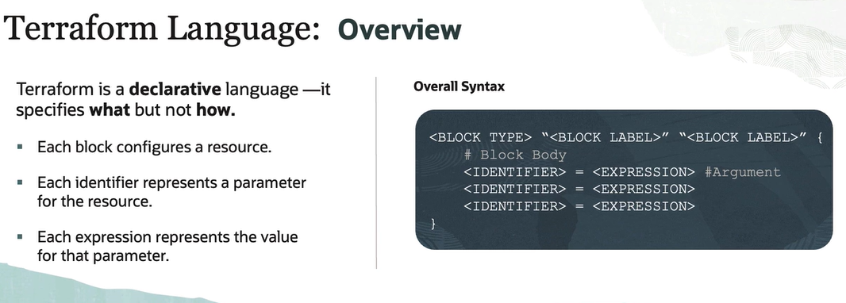

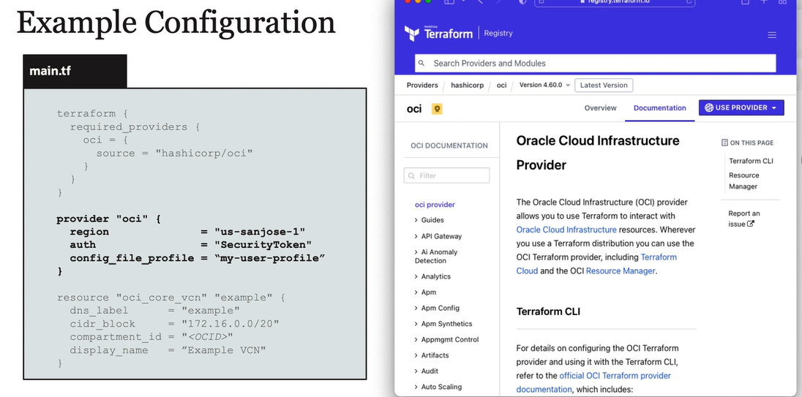

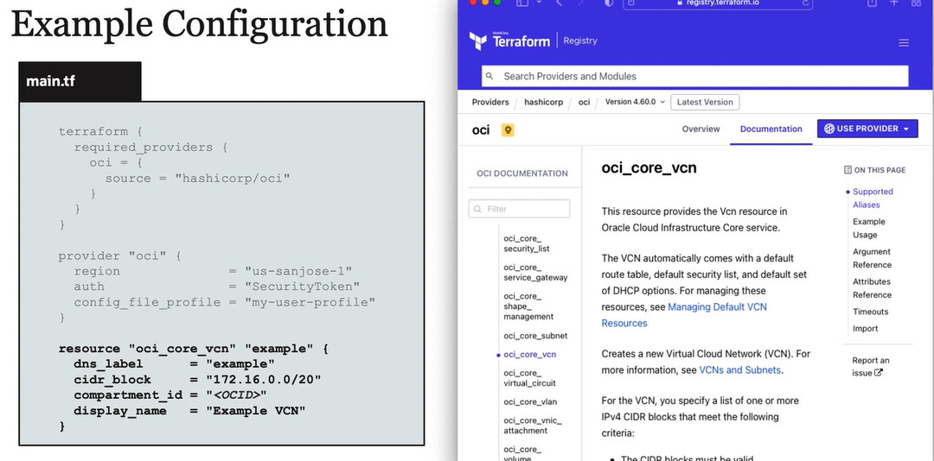

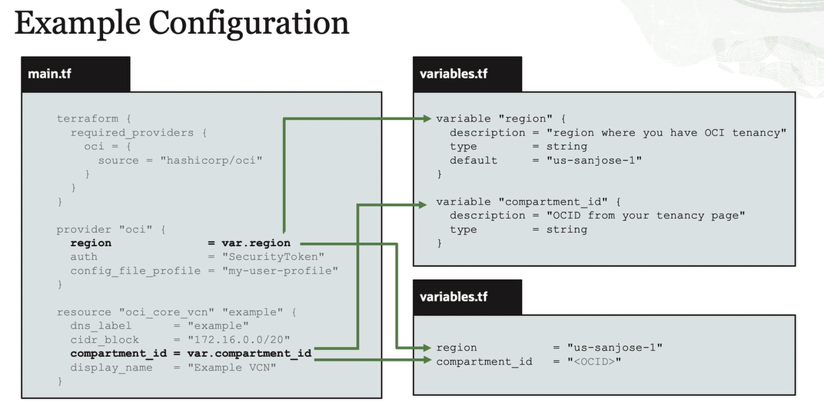

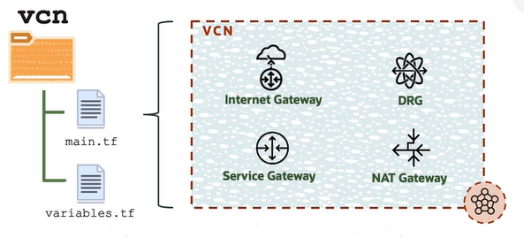

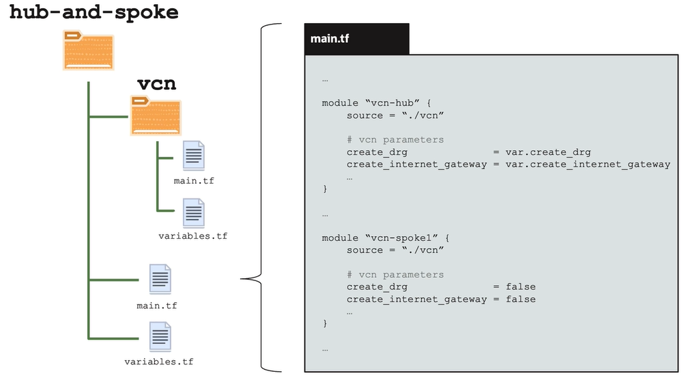

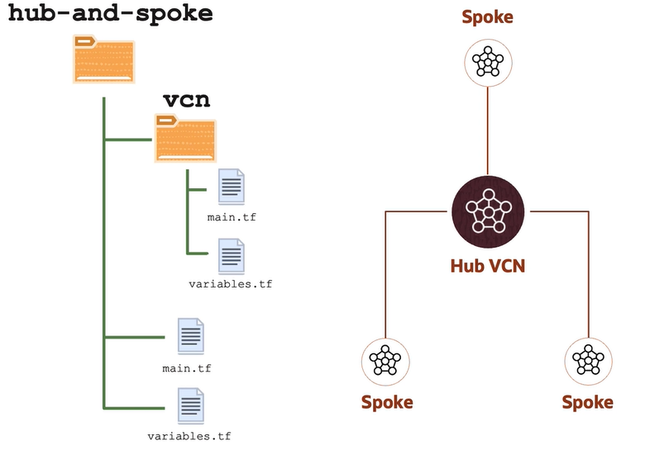

OCI Resource Manager.

In our first model for Terraform, you draft configurations on your local machine, run Terraform on your local machine, and it reaches out to cloud providers like OCI to manage infrastructure. It's great for experimenting, but there are two obvious problems with this approach.

The first is lack of version control. You need to keep track of various versions of the code for things like rolling back and branching for features. The second is in collaboration. You have to centralize the configurations and plan outputs to make sure everyone is on the same page. This leads us to storing the configuration and plan outputs in a centralized version control repo.

So now we have this model where everyone can collaborate. Note, the state isn't uploaded because it can contain sensitive info, like OCIDs and IPs. Contributors then write configs and test plans on their local machines before merging changes together. One pulls from the latest version in the shared repo before running Apply. OK, this is a great improvement, but there are still a couple of problems.

To understand those problems, we need a quick tangent on Terraform Apply, Plan, and Refresh. When you call Apply, it calls Plan, which calls Refresh to update the state, which is used to generate a diff, which is executed to provision the infrastructure. The flow for Plan is the same, except the diff isn't executed.

This works well for small stacks, but for larger, more complex ones, Refresh becomes an expensive operation, especially because it relies on API calls to the Infrastructure. Similarly, actually computing Plan becomes very expensive on more complicated stacks. To deal with these problems, we get rid of the automatically cascading invocations and replace them with manual invocations, almost. Technically, explicit invocation of Refresh is deprecated and is done with an option when calling Plan.

OK, now that we have our more sophisticated workflow, what does that get us? Let's look at the diagram again. First, the state file isn't centralized, so different configuration authors could be working with different state files while calling test plans. Second, the actual diff that is executed against the infrastructure isn't centralized, so there's no guarantee that what happens is what everyone agreed on.

These bring us to our third model for Terraform usage. If we actually run Terraform from within the cloud, we can guarantee that we're using the latest version of state or diff files. In this workflow, we draft configurations locally, sync them with a centralized repository, and execute Plans and Applys in a centralized manner.

This brings us to a really important tool to get familiar with, OCI Resource Manager. You can think of it as a cloud-based Terraform host for centralized source control, state management, and job queuing, plus some Terraform-based automation, like resource discovery and drift detection. We'll go over each of those in detail later, but for now let's dive into this workflow with a demo.

To start, we have Terraform in a GitHub repo. Let's look at the main.tf file. It configures Terraform, and it configures the OCI provider. And this code provisions the VCN and two subnets within it. Now let's go to the variables file. Here, we only have two variables-- compartment_id and region.

The next step is to create what's called a stack in Resource Manager. A stack is a set of resources to manage infrastructure. For our demo, we'll mirror our GitHub repo. We'll start at the home page of the OCI console. Navigate to the menu, Developer Services, and Resource Manager. Here, we can select Stacks. And let's go ahead and create one.

You can upload Terraform configuration files directly, use an OCI-provided template, mirror from GitHub or GitLab, or create one based on an existing compartment. We'll mirror from GitHub.

Here, you select a configuration source provider, which is just a connection to GitHub or GitLab with an authentication token. I'll select the connection I made to GitHub earlier. I'll select the repository I just showed, and I'll select the main branch.

Here, we can name the stack, select its compartment, Terraform version. And let's go to the variables. Right now, this part just reads the variables file and provides us fields for each variable. We'll grab a compartment ID, and select Phoenix for the region. We can review. And let's Create.

Now we've created our stack, but we haven't run any Terraform. For that, we'll have to hit the Plan or Apply buttons. So now we have a stack with a configuration. And since we selected to not provision immediately, we also have a state file that just states that nothing is provisioned.

We can also hide the local machine and GitLab from the picture for now. Next, we want to run a plan. For every stack, there is a queue of jobs, commands that will be run. We'll add a plan to the job queue, which will lock the state file, get passed to the Terraform host, which executes it and generates a diff. Once that's done, the state file will unlock.

Let's go ahead and hit Plan now. Let's name our plan, and hit go. It will take a second to run, but here you can download the Terraform configuration as well as cancel the job. You can view all of its details here, and it will show all of its outputs down here. So you can see that it finished, and it created a plan down here.

Finally, we'll add an apply to the queue that will lock the state file and execute the diff to provision the infrastructure. We're going to go ahead and hit Apply. Name the job. And then we can choose either using an existing plan or running a new one. We'll choose an existing one. And we'll hit go.

And you can see that it succeeded, and the logs are down here. Now let's go back over to VCNs to see what it created. You can see it created the example VCN, and it should have two subnets. So that's the basics of using Resource Manager for Terraform. In the next video, we'll go over how to handle when Infrastructure and Resource Manager are out of sync.

Syncing Resource manager and Infrastructure

In the previous lesson, we introduced Resource Manager to provision and manage infrastructure. However, we assumed a perfectly linear workflow where all changes made to the infrastructure are made through Terraform, which is not totally realistic. To mimic this, I made two changes to the VCN. First, I added a new subnet. Second, I added another CIDR block.

This is called drift, the process of real infrastructure slowly diverging from what was configured. For this, Resource Manager can run what's called Drift Detection to compare the configuration and the infrastructure to generate detailed drift reports for each resource. To do this, we'll go to our Stack in the Console, and click More Actions, Run Drift Detection, and Confirm.

We now have a Drift Detection work request down here. It'll take about a minute to run. Now that it's done, we can go back to More Actions, View Drift Detection Report, and we'll see that it's detected a modification on the VCM, specifically, a new CIDR block.

We'll minimize those. And we'll see that, while it did detect the new CIDR block, it didn't detect the extra subnet. This is because Drift Detection only reports on resources that Terraform knew about already. We can address this, but to do that, we'll take a quick tangent.

Another problem with our idealized workflow is that it's not realistic to always draft the Terraform first and then provision a stack for it. Sometimes it's easier to just mess around in the console and provision the infrastructure first. For this, Resource Manager can take all of the infrastructure in a compartment and generate the stack and configuration based on it.

To do this, we'll go to our Stacks and Create a new one. We'll select Existing Compartment. Pick the compartment we want to scan. And select the services that we care about, in this case, core services. We'll name our stack. And go ahead and Create it. It'll take about a minute to run.

And now we have a stack based on the existing resources in a compartment. You can download the Terraform configuration right here. If we open up the Terraform, we can now see how we can address that extra subnet that Drift Detection didn't catch. We can take the Terraform from here, paste it into our Terraform configuration, and update the state using Terraform CLI. We can also update the VCN's Terraform with the new CIDR block captured here.

Now, we can not only use Terraform and Resource Manager to provision infrastructure, but we can also use Drift Detection to find changes and Resource Discovery to write Terraform for us. This way, we can support a more nonlineat workflow that's representative of the real world. In the next video, we'll talk about extending the console to support our stacks more seamlessly.

Extending the Console

In the last few videos, we talked about using Terraform with Resource Manager. Now, we'll discuss some final touches streamlining Terraform usage with OCI. So far, we've talked about using Terraform as an input to Resource Manager to provision the infrastructure, as well as using Resource Manager to write Terraform based on existing infrastructure.

This picture should be a little more complex, though, because we'll often use the same configuration to provision multiple stacks. For example, we might have a development, a QA, and a production environment. Also in a microservices-based application, as we'll talk about in later modules, an application can be broken up into multiple, loosely coupled pieces.

Finally, one of the big parts of DevOps is that it's not only traditional ops people that manage infrastructure, but also traditional developers that aren't necessarily experts on Terraform. The way Resource Manager makes it easy for DevOps personnel to manage infrastructure is by allowing you to hide the Terraform a way into what are called templates.

To make a template, we can just upload our Terraform configuration here. It'll also need a schema document, but we'll address that later in this video. To use the template, we'll go to the stack creation form and select to use the template. Here we can select between Oracle provided templates and our custom ones. Then we just need to go through and fill in all the variables.

A template consists of two pieces-- a Terraform configuration and a schema document. You should be familiar with Terraform configurations, but schema documents are probably new. These are YAML documents that list the variables in the code, the constraints on those variables, and what variables to show on the stacks page in the web console. These allow the web console to render forms for provisioning these stacks.

Let's run through an overview of the syntax before showing an example. The fundamental thing that is specified in the schema document is a list of all of the variables. In this example, we specify a variable named functions app name that takes a string. The field is titled application name, and has the description do not use spaces. It ends up getting rendered like this.

The other main thing that is specified is how variables are grouped. To specify a variable group, we just give it a title and the list of variable names. Each variable group renders as a box of fields to fill in. For this example, let's walk through some simple Terraform.

The first block configures Terraform, the second block configures the OCI provider, the third configures a VCN, the fourth configures a subnet in that VCN, and the fifth declares a compute instance in that subnet. Note how he factored all the parameters out into variables.

Now let's take a look at the variables file. Here we declare everything, but we skipped specifying anything about the variables because we'll do that in the schema document. If you intend on also using the Terraform CLI with these configurations, you should fill this in too.

Onto the schema document. The first block gives the template a title, description, and quick blurb. This is displayed when selecting between templates. You could also add a thumbnail here, but it's optional. The next main block that we have is for variable grouping. Here we have a group for hidden auto-populated variables. In this case, just region.

And then we have a block each for the VCN variables, the subnet variables, and the compute variables. The VCN variables just include the compartment, the display name, the DNS label, and the CIDR block. The subnet has the same variables, just with different names.

The compute has compartment OCID, display name, shape, image, and availability domain. Here's where we actually specify the metadata on each variable. First, let's look at region. Type is the most important thing to specify. The OCI docs have a list of allowed types. By specifying that it's a region, OCI can then just auto populate this variable. Next, we give it a title and say it's required.

Now let's look at the VCN variables. By giving compartment ID its respective type, it tells OCI to provide a dropdown of all the available compartments. This way, you don't have to go searching for OCIDs anymore. Then we just say it's required, and give it a title and description.

String-based variables like display name are largely boilerplate. However, some string-based variables like CIDR block are best given a regex pattern for input validation. For DNS label, we gave it a maximum character length of 15. The subnet variables are identical, so we'll skip that.

Onto compute variables. Compartment ID has the same configuration as before. Display name is also very straightforward. Shape is more interesting, because by specifying its respective type, OCI will give us a dropdown of possible shapes.

By saying it depends on the compartment ID, it will also filter by the shapes that are available in the selected compartment. Likewise for image, it gives us a dropdown that we can filter by the compartment and by the compute shape chosen above. Finally, for the availability domain, it can get a dropdown with the 80 names that are specific to our tenancy.

Now we can take a look at how this renders when provisioning the stack. We'll start off by hitting Create Stack. Then we'll upload our configuration. This is the one that I just showed. Here's where it shows the title, info, and thumbnail. We'll name our stack, and we'll see that the description was pre-populated.

Now here's what the schema document does all the heavy lifting. We'll use this dropdown to choose our compartment. We'll name the VCN. Give it a DNS label. And give it a CIDR block. Now we can do the same for the subnet.

We'll select our compute instances compartment, give it a name, and now notice how compute shape filled in with a default, and the dropdown is populated by available shapes in the compartment. The dropdown for image then is filtered by compartment and by compute shape. Finally, we'll pick our availability domain.

Now let's create the stack. And we'll hit Apply. This will take a few minutes to run. But I'll cut that. Now that it's done, we'll go ahead and look at our resources. Go to the Menu, Networking, Virtual Cloud Networks, and we'll see our VCN. Now let's go back to the menu, hit Compute Instances, and we'll see our example instance.

*And that wraps up our module on infrastructure automation. We first went over configuration management with Ansible, and demonstrated how to configure multiple machines with Ansible plays in playbooks. Then we gave a brief introduction to infrastructure as code with Terraform, and using it with Resource Manager. Then we went over detecting changes with drift detection, and using resource discovery to write Terraform for us.*

*Finally, we went over using templates and schema documents to neatly package a Terraform configuration for easy reuse. We went over a lot, and all of this stuff goes pretty deep. But what's important is that you should have a feel for managing infrastructure in this way, and would be able to dive deeper on your own when needed.*

*For the certification, I highly, highly recommend that you write some Terraform and play with it in Resource Manager. You could do a lot with just the free tier. With infrastructure automation in our tool belt, we can start to think about the application that sits on top of it.*

How can we structure the software in such a way that it's conducive to the fast-paced DevOps lifecycle? For that, I'll pass the floor to my colleague Mohenjo Mehra to dive into microservices and orchestration.

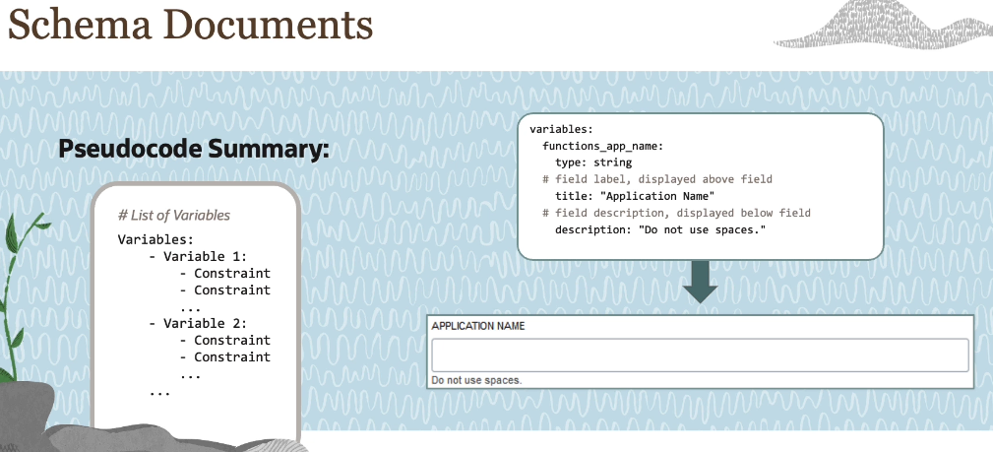

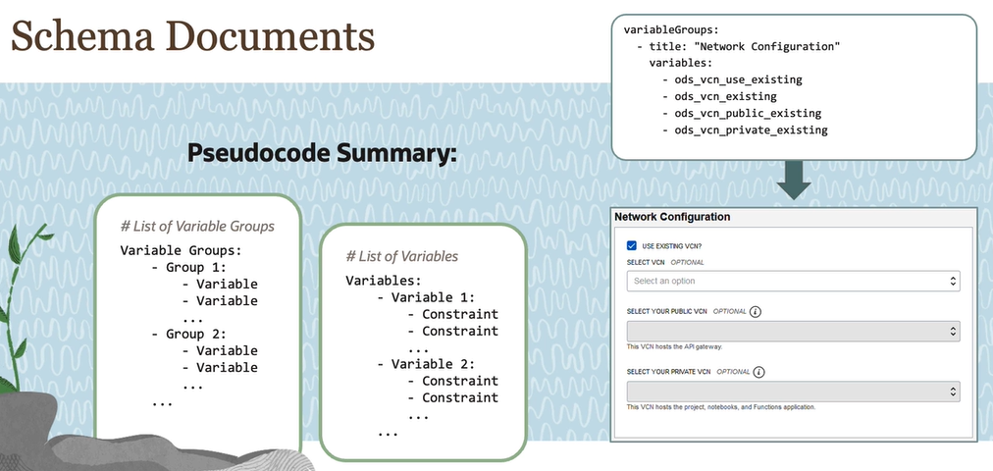

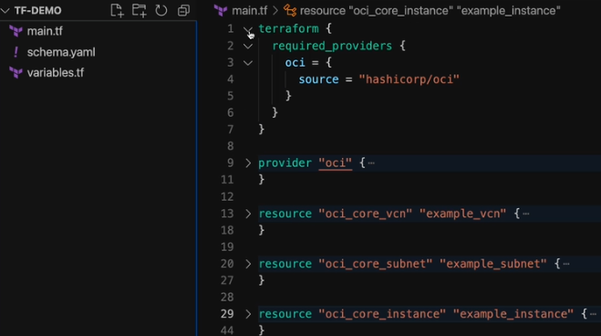

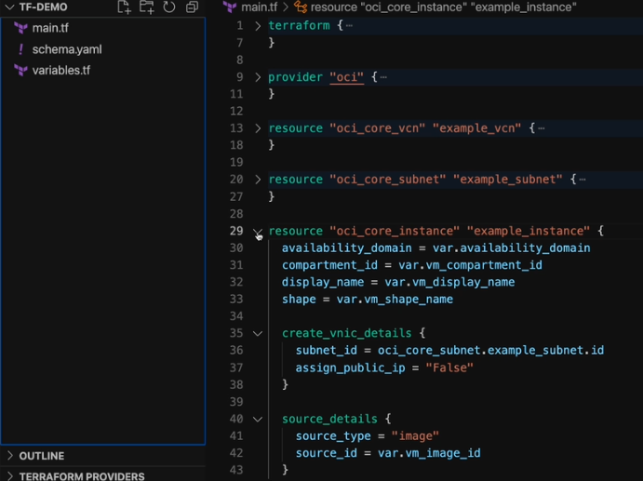

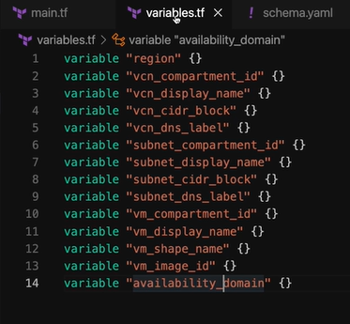

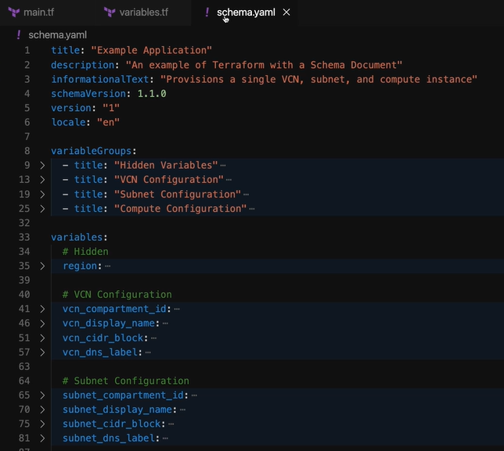

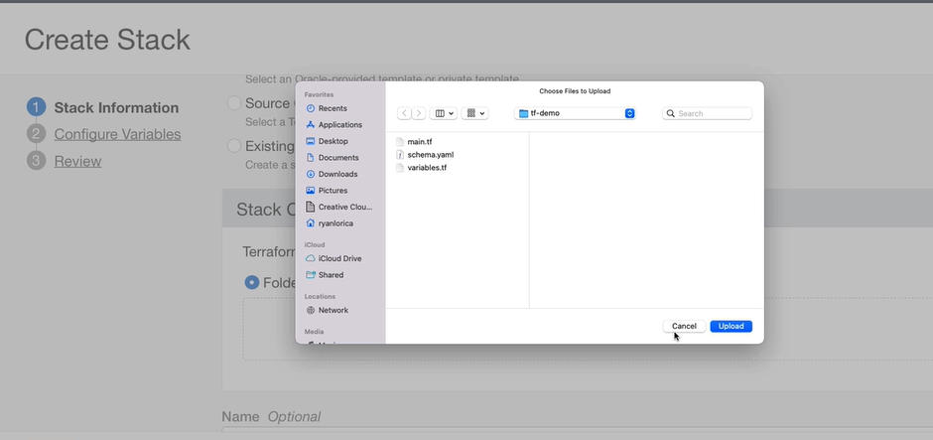

1. Which three statements about using Ansible on OCI are true?

You can use Ansible to collect billing and usage data for your OCI tenancy.

You can use Ansible to restart Apache on all web servers as defined in an inventory. (*)

You can use Ansible to create and destroy OCI resources, such as compute instances and load balancers. (*)

You can use Ansible to execute a shell command on a collection of hosts. (*)

The task sequence in your Ansible playbook does not matter. Ansible will evaluate dependencies and execute tasks in the most effective sequence.

Correct. Ansible can be used to manage and configure resources on Oracle Cloud Infrastructure (OCI). With Ansible and its modules, you can create and destroy OCI resources, execute shell commands on remote hosts, and manage services on remote hosts. Those tasks are organized sequentially in playbooks. However, Ansible is not designed for collecting billing and usage data for your OCI tenancy.

2. Which three statements about Resource Manager (RM) are true?

RM can mirror repositories from GitHub and GitLab. (*)

Resources provisioned through RM cannot be destroyed from outside of RM.

Terraform configurations used by RM cannot contain any variables.

RM can generate Terraform based on the resources in a compartment. (*)

RM can render custom "Application Information" pages for stacks. (*)

Incorrect. OCI Resource Manager enables you to manage infrastructure as code by uploading code from files or mirroring code from GitHub or GitLab repositories. With the Terraform import feature, RM can automatically generate configuration files for the infrastructure in a designated compartment. Additionally, RM allows customization of stacks by including custom "Application Information" to guide users on how to configure and deploy the stack.

3. A DevOps engineer is new to Ansible. He wants to write a manual for configuration, deployment, and orchestration. Which Ansible term is he describing and in what language will he write the manual?

Plays; YAML

Inventory; JSON

Playbooks; YAML (*)

Playbooks; JSON

Role; Python

Plays; Python

Correct. Ansible Playbook, which is a configuration management tool that enables users to define the tasks and steps needed to configure, deploy, and orchestrate infrastructure and applications. To write the playbooks, YAML is the required markup language.

4. What is an advantage of declarative code (e.g. Terraform) over procedural code (e.g. Ansible)?

Performance

Ad hoc commands

Security

Predictability (*)

Correct. Declarative code, like Terraform, offers a higher level of abstraction by focusing on the desired end-state of infrastructure, reducing complexity and the risk of unintended changes, hence predictability. Procedural code, like Ansible, is better for tasks with complex logic, while declarative code is better for infrastructure configuration and management.

5. What is an advantage of mutable infrastructure (e.g. Ansible) over immutable infrastructure (e.g. Terraform)?

Performance

Security

Flexibility (*)

Predictability

Correct. An advantage of mutable infrastructure, such as Ansible, over immutable infrastructure, such as Terraform, is that mutable infrastructure provides more flexibility and allows for easier maintenance of existing infrastructure. Mutable infrastructure allows for changes to be made to existing resources, such as upgrading software versions or applying security patches, without requiring a full rebuild of the infrastructure.

**Deploy a Monolithic Architecture**

**Case study Architecture Ruby on Rails Redis PostgreSQL**

Throughout this module, we'll deploy a real-world architecture in OCI as a case study. The application that will deploy is a social network called Mastodon.

If you're unfamiliar with Mastodon, it's a nonprofit-led social network that was first released in 2016. Its infrastructure is decentralized. Its code is open source. And its messaging protocol is interoperable with any other site that uses the ActivityPub open standard. It has many features common to social networks, such as posting photos or videos, having a profile or messaging other users.

However, unlike many other social networks, Mastodon isn't hosted as a single, centralized entity. Instead, it consists of many separate sites called instances that share information with one another. Each instance hosts its own users and content. And perhaps most importantly, its own moderation. For this module, we'll be deploying one of these instances. So let's take a look at how one works.

Within a single instance, clients such as mobile app users, web app users, and more, all talk to an application server. This server can then retrieve media assets, like static pages and images, from a separate host. Persistent data like posts are held in a separate relational database.

For a cache and job queue, the application server also uses a separate in-memory data store. Under the hood, the application server is Ruby on rails. The media assets are stored in either object or file storage. The relational database is PostgreSQL. And the in-memory data store is Redis.

I want to emphasize that these specific technologies aren't really within the scope of this course. They just happen to be part of the example that we're using to demonstrate different components of operations in OCI. Specifically, we'll need to place all of these resources within a Virtual Cloud Network.

Set up routing and configure security rules and gateways. Second, these applications will need to be deployed on compute instances. We'll deploy each of these applications with a slightly different method, namely, it will go for custom images with PostgreSQL, cloud in it with Redis, and Ansible with Rails.

Third, we'll talk about using external block volumes in the context of Postgres. And we'll go over backups, clones, and replication. Fourth, we'll implement media storage in two separate ways-- first, using file storage and second, using object storage. Finally, we'll use our relational database to talk about load balancing and request routing. And along the whole way, we'll talk about different methods of interacting with OCI and its resources, including the console, the CLI, Terraform, and a little Ansible.

So we've got a lot to go over. By the end, you'll have a good feel for deploying a real-world monolithic architecture on OCI. And you'll have the foundations to approach many new problems that will come your way as an operations professional.

**VCN deep dive**

In this video, we'll go over all the concepts necessary for setting up a VCN. And we'll design one for our case study architecture. Just as a reminder, our goal is to implement this architecture. We'll break this out into three phases.

First, we'll need a VCN and subnets to put our resources in. Then we'll need to set up gateways and routing to allow ingress and egress. And finally, we'll set up security rules that determine what traffic will be allowed in the VCN.

To get started, we'll take a look at our conceptual diagram that shows what devices will be involved. In terms of networking, we can split this up into two regions, the internet and OCI. Within OCI, let's have a single VCN.

In more advanced cases, you could have many VCN or even many VCN within many different regions. But that goes a little beyond the scope of this course. Our Architect Professional course goes into more detail on that domain.

Aside from VCN, an OCI region has the Oracle Services Network. This is where services like object storage or Autonomous Database have endpoints. Next, let's break our VCN into two subnets, one for a front end app subnet and one for a backend data subnet. We can place our application server in the app subnet. The database and in-memory data store can go in the data subnet.

If we use file storage for our media assets, then they'll go in the data subnet. If we use object storage, then they'll be in the Oracle Services Network. All of the clients will be communicating from the internet.

Finally, let's give the VCN a sided block, as well as partitions for the app subnet and data subnet. If you need a quick refresher on CIDR blocks, they are a way of notating ranges of IP addresses.

There are four numbers separated by periods and then one separated by a slash. Each of the first four numbers represents eight bits. The number after the slash represents how many of the bits stay the same. The rest of the bits are free to change. So this CIDR block contains everything from 10.0.0.0 to 10.0.256.256.

There are specific ranges within the IPv4 space that are reserved for private networks. These are 10.0.0.0/8, which contains about 16 million addresses, 172.16.0.0/12, which contains about a million addresses, and 192.168.0.0/16, which contains about 65,000 addresses. You'll probably just need to look these up when you want to use them.

So if we look at our examples, our VCN is 10.0.0.0/16, with about 65,000 addresses. And our subnets are 10.0.0.0/24 and 10.0.1.0/24, each with about 256 usable addresses.

I usually just use an online subnet calculator to figure these out. So that gives us our VCN layout. Now we can address gateways and routing. First, let's look at the communication between the clients and application server. On our network diagram, that would correspond to this.

However, traffic can't just flow into VCN from the internet since it's a private network. So we need to place an internet gateway, a device that can bridge traffic between the internet and a VPN. This can only work if we declare the app subnet as public, meaning that devices within it are allowed to have public IP addresses.

Private subnets forbid any public IP addresses, so nothing outside of the VCN can ever directly address something inside the private subnet. We'll make our data subnet private. Next, let's look at traffic between the application server and the backend servers.

If we're using file storage, then this would just look like flow between the app subnet and the data subnet. Traffic within a VCN doesn't need any gateways, so this is fine as is.

If we're using object storage instead of file storage for the media assets, then there would be traffic leaving the VCN and entering the Oracle Services Network. Since our app subnet is public, it can just re-use the internet gateway for this traffic.

In comparison, let's consider database backups to object storage. This would be traffic from our private subnet into the Oracle Services Network. A private subnet can't use the internet gateway, so we'll need to add a service gateway to privately bridge our data subnet and object storage.

Finally, there's one last kind of traffic that's not really shown here. Consider if we wanted to update the software of our database or data store. This would require servers in our private subnet to reach out to software repositories on the internet. Nothing in the private subnet can have a public IP address, but we can still accomplish this with a NAT gateway. This kind of gateway allows communication sessions that are initiated from within the VCN without exposing any private IPs.

And there we have our VCN with all of its gateways. There are two more gateways that we won't use but I'd briefly like to touch on. First, if we wanted to connect two VCNs within the same region, we could use a gateway called a local peering gateway. This would require that the VCNs don't have overlapping CIDR blocks. If we wanted to connect a vaccine that did have an overlapping CIDR block, we could use a dynamic routing gateway, instead, of an abbreviated DRG.

This kind of gateway is actually a lot more powerful. First, it can connect to other OCI regions over the Oracle backbone rather than the internet. This is called remote peering. And second, it can connect to private premises, both over a private connection, using FastConnect, or over the internet using IPsec VPN.

For more complex networking, check out our Architect Professional course. In any case, now that we have our gateways, we'll need to consider actually routing through them. By default, all subnets share the same routing table. But we can create new routing tables and attach them to specific subnets.

Let's make a routing table for public subnets, which, in this case, is just our app subnet. First, if we look at traffic within the VCN, we don't have to add anything because this traffic is automatically routed.

Note that if you actually look at a route table in the console, it won't show this rule because it's implicit. But you can rest assured that traffic from inside the VCN to inside the same VCN can be routed. But whether or not this traffic will be allowed by security rules is a separate story that we'll talk about later.

Next, let's look at traffic that goes through the internet gateway. For this, all we need to add is a rule saying that traffic outside the VCN goes to the internet gateway. We can specify this with a rule saying that for destination 0.0.0.0/0, target the internet gateway. These zeros just mean all IP addresses.

Next, let's look at a route table for our private subnet. Like before, the traffic within the VCN is routed automatically. So we don't have to worry about this.

For traffic through the service gateway, we'll need to add a rule, saying, to use the service gateway for Oracle services. For the NAT gateway, we'll need to add a rule saying to send everything that is neither within the VCN nor the Oracle Services Network to the NAT gateway.

When looking at route rules, the VCN always uses the most specific route first. So in this case, VCN is more specific than Oracle services. And Oracle services is more specific than all IP addresses.

So if we clean the diagram up to just the network we have our VCN layout, gateways, and route tables that will implement up next. We'll first run through it in the console. And then we'll go through it again using Terraform.

So we went through a bit of a crash course on how to take an architecture and plan our VCN, subnets, gateways, and route tables. I realize we blazed through it despite it being a topic that goes way deeper. But my goal is just for us to have a familiarity with each of these pieces.

Like I mentioned before, check out our Architect Professional course for more details on networking. What is crucial for this course is what's next, taking our design and turning it into a real network.

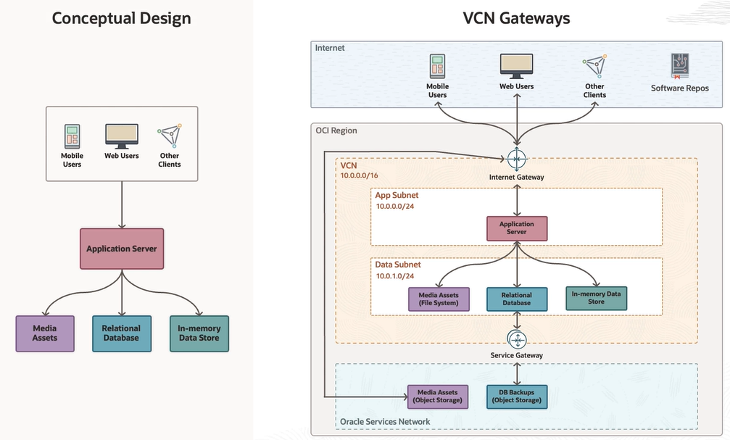

**VCN security**

works and we'll design the security rules for the case study architecture of this module. Throughout this module, we're implementing this architecture for an instance in a decentralized social network. We broke out networking into three parts: subnet layout, gateways and routing, and security rules.

In the last few videos, we talked about the first two points, and we implemented this network architecture. Let's also depict the Oracle Services Network and the internet. At this point, we could technically place a compute instance in the subnets and we could even give the compute instances in the app subnet public IP addresses.

However, as is, if a user were to send a request for a web page, the request would actually get silently dropped. This is because between every instance and the rest of the VCN, there's a specialized card called a virtual network interface card or VNIC for short. On this VNIC lies a table of all the traffic that's to be allowed in. The first column in this table specifies the source that we're going to allow.

Here, we can specify a CIDR block, other VNICs that have a particular network security group attached, or an OCI service. The second column specifies the protocol that we're going to allow, such as TCP, UDP, ICMP, or even general IP. The final part specifies the details for the protocol. If we have a rule for TCP, then we can specify a source port and destination port. For example, if we wanted to allow HTTP and HTTPS for a web traffic, we'd need a rule to allow TCP ports 80 and 443.

If we have a rule for ICMP, then we can specify type and code. For example, if we wanted to allow ping, then we can allow ICMP Type 8. So for some full examples, we can allow web traffic from anywhere, web traffic from just within our CIDR block, or ping from within our VCN. Some more specific examples would be like MySQL from within our VCN or Postgres from within our VCN.

The default destination ports for applications like these are generally just something you look up every time. When it comes to setting these rules, a common point of confusion is that you don't set the rules on the VNIC directly. Instead, a VNIC allow list consists of the combination of all security lists that are attached to the subnet, and of all network security groups that are attached to the VNIC. The allowed lists on the security list or NSGs are what you actually edit.

Let's go over how we use this combination of security lists or NSGs for our case study. We'll have our rails instance in the app subnet, and our Redis and Postgres instances in our data subnet. Let's also depict the VNIC for each of these instances.

First up, every VCN has a default security list. With ingress rules for SSH and some ICMP rules that are necessary to allow a VCN to function. It also includes an egress rule to allow all egress. If we attach the default security list to the app subnet and the data subnet, then we should be able to SSH from the internet into the rails instance, as well as from the rails instance into the private instances.

Another type of traffic we'll need to consider is HTTP and HTTPS from the internet. There's no rule for this right now so this traffic would be dropped. We don't want to edit the default security list because that would apply to everything. Instead, let's make a network security group specifically for rails, and attach it to the rails instances VNIC. This would just need a rule to allow TCP traffic to ports 80 and 443. Then web traffic to rails would be allowed.

Next up, rails needs to be able to connect to Redis. To allow this, let's make another NSG for Redis and attach it to the Redis instance. Notice how by using NSGs instead of security lists, we can edit the rules of the Redis instance without editing the rules of the Postgre instance. This NSG will just need to allow traffic from the rails NSG to TCP port 6379.

By specifying the source as the rails NSG instead of a whole CIDR block, we can limit access to a specific VNIC or set of VNICs. So any other random instance in the app subnet can't talk to Redis without being added to the rails NSG.

We can do a similar thing for Postgres. We'll make a Postgres NSG, and attach it to the Postgres instance. It'll just need a rule to allow traffic from the rails NSG to TCP port 5432. So now, the rails instance should be able to access both Redis and Postgres. For media assets, we'll also need to consider that the rails instance will need to make HTTP calls to object storage.

We already have a rule to allow all egress, but you might think that we need to add a rule to allow the response from object storage to the rails instance. However, the default rules are all stateful, meaning that a response will always be allowed. For all the rules that we are adding, we can choose between stateful and stateless rules, but let's just assume we're always going to use stateful rules for now.

The last kind of traffic we'll need to consider is for file storage. While the file storage system itself exists outside of the VCN, it'll need to have a mount target inside of the VCN. Each of the Phoenix will connect to the Mount Target using the NFS protocol. We can allow this traffic by creating a file storage NSG and attaching it to each of these VNICs.

Notice again how the flexibility of the NSGs lets us edit VNICs across multiple subnets. NFS requires two rules, one for TCP and one for UDP. And so now, we have all the network security resources we'll need for our case study app. In the next video, we'll take a quick look in the console how to edit security list and NSGs, and then we'll go ahead and create them through Terraform.

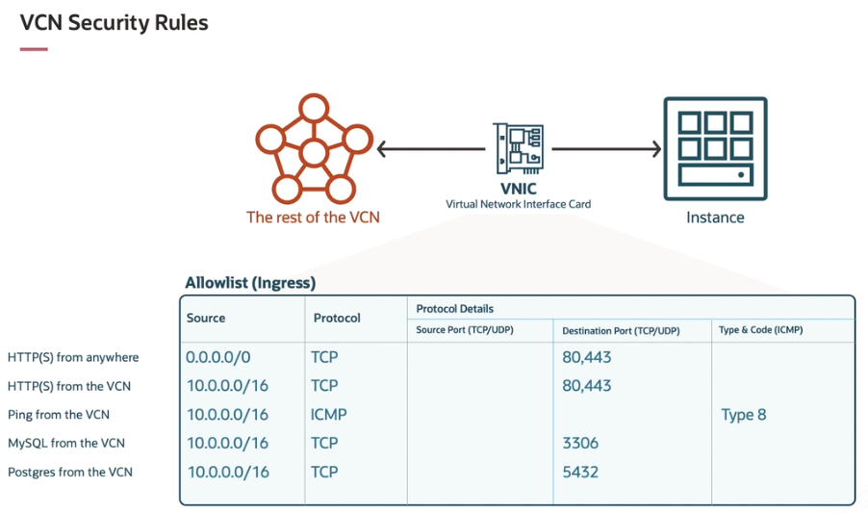

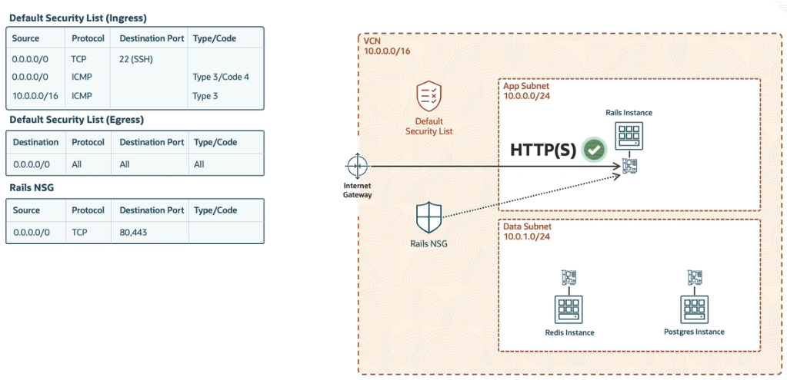

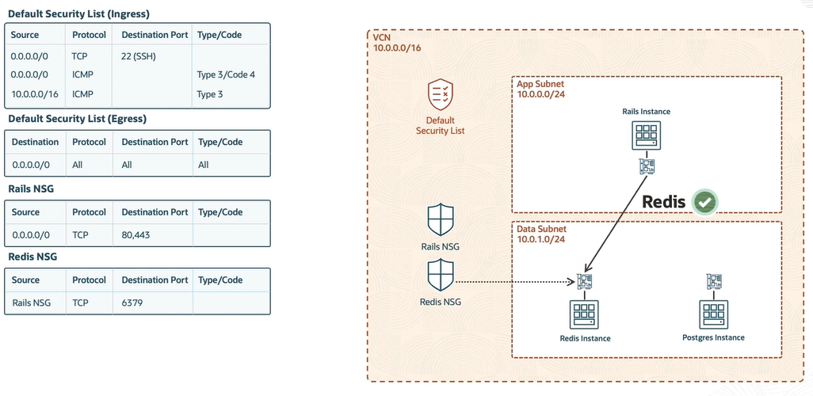

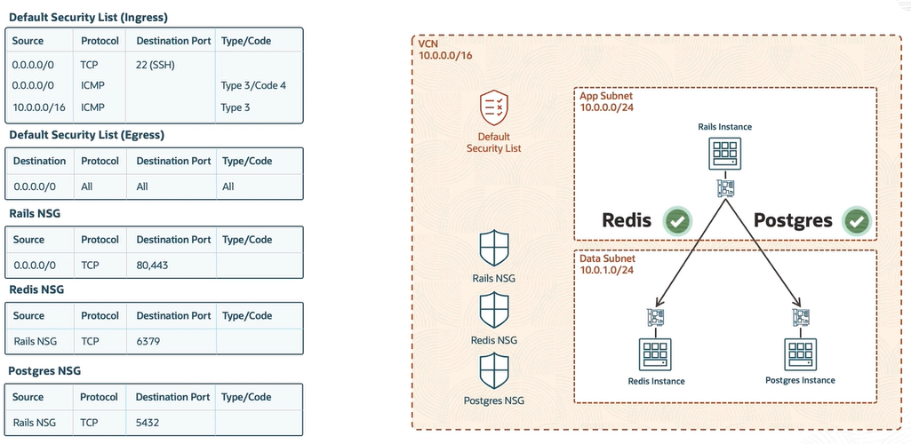

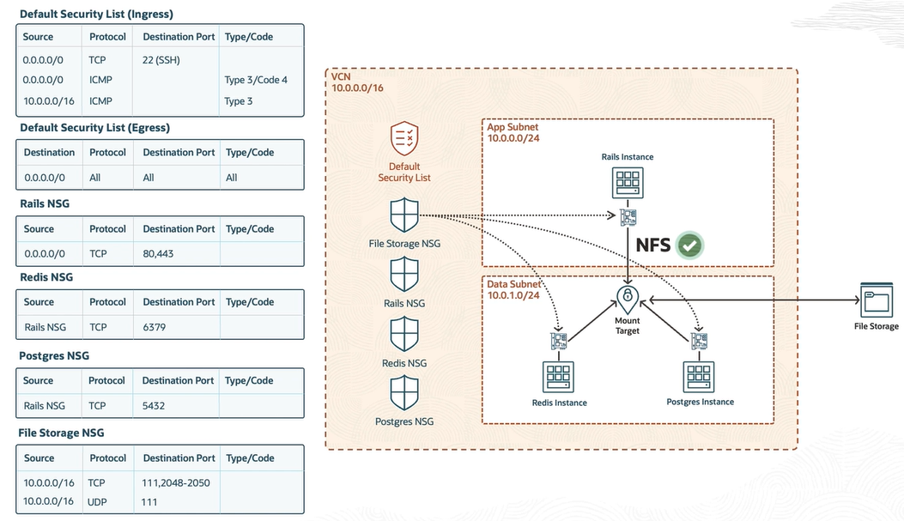

I**nstance life cycle**

Overall, our goal is to implement this architecture for a Ruby on Rails application, specifically Mastodon.

So far, we've implemented a VCN, subnets, gateways, route tables, and network security groups. Now we can turn our attention to provisioning the compute instances. However, we don't just want to provision individual compute instances and then manually configure them to be Rails, or Redis, or postgres every time.

To understand how we can operationalize this process from provisioning to configuration, we have to understand the instance lifecycle. We can break it out into four parts.

First, we provision the actual hardware. Let's also depict the virtual network interface card that sits in front of every instance. After the shape is provisioned, OCI will use the source details to either attach an existing boot volume or use an image to create and attach a new one.

Next, an agent called Cloud-init runs on the instance and connects to a metadata service that runs on the VNIC. This metadata service is accessible via HTTP at this magic URL. This URL hosts things like ssh keys and user data.

User data can come in many forms, including shell scripts, cloud-configs, or MIME multi-part archives, which can be a combination of many different types. This is how you can program Cloud init to run scripts or transfer data automatically when the instance boots.

And finally, we can connect from a remote machine and perform any final configuration. This could be manual configuration like ssh and terminal or RDP in a desktop. It could also be automated configuration with tools like Ansible.

And so this gives us four different phases where we can perform various tasks. We can refer to these as provisioning, sourcing, bootstrapping, and fine tuning. With these phases in mind, we have to try and figure out where we want to place each task.

While not a comprehensive list, we can list out some configuration tasks that we'll need to consider. These include tasks for infrastructure, the base system, access control, system maintenance, data management, and application deployment. The entire infrastructure section obviously goes in the provisioning phase.

Similarly, the base system tasks definitely belong in sourcing. But the rest of the tasks aren't so clear. We'll have to choose how to distribute these tasks based on our specific needs.

For example, if we value infrastructure immutability, we'll shift tasks upward. If we value flexibility, then we might shift tasks downwards. So if we want to have a completely immutable infrastructure approach, so that when we provision an instance, we know exactly how it's configured, we could shove all of these tasks into the sourcing.

We'll actually demonstrate this approach with PostgreSQL, where we'll provision an instance, manually configure it, create an image of that instance, and then provision more instances based off of that image. Another approach could shift some tasks into bootstrapping. We'll demonstrate this approach with Redis.

We'll have an image with software pre-installed. But we'll use Cloud-init to do things like update software and set firewall rules. Finally, we could push more tasks into fine tuning. We'll demonstrate this approach with Mastadon, which is a Ruby on Rails application.

With this approach, we'll use Ansible to configure the final pieces like rails and environment variables. Of course, real world approaches can end up being any combination of these. And this doesn't even address other paradigms like containerization.

But I think that demonstrating these will give you a strong enough feel for OCI Operations that you can figure things out on your own when presented with a another problem. Let's get started by talking about instance provisioning and sourcing in the next video.

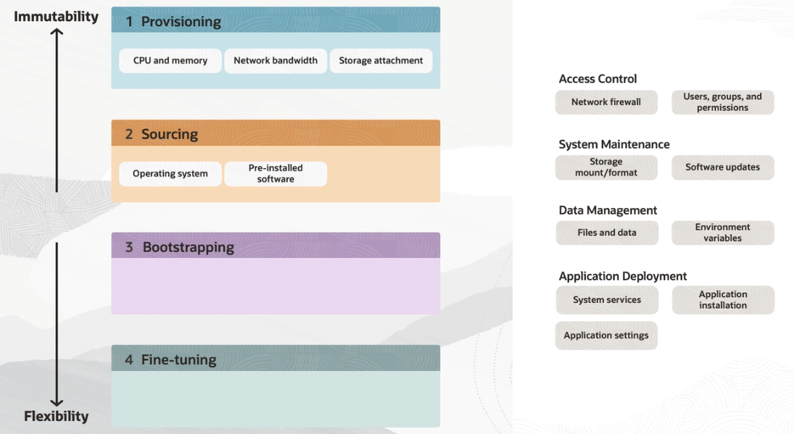

**Compute provisioning**

so that in the next video, we can provision an instance for creating a custom image with PostgreSQL. In the previous few videos, we broke out the instant life cycle into four parts, provisioning, sourcing, bootstrapping, and fine tuning.

Then, we listed many of the tasks that are to be involved in instance configuration, such as tasks regarding infrastructure, the base system, access control, system maintenance, data management, and application deployment. Then, we showed how we can group these tasks into different phases.

We have three different solutions for this. One approach we'll show with Postgres. Another, we'll show with redness. And one last approach we'll show with Ruby on rails. These next couple of videos, we'll be working towards the first approach.

To do this, let's plot our workflow. First, we start with an existing network that we provisioned in the previous videos. Then, we'll provision a compute instance.

We'll manually configure it to host Postgres. And we'll create a custom image of that instance. And then we'll provision more instances based on the custom image.

Let's dive into that first portion, instance provisioning. Since we're going to be provisioning the compute instances through Terraform, we'll need to understand which fields are actually essential. This is because, in the Terraform docks, when a value can be provided through multiple different fields, they will all be listed as optional, which can be a little misleading.

The first three values you can't provision an instance without a compartment, availability domain, and subnet. I like to think of these as I am location, physical location, and network location, respectively. The next value you need is shape.

This is just what hardware is involved. And finally, you can't provision an instance without specifying a source, which is just the base operating system. With these, we can have a minimal seal command that would provision a compute instance.

We can provide the same info in a different form through Terraform. If these OCS were real, this would provision an arm virtual machine with four OCPUS and 16 gigs of memory. However, this is still missing some values that we'd really want to set for our compute instances.

These are display name, hostname, network security groups, and metadata for SSH keys and Cloud configs. We could set a lot more, but we won't need to for now. For our CLI example, each of these would just be parameters that we'd add to our command.

For a Terraform example, again, we supply the same info, but just in a different format. Let's go ahead and provision this compute instance with Terraform in the next video.

**Compute: provisioning and sourcing**

 we're going to create a custom image of our compute instance through the console and then use that image in a Terraform stack. As a reminder, this is the workflow we're currently implementing for a PostgreSQL database for a Ruby on Rails application. We've implemented the network and provisioned an instance in previous videos. Now, we'll manually configure PostgreSQL and create a custom image. That way, whenever we want a fully configured PostgreSQL database, we can just provision our custom image.

Before we go on, let's have a quick aside on instant sourcing in general. There are two types of sources. First are image sources. These can be custom images that you make, platform images that OCI makes, or marketplace images that third parties make. If we take a quick look in the console and go to Instances, and create an instance, we can see these images here.

Here are platform images, here are marketplace images, both partner and community-based, and then here are custom images. We can also select boot volumes here which shows us our second type of source, existing boot volumes.

The difference is that with an image source, it creates a new boot volume. In both cases, the boot volume will be attached to the instance. Once you have an instance, you can then create a custom image which can become the custom image at the start of the workflow.

On the other side, you can detach, backup and restore, clone or replicate a boot volume to get one that's not attached to an instance, and this can become the existing boot volume at the start of our workflow. This raises the question of how do we select which one to use?

There isn't really a massive difference in terms of what's technically possible with either side. Most likely if there's a discriminating factor it'll be very project specific. My preference is to use custom images for what are called golden images where the instance has been perfectly configured for re-use. Meanwhile, I'll use boot volumes for disaster recovery purposes as well as during the test and development process before I've reached an instance state I can call a golden image. But again, that's less technically driven than it is preference driven.

In any case, let's take a look at examples of provisioning from images versus boot volumes. On the top, we have a minimal example of provisioning with an image. On the bottom, we have a minimal example of provisioning with a boot volume. After looking long enough, you'll see that the only difference is at the bottom with the source details parameter.

We can either give a source type of image and specify an image OCID or we can specify source type of boot volume and specify a boot volume ID. We can see the same pattern if we turn to a Terraform example. The tops are the same. So if we look at the bottom, we can again see that the difference is just in source type and source ID.

Now that we've seen the difference between provisioning with boot volumes and provisioning with custom images, we can dive into implementing a custom image for PostgreSQL. Let's start by navigating to the compute instances. Here you can see the instance we provisioned in the last video.

We're going to SSH in and configure PostgreSQL, but notice that PostgreSQL itself is way beyond the scope of this course. What's important is to see the workflow overall, so I'm just going to speed through this and state the steps I'm taking. Let's open up Cloud Shell.

If we try to SSH in right now, it'll actually just hang. This is because the PostgreSQL instance is in a private subnet, so it's unreachable anyway. To fix this, we can change the Cloud Shell's VM's VNIC to the same subnet as the PostgreSQL instance.

Now that we're in the instance, I'll change to root to have all permissions. Next, I'll paste over a couple of commands to add the PostgreSQL repository to my package manager and I'll update and upgrade all the packages now. These upgrades actually require a restart, so we'll do that now.

Now we can install PostgreSQL. I'll open up the PostgreSQL client and add a user and database called Mastodon. Then I'll open PostgreSQL to remote connections. And finally, I'll open up the Ubuntu firewall to connections on TCP port 5432. This step is important to note in general. The operating system's firewall is separate from the VCN security rules, so you have to make sure to set it too.

Now before we can make a custom image of this, let's create a different instance to test connecting remotely to this database. We need to add it to the Rails NSG so that it can communicate with the PostgreSQL NSG on port 5432. I'll add the PostgreSQL repository so that I can install the client. This is probably unnecessary, but I'll update, upgrade, and restart this machine as well.

Now all installed the PostgreSQL client. Finally, I can try to connect to the database from this probe instance, and we can see that I'm in. Let's create a custom image of the PostgreSQL instance now. We can just do this through the console on the Instances page. This part takes a few minutes.

Now that we have that image, we can terminate the instance. To provision a new instance using the image, let's go back to our resource manager stack. We can open up our variables and just change the image OCID to our custom image. I'll open up the custom image in another tab to get its OCID, and I'll change the display name so that we can easily identify this. I'll go straight to running an apply to provision the new instance. That looks successful.

Now let's go to the new instance. To test that this new instance works, let's SSH back into the probe instance and try to connect to the database. And we can see that this works. So now whenever I want to provision a PostgreSQL database for Mastodon, I can just use this custom image and it will be configured exactly for what I need.

However, let's take a second to think about a couple of the disadvantages of this approach. First, in a sense, it lacks flexibility. Suppose I wanted to provision a copy of the stack with a different port for PostgreSQL. Using the default is not the most secure anyway. Then after provisioning the instance, I would have to SSH in and configure PostgreSQL manually. In the later approach, we'd just be able to do this with changing a variable.

Second, the image itself is extremely specialized. I edited the database and opened ports based off of this project. Suppose another team wanted to use PostgreSQL, but they wanted to limit connections to the database to local only. Then there's a security hole waiting to happen since I already configured the database to allow remote connections.

In the next videos, we'll talk about using the bootstrapping phase to do some configuration instead of just the sourcing phase. This next approach will trade a little bit of the certainty we'll have in our instance for a lot of flexibility.

**Compute: Bootstrapping with Cloud-init**

we'll go over bootstrapping compute instances with cloud-init and demonstrate it to implement Redis. To quickly review, in the previous videos, we broke out the instance lifecycle into four parts-- provisioning, sourcing, bootstrapping, and fine-tuning. Then, we listed many of the tasks that are involved in instance configuration. And then we talked about how we can group these tasks into different phases.

We gave three approaches for this. The first we demonstrate with PostgreSQL. The second we'll demonstrate with Redis. And the third we'll demonstrate with Ruby on Rails.

This video will go over the second approach. This will involve taking our last workflow and shifting some of the tasks into cloud-init. Let's dive into what's involved in the bootstrapping phase.

There are two components to bootstrapping. First is instance metadata. This is an HTTP service that is reachable at a magic URL. It stores both arbitrary key/value pairs as well as values for predefined keys. The predefined keys are SSH authorized keys and user data.

The user data field can store a lot of different formats, but the three we're interested in are shell script, cloud config, and MIME multipart archive. This last one can be a combination of any of the others.

The second component is cloud-init. This is an agent that runs on the instance and queries the instance metadata service. It adds the SSH keys to the instances authorized keys file as well as executes the arbitrary configuration in user data. Let's translate this into our Mastodon architecture.

We already provisioned our VCN and subnets. In the last video, we provisioned an instance, updated the software, installed Postgres, created a user and database, opened Postgres to remote connections, opened the firewall, and used all that to create a custom image. We terminated the instance, and now we can reposition Postgres without any manual configuration.

In this video, to show a more advanced approach, we'll provision another instance, only update the software and install Redis, create a custom image, and then combine that with a cloud-init script that enables the Redis server and opens the firewall to get a fully configured instance. Let's head over to the console to get started.

So we're here in the console with our stack from the previous videos. The first thing that we want to do is provision a new instance for Redis. To do that, we'll open code editor and basically just copy and paste the code for Postgres. I'll open up a terminal and copy postgres.tf to redis.tf.

Now, let's open redis.tf. I'm literally going to change all the occurrences of Postgres to Redis. Looks good.

Now, let's go add the variables all the way at the bottom. Let's save this. And let's go to find these variables.

Let's grab the availability domain as we pass. The shape will be the same. We'll get one CPU, 6 gigs memory. For the image, we'll grab the OCID of the base image of Ubuntu. You can see I previously grabbed this.

And let's run the plan. Let's see what it plans. It should see that the difference is that there's a new instance.

And we're good. It just plans to add that one new instance. Let's go run and apply for this. Looks like it worked.

Now, let's navigate to that compute instance. To preconfigure this instance, all we want to do is install Redis. So let's open up Cloud Shell and SSH in.

Since we enabled private DNS within this VCN, we can actually use its hostname here. We set the value for the VCN, the subnet, and the host name all in the Terraform variables. I almost forgot. We have to change our network to private.

Let's change to root. And then I'll paste over some commands to add the Redis repository to my package manager. You just get these from the Redis documentation.

Now, let's update our package indexes. And now let's upgrade our packages. And let's reboot this machine.

Now, let's install Redis. And that's all we want to do for this instance. Let's exit and make a custom image.

Now, we have a custom image with Redis installed. Before we use that image to provision a new instance, let's write the cloud-init script that does the rest of the configuration. We'll name the new file redis_setup.tftpl for Terraform template. To keep this simple, we're going to make it a shell script. That means we have to start with #!/bin/sh.

Then the first thing we want to do to configure Redis is open it up to remote connections. I'll paste over a command that does that. This uses a program called sed to replace every instance of bind this address with this within the Redis configuration file. The details of sed aren't within the scope of this course, but it's pretty useful to know.

Next, I'll paste over a similar command to set the password for Redis. This does a similar thing, where it searches the file redis.conf and replaces every instance of this with requirepass and then redis_password. The syntax with the dollar sign and the braces is what makes this a Terraform template. When we pass this file to Terraform, we can have it replace this part with one of our variables. After these, let's restart Redis.

And then lastly, we want to open up Ubuntu's firewall for TCP connections on 6379, which is Redis' default port. And we want that change to be persistent. Don't get too caught up in the details of this script itself. What's important is just to see the workflow overall.

Now, let's go into the Terraform and pass in this script. To do this, we'll add a data block and use a built-in module called cloud-init_config. And then we'll label this redis_init.

First, we want to set gzip equals true so that it compresses the file. Next, we want a base64encode the file. And then we'll add our file inside of a part block.

First, we need to specify the content type, and we're giving it a shell script. And then we'll pass it the content. Terraform has a function called templatefile to load a template file. We'll give it the name of the template file. And then we have to specify all the variables that we want to replace.

So remember, in our template file, we had one variable called redis_password that we wanted to replace. We'll set that by just saying redis_password equals var.redis_password. And so that's a variable we haven't created yet. Lastly, inside of the part block, let's give cloud-init a file name so that it knows what to name the file after doing the substitutions for the template.

Finally, we can pass this data to the user data. We'll do that by referring to our data source and then adding .rendered at the end.

And so this block will take the template. It'll substitute in the redis_password. It'll base64encode it. It'll zip it and then pass it to the user data field and metadata. Let's add the variable for the redis_password.

I'm also going to go over to the schema document and add this variable, but you can ignore that. This will just make it display nicely on the Variables page. And let's save this. And let's define our password.

And let's run a plan. I almost forgot. We also have to change our image to use the Redis image we prepared.

Now, let's actually run that plan. And apparently, I missed a comma. It looks like it wasn't actually a comma but rather a pair of braces that was missing. Let's save and run a new plan.

It looks like I also missed an underscore. Let me just go add that real quick. Awesome. Now, let's run and apply based off this.

All right, now let's SSH into our probe instance from the last video and try and test for Redis instance. We'll have to install Redis on this machine too. And for the moment of truth, let's try and connect to Redis. And it looks like we're good.

To sum up, we created an instance from the platform image for Ubuntu. We then updated its software and installed Redis. We used that instance to source a custom image that's ready for Redis configuration.

We wrote a shell script to configure Redis, then passed to that shell script as well as the custom image to our Terraform. So now, we can automatically deploy Redis, and it'll be ready to connect.

In contrast to our previous approach, the custom image isn't particularly overconfigured. If another team wanted to use Redis, they could use the same image. Even more crucially, we showed how to use Terraform templates to create a cloud-init script based on a variable, specifically, the redis_password. So if we wanted to change the password, we could just change the variable, and it would get repositioned for us. We only did this with the password, but we could do it with other settings, like, port username, memory settings, or really anything else you can imagine.

By adding cloud-init to our Terraform, we've gained a lot of flexibility in our configurations. However, we still need to be aware of a couple of drawbacks. First, if we compare to our previous approach, there's more moving parts. As opposed to just having all configurations baked into the custom image, the bootstrapping process could fail at some part, and two instances that are supposed to be the same could have a difference. So while we gained flexibility, we lost some of the certainty that comes with immutability.

On the other hand, configuring only through Terraform and cloud-init seems to lack agility. Suppose I had already deployed a fleet of Redis instances and now I want to change them all from the default port to port 30,000, changing a Terraform variable and having it wipe out the fleet to reposition might be a little extreme. As you'll see you in the next video, we can bring in one last tool to fine-tune our instances after they've already been deployed.

**Compute: Fine-tuning with Ansible**

we'll talk about configuring compute instances after they've been provisioned. We'll then demonstrate Ansible by deploying an open source Ruby on Rails application called Mastodon that will connect to the PostgreSQL and Redis instances that we provisioned in the last videos.

To quickly reveal, in the previous videos we broke out the instance lifecycle into four parts, provisioning, sourcing, bootstrapping, and fine-tuning. Then we listed many of the tasks that are involved in instance configuration, and then we talked about how we can group these tasks into the different phases.

We gave three approaches for this. The first one we demonstrated with PostgreSQL. The second we demonstrated with Redis. And now the third we'll demonstrate with Ruby on Rails. Like before, this will mean taking our previous approach and shifting some of the tasks down to the fine-tuning phase.

Let's dive into what's involved. You'll often actually hear this part referred to as configuration management. For example, Ansible's website does this. I'm going to try to avoid that term though, because it's also used for much broader processes involved in the design and operation of entire complex systems. And then I even tend to use the term for a bit of an in-between referring to managing the lifecycle of a single instance, including provisioning. So the term can get pretty confusing.

In any case, there are three approaches to fine-tuning that we're going to talk about here. First is manual configuration. This is when you connect remotely through SSH or RDP and then run commands. While fine for prototyping, this approach doesn't scale well and is really error-prone.

Second is Ansible. This is a program that will also connect remotely, as opposed to living on the machine itself, and then you can run ad hoc commands as you need. This alone isn't a huge step up for manual configuration, though you can use it to run commands on many instances at once.

The real power in Ansible comes in its declarative modules. This is where you use a simple markup language to specify things like I want this system service to be in this state, or I want this and that application to be installed. And then Ansible figures out how to get it to that state regardless of what state the machine is currently in. This is often referred to as idempotence. This is also how we can bring back some of the consistency and guarantees that we had in a more immutable infrastructure model.

Ansible alone could easily fill its own course. For this video, we just want to demonstrate it to show you how it can fit into a workflow and what different tasks can look like in a realistic environment. Then when you need it, you'll know to look into it some more.

Before we go on, I want to mention another tool that's pretty relevant, and that's the Oracle Cloud agent. This is an agent that lives on the instances and can do some amount of configuration. To use it, you don't even have to connect to the instance. This is because through the console, or CLI, you can push jobs to the instance metadata service on the instances VNIC and then the agent will pull the metadata for jobs to execute.

It can run ad hoc commands, update packages, scan for vulnerabilities, perform OCI-specific configuration like block volume attachment and a lot more depending on what plugins you have enabled. We won't use it in this video, but I always like to have it in mind as an agent-based approach to contrast Ansible's agentless approach.

And that brings us to our plan for this video. So far, we've already provisioned our VCN and subnets. We also provisioned an instance, updated the software, installed PostgreSQL, created a user database, opened PostgreSQL to remote connections, opened the firewall, and used it to create a custom image, terminated that instance, and now we can reprovision PostgreSQL without any manual configuration.

In the last video, we provisioned another instance, updated software, and installed Redis, created a custom image, and combined that with a cloud init script that enables the Redis service and opens the firewall to get a fully configured Redis server. Finally in this video, we're going to provision another instance, install software like Ruby, Rails, and Node.js, create a custom image, create a cloud init script to open the firewall, provision an instance with the custom image and cloud init script, then use Ansible from Cloud Shell to install and configure our case study application, Mastodon.

Let's head over to the console to get started. First off, we'll open Code Editor. Then we'll use the Redis Terraform as a template for our Mastodon Terraform. We'll change all instances of Redis to Mastodon. Then we have to be careful to change the security group to Rails, change the private subnet to a public subnet, and assign a public IP address.

We'll comment out the cloud init stuff because all we want to do is set up a custom image with software pre-installed. Let's uncomment the variables that I'd previously typed out, save those changes, and head over to set these variables. Resource manager actually saved these from when I was testing earlier, but they were done just like in the previous videos.

Now let's run our plan to get a fresh Ubuntu instance. Looks good. Let's go run our apply. Great. Now let's go head over to that instance. Let's open up Cloud Shell to SSH in.

This area looks a little scary, but this is just because I had another instance that had the same domain name earlier while I was testing. I'll just erase the record of that so SSH doesn't yell at me. Not great for production, but works here.

Now I'm just going to paste over a bunch of commands that come straight from the Mastodon documentation. First, we change to root. Then we check that a few prereqs are installed. We'll add the Node.js repository and we'll add the PostgreSQL repository.

Now let's get out of root. Let's use APT to update and upgrade. Now we'll paste over a list of dependencies, again straight from the docs. We'll set up Yarn, a package manager for Node.js, and I'm going to add this permission to the home directory because I found I was getting errors without it. More testing is needed to figure out why, but Mastodon itself isn't important for this course.

Here we set up a Ruby environment and install Ruby. And like we did with Yarn for node, we'll install Bundler for Ruby. And that's all the software we'll pre-install on this.

Let's go make a custom image of this instance. While that image is being created, let's hop over to Code Editor and work on our cloud init script. All we want to do in this script right now is open the firewall to TCP ports 80 and 443 for HTTP and HTTPS. I'm just going to paste these over.

You might notice that in these commands there's the somewhat magic-looking numbers 6 and 7. That's because I already know what the existing IP table looks like in Ubuntu from checking earlier. So I know that these rules need to go sixth and seventh. Specifically, there's a rule at the end of the table that says to reject traffic, so anything you want to open needs to be before that. That knowledge is a little specific, but if you're going to use the Ubuntu platform image, that's probably going to trip you up at some point.

Anyway, let's pass the script to Terraform. It's not a template this time, so I'll change the template file to just file, and the rest looks good. It also looks like the custom image is done, so let's provision a new instance that includes the cloud init script and custom image.

Let's grab the new OCID, paste it in for our image, and let's run a plan. Looks like it plans to make one instance. Let's go run an apply. All right. Let's go check out our new instance.

I'm going to open up a Cloud Shell, but just to show you that Cloud Shell and Code Editor are connected. If I list the directories here, you see ignore, a plugins folder, and recordings. If I change directories to recordings and LS, you see a bunch of files I've prepped for this video.

Now let's jump over to Code Editor and change from plug-ins to explorer on the left. And now at the left bottom, you can again see ignore, plug-ins, and recordings. I bring this up because often you'll want to switch back and forth between them and use the same files.

Let's open the recordings and look at the Ansible playbook to set up Mastodon. First, let's have a look at the host files. Ansible will use this to refer to different groups of machines. In this, I just have three groups, Mastodon, Redis, and PostgreSQL. And in each group I've listed one DNS label. Remember, though, that these DNS labels will only work inside of the VCN so we need to make sure that our Cloud Shell is set to the VCN network.

Now let's go over the actual Ansible script. It's a little long. So instead of typing it out with you, I'm just going to walk you through each of the pieces, which is fine anyway because the details aren't important. This part of the course is all about having a sense of the different pieces that can be involved.

First let's look at the top. We specify a name for the Playbook, and then we specify which host we want it to apply to. Here we're picking the group Mastodon, which is just one instance. Then we specified three variables that are referred to later in the script.

Onto the actual tasks. This first one uses the Ansible built-in Git module to clone the mastodon GitHub repo to Ubuntu's home directory. Then-- and this one's a little more complicated-- we use Bundler to install the Ruby gems that are specified in the directory we just cloned. This task looks a little more complicated, because Ruby requires some environment variables to run properly. If we hide these, we see what's actually going on. After that, we use Yarn to install all of the Node.js packages that are specified in the repo we cloned.

The next one is actually an important one to pay attention to. This grabs a template file, replaces variables in it, and places it onto the target machine. In this case, the template file is a variable that resolves to sample ENV production, which is in this directory. This is a config file that's so Mastodon-specific that it's not worth to look at in detail. However, do note that we have variables in here that Ansible will fill in based on its own variables. And that part is an Ansible thing, not a Mastodon thing.

Next, we have a task that runs a shell command to prepare the PostgreSQL database. This command is against the spirit of Ansible. This is because shell commands, unlike most other Ansible modules, don't have good ways of being idempotent. Running an Ansible module 10 times in a row is supposed to have the same effect as running it once. The same can't be said about shell commands.

However, this is how Mastodon is set up to prepare its database, so we're stuck using this command. It does just so happen that this command errors out if it's run more than once, so I have errors ignore to be true. That way the playbook continues to run if it errors out. That reclaims a little bit of idempotency, but still it's far from ideal.

The same goes for this next command. Shell commands aren't inherently idempotent, but this compilation command just so happens to be implemented in a way that checks to make sure it doesn't redo work. This next command copies a file from the cloned Mastodon repo into NGINX's directories so that NGINX will act as a front end.

This one creates a soft link from available sites to enabled sites. Again, the advantage of doing these things like copying and linking through Ansible modules over shell scripts, is that the Ansible modules will not just overwrite what's already there. Unless you tell it to, of course. This command just makes an empty directory.

These next two commands generate a temporary key and certificate so that we can boot up NGINX to get real ones later. These modules, command and expect, also just run shell commands so they aren't inherently idempotent. However, we can use the Creates field to tell them that if they see this file is already created, then they don't need to run.

You can also see that expect is able to answer prompts given by interactive commands. Ansible replace is kind of like said. Here we're using it to replace example.com with our domain name in the NGINX configuration files. The next few modules are all doing a similar thing.

This one's also important to note, the service module. It's used to specify the state that you want a service to be in. Here we say we want NGINX to restart, and next we use expect again to have cert bot issue us a real SSL certificate. And the last few modules are all just replacing strings, moving files around, and then enabling Mastodon services.

Let's go ahead and run this. And this terminal is in the wrong directory. Let's open up the right one. And this errors again, because I've been using many machines under the same DNS label. Let's just remove known hosts. And this error is because I forgot to specify that we want to connect as Ubuntu, which is the name of the default user. And then this error.

After a short debugging session where I checked firewalls, read configuration files, and frantically Google searched, it was because I forgot to update my DNS record for OCIoperations.com to this new instance. Now that I've done that, let's run it again.

On the bright side, you can now see how it mostly skips over the modules where it doesn't need to do anything new. Looks like it's done. Let's open up the web page. And you can see we have the home page of Mastodon.

So we have successfully combined Terraform, custom images, cloud init scripts, and Ansible to deploy a real-world application. It was certainly overkill for this application-- there is an interactive script that they provide to deploy it-- but hopefully seeing different tools and approaches in action gives you the right foundations to know where to start on deploying much more complex architectures down the road.

**File storage: Provisioning, Exporting and Mounting**

we'll review the parts of file storage, then we'll provision a file storage system using Terraform and mount it using Ansible. So far in this series, we've provisioned a VCN with three compute instances. We configured one instance to be Redis, one to be PostgreSQL, and one to be a Ruby on Rails application called Mastodon. Now, we're going to upgrade Mastodon to use network file storage for static assets instead of local storage.

And then just to add a little more sophistication, we'll also attach the file storage system to the other instances. This way, files will be stored on five-way replicated storage that is automatically scaling based on usage. For this system to connect to an instance, it needs to have an endpoint within a VCN.

This endpoint is called a mount target. This target will have a private IP address assigned by the VCN. The file storage system then exposes a virtual directory or folder through the mount target through what's called an export. The export then has a specific path that's appended to the IP address.

Then a network file system client on an instance can access the export and surface it as a directory or folder. This way, the folder can actually live on the file storage system, be exposed as an export on a mount target, and then be surfaced as a directory on an instance. The export can actually be mounted by multiple compute instances.

So they will have a shared directory. This is more or less the core picture you should have in your head for file storage. But there are a couple complications that are important to know. First, a single file storage system can have multiple exports within the same mount target. These are like separate folders and can be mounted independently of one another, distinguished by their paths.

Second, since file storage systems and mount targets are independent entities, a single file storage system can have exports in multiple mount targets. Note that export paths represent paths within the file storage system as well. So if two exports have the same path, they'll also share the same files. Third, again, because file storage systems and mount targets are independent entities, the same mount target can have exports from multiple file storage systems.

It's important to understand the separation of duties between each of these resources. File storage systems are just the storage resource. Mount targets are just the network resource. And exports represent a directory to mount. So taking this, we know that our example architecture will look a little like this.

We'll have a single file storage system with an export to a mount target in the data subnet. And we'll mount that on all instances. Mastodon itself will be the only app to actually use it. But will mount to all instances just to show how we can do that. So let's hop over to the console and set this up. All right. To start, we have our stack from the previous videos. Let's open code editor and add the Terraform to provision a file system. And name it nfs.tf.

We'll start with our file system. That's a resource. And then its service name is OCI File Storage. And then it's resource type is file system as the general naming pattern for a lot of resources in OCI. And we'll give it a label, Mastodon file system. As always, we'll add the compartment ID. And this needs an availability domain. And let's add a display name.

Next step, set a mount target. We use the same compartment and availability domain. And then since this is a networking resource, it needs to be placed in a subnet. And we'll use our private subnet. Next, for traffic to be allowed, we'll need to add that nsg we created earlier for file storage.

While we have this, let's also add the nsg to the different instances. Let's give it a display name and a hostname. And finally, let's add our export. First, we know that an export needs a file system. And then we know that an export needs a mount target.

However, we're not going to refer to the mount target directly, but rather, we're going to refer to the mount target's export set. The export set is just the set of exports in a mount target. The way that we're going to refer to that is we'll take this, the type and label.

And then instead of saying the ID for the mount targets ID, we use export set ID. And then this needs a path. Let's go make the variables we need. I've already typed them out here. And then I'll also add this to the schema document.

Let's save this. And let's set these variables. Let's just use AD-1. We'll give it the hostname files. And let's give it the export path /assets. The export path always needs to start with a slash. Let's run a plan.

This should want to create a file system, create a mount target, create an export, and add the nsg for file storage to each of the instances. Here it's adding the nsg to the Mastodon instance. Here it's adding the nsg to the Postgres instance. And here it's adding the nsg to the Redis instance. Notice that it can do these in place, which means that it won't have to destroy and recreate the instances. It can just do it after the fact.

Here's the export, here's the file system, and here's the mount target. That's everything. Let's go run and apply. Let's go take a look at the file system. It'll be under Storage, File Storage. We can see the file system here, and then the mount target over here. We can see its export in either one.

So if we go to the mount target, we see an export here from the Mastodon file system. Well, if we go back to the file systems, we have an export here to the mount target. Now that we have this, let's use Ansible to mount this onto each of the instances.

I have the script pre-written here but we'll walk through it. First, we're specifying that we're going to mount to all hosts. If we only wanted to mount to one, then all we would have to do is change this. Next, we're creating new Ansible variables for the file storage host, for the export path, and the target directory.

The first thing that we want to do is make sure that the NFS client is installed. And we'll do that with the apt module. Next, we have to create a directory to mount the export to. Here, we're mounting to this path, which gets substituted by our target directory. And then we're specifying that we have read/write, execute permissions on this directory. And then finally, we have our module to mount the file system.

We mount to this directory, at this source, which gets replaced by the file storage host colon the export path. So that'll be files.data.mastodon.oraclevcn.com:/assets. And then it's file system type is nfs. And then we're picking the state mounted. For state, you want to look in the documentation for all the possible values. But mounted means that it will both actively mount the file system, and it will create an entry in the file system table, which in Ubuntu, is located at /etc/fstab.

Let's check our network. That looks right. This terminal is in the wrong directory. So let's close this and open a new one. And let's run this. So you can see it didn't have to install anything. It created the directory and then it mounted the file system.

Let's ssh into these machines to test it out. First, we'll ssh into the Mastodon machine. So we mounted to /mnt, and we can see the assets there. And let's list what's inside. Nothing. So let's create a file. We'll just enter hello there and exit.

Now, let's go over to another machine and take a look. Let's go to the Redis instance. That's ls/mnt. We see the assets and we see our example file. Let's take a look at it. And there we go. So we use Terraform to create a file storage system, mount target and export, and then we use Ansible to mount that on each of the instances.

In order to get Mastodon to actually use this, we'd have to change around some configuration files. But we're going to skip that for now, because it's too Mastodon-specific to really matter. In any case, in the next video, we'll talk about object storage, and we'll set this up to use object storage instead of file storage.

**Object Storage Deep Dive**

we'll review object storage then we'll provision a couple of buckets with lifecycle management policies enabled using Terraform. So far, in this series, we've provisioned a VCN with three compute instances. We configured one instance to be PostgreSQL, one to be Redis, and one to be a Ruby on Rails application, called Mastodon.

Then we attach network file storage to each of the instances. Now we'll set up buckets for object storage and add lifecycle management policies. To review object storage, it stores objects redundantly across three availability domains in multi-AD regions or three fault domains in single AD regions.

Objects are accessible via API requests at this URI-- objectstorage.region.oraclecloud.com, where region is replaced by the region identifier. And the specific object is accessible at this path, where you'd fill in your namespace, bucket, and object name. To use the Amazon S3 compatible API, instead of the OSI style one, you can use this URI.

And the path will change to /bucket /object. There are two features of object storage that I want to go over in a little more detail because they can get a little confusing. First is versioning. When you have an object in a bucket, where versioning is enabled, each version of the object is given a unique version ID.

The latest version is marked and is what you access by default when you access an object. Every time you upload a new version of the object, the old version is retained, but the new version is tagged as the latest. Object deletion is a little more complicated. When you delete an object as you normally would, the latest version is converted into a previous version and replaced by a deleted marker.

If you then upload an object by the same name, it will become the latest version, and the deleted marker is pushed to become a previous version. This contrast to deleting an object where you've explicitly specified a version. This physically deletes the version from storage.

If you use this object version deletion to delete the latest version of an object, it makes the last previous version into the latest version. The second feature that we'll go over is lifecycle management. This automates various actions based on rules. These rules are composed of three parts-- action, target, and time.

Let's assume versioning is disabled for now. For a simple example, you can take an object, archive it, move it to infrequent access, or delete it after a set amount of time since the last update. If versioning is enabled and your target is still objects, then each of these actions will have a slightly different meaning.

Infrequent access and archive will change the tier of all versions, but delete will only leave a delete marker, like what we talked about before. If instead your target is previous object versions, then infrequent access and archive will target a specific version. Delete will physically delete the object version, and the time now refers to the time since the version became a previous version.

To show concretely what these rules look like, let's head over to the console and implement a couple of these. The first that will implement is for Mastodon to store its static assets, and the second is for Postgres to put its backups in. To start, we have our stack from the previous videos. Let's open code editor.

First, we'll add a file named object_storage.tf. First, let's add our Mastodon bucket. We'll give it our compartment ID. And we need to give it our tenancies, object storage namespace. You'd usually find this with the CLI command oci os for object storage, ns for namespace, get. And we'll give our bucket a name.

This needs to be unique within the namespace. We'll hardcode the access type to be private. And we'lll enable versioning. We can reuse this code for our Postgres bucket. Next, let's add a life cycle policy to our Mastodon bucket.

We need to give it our namespace, and we need to refer this to the Mastodon bucket. . We'll use .name instead of .ID. Now we can give it a rule. The first rule that we want to add is to move objects to infrequent access after a few days. So we'll give this rule a name.

Its target will be objects. The action will be infrequent access. The time unit will be days, and we'll set the time amount to a variable. Lastly, we'll enable this based on a variable as well. Next up, we'll add a policy for our Postgres bucket.

We'll give it our namespace, and we'll refer the bucket. First, we'll add a rule to automatically archive old versions after a set amount of days. So the target will be previous versions, the action will be archive, and the time unit will be days. Again, we'll set variables for the time amount and whether it's enabled.

We can add multiple rules block for multiple policies. Let's add another to delete old versions after a few years. The target will be previous versions. The action will be delete. The time unit will be years, and then we'll have variables for the time amount and whether it's enabled.

Let's go ahead and make the variables. I went ahead and typed them out beforehand. Likewise, let's add these to the schema document, just to make it display nicely. Let's save this. And let's fill in those variables.

You can see they were retained from a previous run I did, but we have our object storage namespace, our first bucket name, the amount of days for the infrequent access rule, whether it's enabled, the name for the second bucket, the amount of days for the archive, whether it's enabled, the amount of years until deletion, and whether that's enabled.

Now, let's run a plan. That looks right. Let's run and apply. Let's go over and look at these buckets in the console. We can see our two buckets. We can go into the Postgres one.

You can see there's no objects, and we can see our two lifecycle policy rules. We won't actually set up Postgres to back up here or set up Mastodon to use this for static assets. But hopefully, this gives you a better idea of how to use object storage for your own projects.

1. Which two are configurable predefined keys for the instance metadata service?

ssh_authorized_keys (*)

cloud_init_scripts

region

user_data (*)

Incorrect.  
The primary predefined keys for uploading custom content are ssh_authorized_keys and user_data. Cloud-init scripts are uploaded through user_data. The region is a key in the instance metadata service, but it is automatically populated and not configurable.

2. Suppose you have an empty standard Object Storage bucket with versioning enabled. You upload a file a single time. You then delete it and specify a version number. Which is true in this scenario?

The file is marked as deleted but remains in standard-tier Object Storage.

The file is marked as deleted and moved to Archive Storage.

The file is marked as deleted and queued for physical deletion after 30 days. It can be restored at any point during the 30 days.

The file is physically deleted and unrecoverable. (*)

Incorrect.  
Deletion of an object without specifying a version only leaves a "deleted" marker, but deletion of an object version physically deletes the file. Resources within the Vault service have the mandatory waiting period before deletion, but objects in Object Storage are deleted immediately.

3. Which two of these make up the security rules on a compute instance VNIC?

Rules from the VCN's default security list

Rules directly added to the VNIC

All rules for all security lists attached to the subnet (*)

All rules for all network security groups attached to the VNIC (*)

Correct.  
Rules on a VNIC are a combination of the attached network security groups and security lists. Rules cannot be directly added to a VNIC. The default security list's rules only apply if it is attached to the VNIC's subnet.

4. Which would be the most appropriate tool for ensuring an application is in a particular state on a compute instance, for example, running or stopped?

Oracle Cloud Agent

Cloud-init

Ansible (*)

Terraform

Correct.  
Ansible is the most appropriate tool for enforcing application state. Terraform has no visibility into a compute instance. Cloud-init can place an application into a particular state at boot, but it cannot enforce it at any other time. Oracle Cloud Agent is relevant for tasks, such as OS package management or bastion connectivity.

5. Which two are valid values for sources_details when provisioning a compute instance through Terraform?

computeInstance

image (*)

dockerfile

bootVolume (*)

Correct.  
Compute instances can be sourced from images or boot volumes. Sourcing from a compute instance without creating an image is not supported. Docker files are relevant for creating container images but not compute instances.

**Secrets and Encryption**

Encryption basics

 In this particular lesson, we are going to look at what encryption is, what different kinds of encryption algorithms exist, what does it mean to have symmetric encryption versus asymmetric encryption, et cetera. So let's start with the basics first.

Encryption is used to transform plain text data into cipher text. What does cipher text mean? Or cipher text is also referred to as encrypted text.

Basically what it means, it's a series of randomized letters and numbers which humans cannot make any sense of. Plain text, you can make sense. Once it's encrypted cipher text, you cannot make sense of that just by looking at it.

Decryption, which is the reverse process, is used to transform the cipher text into plain text. So plain text you take, and then you encrypt it into cipher text. That's the encryption. And the reverse process is decryption.

Now, you also hear this term called key. A key is a piece of information, usually a string of numbers or letters that are stored in a file, which when processed through a cryptographic algorithm-- and we'll look at what these algorithms look like-- can encrypt or decrypt data. So this is the central piece you need in order to encrypt or decrypt any kind of data.

Now, you also hear of this term called key or key pair. Encryption key or key pair is generated for a specific algorithm that can be used for encryption. Or you also hear this term called digital signing. So how does this work if you have to look at it visually?

Well, encryption-- you take the plain text data, and you use the key which is generated for a specific algorithm. So that's what you see here, the key with the specific algorithm here. And that converts into a cipher text, which is a series of randomized letters and numbers. Which, if a hacker gets access to or human gets access to, they cannot make sense of.

And the reverse process is called decryption. You take this series of randomized letters and numbers. You use the key again, which is tied to an algorithm. And then you can get the plain text back. So this is basically how encryption works, encryption or decryption.

Now, you also hear of this term called encryption at rest and encryption in transit. What this means is, data at rest is the data that is stored on a physical device, such as a server, as you can see here. It may be stored in a database or a storage account.

But regardless of where it is stored, encryption of data at rest ensures that the data is unreadable without the keys needed to decrypt it. So if an attacker obtained a hard drive with encrypted data and didn't have access to the encryption keys, they would be unable to read that data. So that's basically what it means by encryption at rest.

Encryption in transit is basically data moving from one location to another, such as across the internet or through a private network. So how this thing works is, you can see the data is moving here. So from the client it goes, let's say, to the server. And you can do in-transit encryption so that the data is secure.

So HTTPS is an example of encryption in transit. Encrypting data in transit basically protects it from outside attackers and provides a mechanism to transmit data while limiting the risk of exposure. So know the difference between encryption for data at rest and encryption for data in transit.

Now let's look at a couple of types of encryption. One called symmetric, one called asymmetric. Now, symmetric-key cryptography is where a single key is used for encryption and decryption.

So if you look, there are two actors here, John and Mike. And John has a message that's as simple as "Hello Mike." And he wants to encrypt it. He makes use of this secret key.

And you can see this series of randomized numbers and letters. This is the cipher text. He encrypts this message, and then he sends it over to Mike. Now, Mike also has access to the secret key. And he takes that, and he uses that to decrypt this message and gets the original plain text message, which is "Hello Mike."

Now, as you can guess, one of the issues with this kind of encryption is everyone has access to the same key. And there are ways to solve around that. This is just a basic kind of encryption, basic lessons, so we're not getting into that. But as you can see, the idea is, both John and Mike, two parties here, they share the same key both for encryption and decryption.

Now, contrary to this, there's another algorithm, which is called asymmetric encryption. Now, asymmetric encryption is where different keys are used for encryption and decryption. So as you can see here, there are two parties again, John and Mike.

And let's say Mike has generated a key pair which has a public key component and a private key component, as shown here on the slide. So each pair consist of a public key, which may be known to others, and a private key, which may not be known to anyone except the owner. So you can see that Mike only has the private key here.

So what happens in asymmetric encryption is, anyone can encrypt messages using a public key. So you see John here. Because public key is public, so he takes this and encrypts the message.

But only the holder of the paired-- this pair here-- private key can decrypt a message. Because only Mike has this key pair here, so he can decrypt the message. If an attacker gets hold of this public key and even this message, because different keys are used for encryption and decryption, they cannot make sense of this cipher text.

So the security of this system depends on the secrecy of the private key, which must not become known to any other party here. So it should only be with Mike because he generated the public and private keys in the first place. So this is what asymmetric encryption is.

Now let's look at some of the-- we looked at encryption, what it is-- transforms plain text into cipher text. Decryption is kind of reverse of that. And key pair is generated or key generated for a specific algorithm to be used for encryption or digital signing.

Now, you also hear these algorithms called AES, Advanced Encryption Standard, where the same key encrypts and decrypts data. Now, AES is pretty advanced, and it's very robust. But the issue around here, as you can imagine, is using the same key for both encryption and decryption.

RSA, on the other hand, is where a public key encrypts and private key decrypts the data. So it has that kind of built in. But there has been discussion on whether to use AES or RSA. Both have their own advantages.

One thing with AES is, it's a symmetric algorithm, absolutely. But it uses the same 128-, 192- or 256-bit key for both encryption and decryption. And so RSA, on the other hand, is computationally more intensive, and it's a bit slower. And there are cases where people use both together. And again, this is basic, so we're not getting into all these details.

ECDSA stands for Elliptic Curve Digital Signature Algorithm. It's one of the more complex public key cryptography encryption algorithms. Keys are generated by elliptic curve cryptography that is smaller than the average keys generated by digital signing algorithms.

So again, basics, we don't have to go into that. But as you can imagine-- we just talked about it-- it's used for digital signing. It's not used for encryption and decryption of data. So that was just a quick primer on encryption basics, looking at the different algorithms, and looking at symmetric versus asymmetric encryption.

Another term which you hear a lot or you would hear in the subsequent lesson is this thing called hardware security module. Think about Hardware Security Module or HSM as a physical computing device that safeguards and manages keys. It performs encryption and decryption functions, also does things like strong authentication and other cryptographic functions.

Now, there are certain characteristics of these HSMs. They are tamper-evident. As we discussed, they are used to manage these digital keys and also perform cryptographic functions.

Now, because the critical role they play in securing applications and infrastructure, HSMs are typically certified to internationally recognized standards, such as Common Criteria or FIPS 140, to provide users with independent assurance that the design and implementation of the product and cryptographic algorithms are sound. So in case of OCI, Oracle Cloud Infrastructure, we have a service called Vault. It uses HSM behind the scenes. And the HSMs it uses meet the FIPS 140-2 Security Level 3 certification. I believe the highest level goes to 4, so 3 is actually pretty high standard.

And it has certain characteristics. Obviously, it's tamper-resistant. It requires identity-based authentication. And if somebody tries to tamper with the device if they get hold of the device, the HSM deletes the key when it detects tampering. So it manages that sort of the superior level of security and independent assurance that it meets certain criteria set in regulatory compliance standards.

So hopefully, this was a quick lesson. We looked at encryption basics, difference between symmetric/asymmetric encryption, looked at some of the algorithms. And we concluded with a quick overview of what hardware security modules are.

**OCI Vault.**

 Here, we are going to look at some of the OCI Vault basics. OCI Vault is a managed service that lets you centrally manage encryption keys and secret credentials. It supports various algorithms, like AES, RSA, and ECDSA algorithms. We look at some of these in the basics of encryption the previous lessons.

Several OCI services are integrated with the OCI Vault Service. And the primary concepts on the Vault service which you need to understand are the vaults themselves, keys, and secrets. And we cover each of these in subsequent lessons.

Now, the whole idea of vaults is you can centrally manage encryption keys and secret credentials. And the idea is Vault removes the need to store these encryption keys and secrets in configuration files or in code. So it's a best practice. You should use service like OCI Vault, and then it helps improve the overall security posture in your organization.

So let's look at each of these concepts in greater detail, starting with vaults. So vaults are nothing but logical entities where the Vault service creates and durably stores keys and secrets. Now, when you create the vault, depending on the two-protection mode-- we'll talk about those-- keys are either stored on a server, or they are stored on these highly available and durable hardware security modules called HSMs, that meet the FIPS 140-2 security level three security certification. That's a mouthful, but think about this as kind of one of the highest independent assurance that the design and implementation of the product and the cryptographic algorithms behind it are pretty sound. So this is internationally recognized standard. So HSMs are used to literally backup these keys inside the Vault.

Now, there are two kinds of vault, as we discussed, as I just talked about. The first one is called Virtual Private Vault. So think about this as a dedicated isolated partition in an HSM. So you take an HSM. You create several partitions on them. And the virtual private vault is basically your own dedicated partition.

And as a result, you can store up to 1,000 key versions. We'll look into what key versions are. You have a better isolation, of course, because it's dedicated to you.

And one advantage with Virtual Private Vault is you can backup the vault and the keys to object storage, so they can really be helpful in disaster recovery scenarios and cross-region replication, et cetera. So think about this as more advanced version of the product.

And then there is something called a shared partition. So you take one partition, and then the same partition is shared with multiple tenants, with multiple customers. And as a result, it's still quite secure. But as a result, you don't get some of the benefits. You cannot back up the object storage, and you get charged for the number of keys and the key versions and the secrets which are stored. And we'll look into this. As we go into the console, we'll do a quick demo.

Now, what are keys? Well, keys are logical entities that represent one or more key versions, each of which contain cryptographic material-- what keys are in the previous lesson on encryption basics. A key's cryptographic material is generated for a specific algorithm-- either AES, RSA, or ECDSA, and that lets you use the key for encryption or decryption or for digital signing.

Now, in the Vault service, basically, there are three kinds of keys which you need to care about-- the master encryption keys, data encryption keys, and the wrapping keys. And we'll look into each of these in greater detail. So let's start with master encryption keys. What are these? And look into data encryption keys as well.

So master encryption key, just because it's a mouthful on the slide. I have shortened it to MEK. People also refer to as master encryption keys. So the idea is these are the keys you create or import in the vault. MEKs are used to generate what are called as data encryption keys. We'll look into why that's the case.

Master encryption keys are always created in a vault. And protection mode-- there are two prediction mode-- indicates how these keys persist and where cryptographic operations are performed. So when you talk about Vault and you talk about keys, pretty much, every time you're talking about master encryption keys, these are the keys which you use to encrypt and decrypt. But you will see that it's actually behind the scenes, a little bit more complex.

So there's also this concept of data encryption keys. And data encryption keys are generated by the master encryption keys, and these are used to encrypt data. Data encryption keys themselves are encrypted with master encryption key. And this is known as an envelope encryption. And you will see why envelope encryption makes sense in subsequent lessons.

But the idea is the OCI services, like block storage or file storage-- they don't have access to the plain text data encryption key. They have access, but they use it for encryption or decryption. And they remove it from memory as soon as possible after usage.

So this is what is being shown on the graphic on the right-hand side. So as we said, when you talk about keys, most of the time, you are referring to as master encryption keys. These keys are generated-- always created inside the vault. And depending on the protection mode, sometimes you cannot even take-- export them outside the world.

And what the master encryption key does is it generates this thing called a data encryption key. As you can see here, data encryption keys is plain key. And then it also encrypts the data encryption key, and it sends it to the different services. The services use the plain text data encryption key to do encryption or decryption, and then they remove it from memory as soon as possible and store the encrypted data encryption key as part of their storage. And we'll look into that in a subsequent lesson, but you can see how this kind of data encryption key is, itself, encrypted with a master encryption key, and that process is called envelope encryption.

So let's look at this, and then I'll switch over to the console, and we'll do a quick demo. Now, master encryption keys can have one or two protection modes. The first one is called HSM. And as we talked, these keys are durably backed by highly available and durable HSMs.

So when you choose this HSM protection mode, the keys, as you can imagine, are stored in an HSM. It cannot be exported from HSM. And all cryptographic operations happen inside HSM. So this is the most secure environment you can get.

The second option is called-- what we refer to as software. In this case, the master encryption keys are stored on the server. They can be exported to perform cryptographic operations. Obviously, this is stored in the server, but they're protected while at rest, and they can be encrypted by a root key on HSM. And there are different kind of pricing mechanisms, whether if you want the keys to be stored on HSM or you want the keys to be stored on software. With that, let me switch over quickly to the console and run through a quick demo.

**Vault Demo**

And if I click on the menu on the left-hand side, I can bring up Identity and security. And then Vault is right here as part of Identity and Security Service. I'm logged into the US West, San Jose region. Vault is a public service, and it's a regional service. So of course, I can create vaults in different regions.

Now, I already have a vault existing here. Let me just quickly go ahead and create a vault. So I already have a vault one. So let me just create a vault two. Now, you can see I'm creating this in the US San Jose region. So I'll just do that.

And as I'm doing this, you can see I need to choose a compartment course. And I can make this a virtual private vault, and this creates the world as a dedicated partition on the HSM and the pricing and other criteria. You could click here. Click this. Check this box. It basically creates a virtual private vault. I'm not going to do that. So I'll just click Create Vault here.

And now what you'll see is the Vault is getting created. As that might take a couple of minutes, let me just go to this vault which already exist. Now, you can see I have certain keys which I have created here.

So to create a key, it's a pretty straightforward process. Click on Create Key here. And as I do that, now, I can see the two protection modes. There is HSM and there is software. And it says, basically-- the protection mode determines how the key persist and where cryptographic operations are performed.

So let me just choose Software first, and I need to-- I would say this is-- give a name. I'd say this is my first key. And I could choose my algorithms here-- AES, RSA, or ECDSA. And if I choose AES, I get a choice between 128, 192, or 256 bits. I could choose 256 here, and I can click Create a Key here.

So now, this key has a protection mode of Software, you can see here. And I could, as well, create a key which has a prediction mode of HSM. Now, the price you have for that-- HSM versus software-- is different. And I could choose another key algorithm here. I'm just going to leave AES, and I choose HSM, and I can create another key here.

So this is how simple it is to create a vault and create these keys. And again, as I said, master encryption keys-- when you say, it basically means the keys, which are used for encryption and decryption. Behind the scene, it uses data encryption keys, but that's not exposed right here. My second vault is also created. I can go ahead and create a key here as well.

**Vault part 2**

The third kind of key which HSM recognizes or Vault Service recognizes is called wrapping keys.

And wrapping key is included with each vault by default. And the whole idea is use the public wrapping key pair when you need to wrap key material for import into the Vault Service. So for example, you want to import keys within vault, and vault supports import, you need to wrap them in the public wrapping key.

And vault has access to the private wrapping key, so it can unwrap it and it could use it. So it just makes it more secure as you're transferring the data, as you're transferring the key to the Vault Service, you can use the wrapping keys for that particular purpose.

Now every vault has a wrapping key. You cannot create, delete, or rotate wrapping keys. So keep that in mind. When you create a vault, you can see this wrapping key information here on the left hand side, you can see, right?

And the way it is used is I'm creating a key here, but I'm importing an external key. I'm not creating this key within the Vault service. And when I click-- check this box, Import External Key, you can see I have to use the public wrapping key. And remember vault has access to the private wrapping key, and that's how it gets qubits you import it can use within HSM and its secure, et cetera.

All right, so let's look at the last part of this lesson. It's getting a little bit longer, which is around rotating keys. Now as we discussed, each key is automatically assigned a key version when you create a key for the first time.

When you rotate a key, a new key version is generated. Periodically rotating key limits the amount of data encrypted or signed by one key version. It's kind of a best practice. And it reduces the risk if a key is ever compromised.

Now you might be wondering if we rotate the key, how does the Vault Service figure out decryption? For example, if encryption was done with a different key version. Behind the scene, key's OCID remains the same across rotations. So older versions cannot be used for encryption anymore, but they can be used to decrypt data which was previously encrypted with it.

**Vault demo 2**

As you can see, I'm using the vault which has previously created. And I created these two keys, my first key and my second key. So if I go to my first key, you can see, if I click on Versions here, you can see I already have a version which got created when I created the key here.

My first key is here. If I click on rotate key and I don't want to import external keywords, I just click Rotate key here. So it will create a new version of this particular key. And now it gives me this kind of text here, which is that cryptographic operations involving objects that were encrypted with a previous version of this key.

We'll continue to use the older key version. You can re-encrypt those objects with the current key version if you prefer. So it gives me that. And now I can see my previous versions and the current version here. So this is how easy it is to rotate the keys. And hopefully, that gives you a good idea of a security best practice we need to follow. I hope you found this lesson useful.

**Import and Export of Keys.**

In this particular lesson, we are going to look at how you can import and export your own keys or what you hear this term as, bring your own key into OCI Vault.

But before we do that, let us look at an important piece of information, which is cryptographic and management endpoints. So as we discussed in the intro lesson, OCI Vault is a public service. It's a regional service. It is a public service. It gives you these public endpoints. And it gives you two public endpoints referred to as cryptographic endpoint and management endpoint.

These are also referred to as data plane URL, which is the cryptographic endpoint; and the controlled plain URL, which is the management endpoint. Now, data plane URL or cryptographic endpoint, as you can imagine from the name, is a unique service endpoint for doing cryptographic operations.

Control plan, or management endpoint, is for management operations. And just hang on for a second. We'll talk about what these actually look like.

Now, when do you need these URLs? You need these URLs when you are running any kind of CLI. We saw a demo in the console where you don't really deal with these URLs. In the next lesson, we are going to encrypt and decrypt some plaintext data using CLI-- OCI CLI. And in that we will be using these particular endpoints.

Now as we discussed, the cryptographic endpoint is the unique service endpoint to perform cryptographic operations against. Right. What do these operations look like? Well, these operations include encrypt, decrypt, and generate data key-- data encryption key-- sign, and verify operations. Right. So these are the typical cryptographic operations.

On the other hand, the management endpoint is the unique service endpoint to perform management operations, right. And what these management operations might look like, these would be create your keys, update your keys, list your keys, and Delete operations for the keys. So remember, the management endpoint is for the keys, not for the Vault. And the cryptographic endpoint is for cryptographic operations using the keys like encrypt, decrypt, generate data encryption key, et cetera.

And you use them in the context of CLI when you are running commands. Right. So here is an example of an encrypt operation using the CLI. And as you can see here, even though the service is called Vault, the previous version of the service was called key management service. And the CLI still refers to that. So it says OCI kms crypto. It's a cryptographic operation.

Encrypt this plaintext data, which is foobar. And you provide the key ID. So this is your ocid for the unique value for the key, which we are using the master encryption key.

And then you are using this cryptographic endpoint here, right, the one which we just saw earlier. So you use this particular URL. And then you can change once you-- the end result of this operation is to give you ciphertext data. Right. So you take the plaintext, use the key, and the cryptographic endpoint. So you are using the Vault. And then you get the ciphertext data. Right.

In the next lesson, we are going to do a demo. And we are going to go through this step by step so you can see how this works. But I just wanted to kind of talk about this.

So let's talk about how you can import keys or key versions. So this is all related to bring your own keys. Now, if you have your own keys, you can import your own either AES symmetric keys or RSA asymmetric keys into the OCI Vault Service. So the service allows that.

After being imported, the function will be the same as the keys were generated by OCI Vault service. So as we discussed, you could run cryptographic operations. You could encrypt, decrypt. You could list these keys, et cetera. Right. All the operations remain the same. Only thing is, the keys are not generated inside the Vault service to begin with. You are importing these keys. You're bringing in your own keys.

The keys to be imported must be wrapped with a public wrapping key provided with each Vault. So remember, every vault-- we talked about this concept of wrapping keys-- has a public wrapping key and a private wrapping key, so kind of a public/private key pair.

And we provide you the public wrapping key. So when the keys are getting imported into OCI Vault, you can use these wrapping keys to wrap your keys. So it gives you that kind of envelope encryption, extra security. So the keys are not tampered and you're not accessible to any kind of attackers.

Then you get into the OCI Vault. And then the Vault's private wrapping key and the wrapping key pair makes it possible for the HSM to unwrap and store the keys securely. Right. So the whole idea of wrapping keys for the transportation, you are using that to kind of get the key-- transport the key securely.

I'll actually show this in a quick demo. And then exporting keys, similar to import. You can export a software-protected master encryption key or a key version if you want to use it to perform cryptographic operations in an application running on a client. So instead of running the cryptographic operation in the Vault in the cloud, if you want to run it in an application on a client, you could export these keys.

But keep in mind that you can only export a software-protected key, not HSM-protected key, right, because the HSM-protected keys you cannot export from HSM. Right. And you could export the key or key versions, whichever version you like.

Exporting a key requires you to generate your own RSA key pair to wrap and unwrap the key material. So it's a little bit more involved because we don't give you a wrapping key pair. So you'll have to generate your own wrapping key pair to wrap and unwrap the material. And then you can-- right now the only way to export the key is by using the CLI.

So let me quickly jump over to the console and show you how you can bring your own keys, how you can import keys into the OCI Vault Service. All right. So here I am in the OCI Console. If I click on the menu, click on Identity Security, bring up the Vault service.

And under the Vault service we created a couple of vaults. We had one existing vault. And we created a vault in a previous lesson. So if I click on this vault which exists, you can see the various keys which exist.

Now if I click on Create Key, I can create a key here. And right here you can see this box. If I check that box, it says, Import External Key. And there's a description here which says, create a new key by importing a wrapped file containing key data that matches the specified key shapes. Right?

And I can pick, kind of choose between a couple of wrapping algorithms. And here is the public wrapping key you can see here. Right. This is provided. Remember, you cannot create, delete, or update this one. Every vault has one wrapping key. So this is the public wrapping key.

The private wrapping key is with the Vault service. And that is used by the HSM to unwrap this key which you are bringing and store it securely within the HSM.

So this is how simple it is. Whether you are creating a new key or you're importing an external key, you can do it from here. So hopefully this was a quick lesson on how you can import and export keys within HSM, and you found it useful.

**OCI services  integration with the Vault service.**

 As we saw in the intro lesson on OCI Vault, there are many OCI services which integrate with a vault for encryption and decryption. And you can see the list here. It's object storage, as you can imagine. Storage services, like object storage, file storage, block storage, streaming for stream pools, container engine for Kubernetes, and autonomous container database.

And this list is going to expand in the future, so you should always check the public documentation to see which services are support OCI Vault for encryption and decryption. And again, as you can imagine, all these services are regional. And so it shows this region, and they're using the vault in the same region.

Now, there is this concept of Oracle-managed keys and customer-managed keys. And we'll talk about these in a little bit of detail, and we'll look into a demo very soon. But when you are using Oracle-managed keys, what you're doing is, as we've discussed in the previous slide-- whether it's block volumes, your file systems, object storage buckets, or key container engine secrets, autonomous container database, stream pools-- they are all, by default, encrypted using Oracle-managed keys.

So in Oracle, the encryption for data at rest is on by default. You cannot turn it off. So that's important to keep in mind. If you don't choose anything, it's done by us.

Now, Oracle-managed keys-- what it means is we have an Oracle-managed Vault, which has a master encryption key, which provides a data encryption key to the respective services to encrypt the data. So it's the same process as we looked into the OCI Vault intro lesson. It's the same process. You have a master encryption key that generates a data encryption keys, so this enveloped in encryption. And that data encryption key is used to encrypt the data, and that's sent to the respective services. So by default, the data at rest is encrypted.

Now, you can see this-- this is a snapshot from the object storage bucket. You can see that there are checkbox-- a radio button between using Oracle-managed keys and customer-managed keys. So you have that option.

So what does exactly this look like? And how do we do this in action? We'll see a quick demo.

Now, if you decide not to use Oracle-managed keys for whatever security reasons, you could use your own customer-managed keys. Now, remember, keep in mind, customer-managed key is not the same as bring your own key. Bring your own key is when you are bringing your own keys. You are importing keys into the Vault service.

Customer-managed keys means the keys are generated within the Vault service, but it's your own key. It's not the key which Oracle generates in its own. Oracle customer also has its own Vault where we generate and keep these master encryption keys. In this case, customer-managed means it's your vault; it's your keys; and you manage-- you are responsible for the lifecycle of the keys.

Now, you can use your own keys, and this the process is exactly the same as we discussed in previously. It's the same exact process. And we'll quickly look into this in a demo.

So let's look at it from a visual perspective because this is important concept and you need to understand. So right here is shown OK Vault service backed by an HSM hardware security module-- the level three FIPS 140-2 Level 3 certification. And within the OCI Vault service, you can have authentication and authorization to decide who has access to the vault and, if they have access to vault, what kind of policies and permissions they have. So that's been being shown here.

Now, let us say you want to encrypt some data. You're putting that data in object storage, and you want to encrypt that data. Let's look at how this process works. And again, keep in mind, the same process holds true for Oracle-managed keys as well as customer-managed keys. There is absolutely no difference whatsoever. The process is exactly the same. It's just that who manages the keys and who controls that the keys, which is different.

So in this example, you have object storage bucket where you want to put some plain text data. Let's say it's a log file. You want to put that in an object storage bucket.

So what the object storage does is it requests a plain text data encryption key and a copy of the key encrypted under the master encryption key from the Vault service. So as you can see here, it's generating a data key request. Now, the Vault service returns the data key, which is the plain text here. So this data key is the plain text.

But it also returns an encrypted data key. So you can see this yellow border here. It's envelope encryption. So this data key is encrypted here.

Now, what the object storage service does is it takes the data key to encrypt data-- this particular data key, which is plain text, so it is used to encrypt the data. And then it removes it from the memory as soon as it's used. So this service has no access to this plain text data key. It uses it, and then it discards it. It throws that away because it should not be storing the plain text data key.

And this encrypted data and the encrypted data key are stored in a bucket. So the data is here, which is now encrypted, and this encrypted data key are stored in a bucket. So even if somebody-- let's say-- gets access to these artifacts, both the data and the encrypted data key, they cannot make any sense of it because the data key itself is encrypted, so it's kind of protected. And your data is also encrypted. It's ciphertext. So this is how the encryption process works.

In the reverse, suppose you want to decrypt this data. What happens is the data is stored in the bucket, and the encrypted data key is stored in the bucket along with all the metadata. So the object storage service follows a similar process, a series of steps.

So first thing it does is it sends the encrypted data key to the vault because object storage service doesn't know what that data key has, so it cannot, because it's all kind of ciphertext. So it sends that to the vault. Now, the Vault service has a master encryption key. So it looks at that. It looks at the encrypted data key. It removes the envelope encryption. And then it sends the data key from the Vault. And this is the plain text data key.

And now the object storage service can take this plain text data key, and it could decrypt the data-- the ciphertext-- back to plain text. And then once it is done, it removes the data key from memory as soon as that process is over. So this is how it works, end to end.

Keep in mind, at any point, the object storage service-- or, for that matter, any other service which integrates with Vault-- has no access to the plain text data keys. So it's always protected. It uses it for encryption and decryption but throws away from memory after it's been used. And the Vault service has the master key, so it can generate an encrypted data key, or it can take an encrypted data key and send a plain text data key back to the service.

So this is how it works, and similar process is followed for file systems and block volumes, et cetera. But this-- I just wanted to represent and show how it works with OCI object storage.

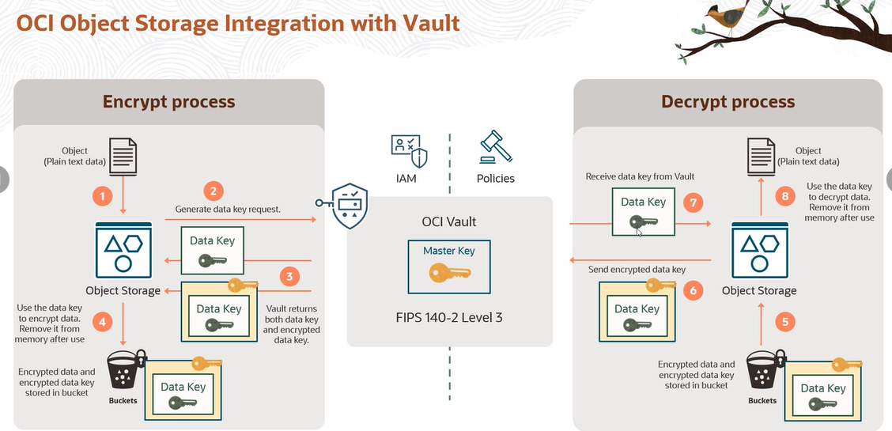

**Backing up and replicating vaults and keys.**

In this particular lesson, first let's look at how you can back up vaults and keys. And then we'll look at something called a cross-region replication.

So why would you back up your vaults and keys? Well, it's a best practice to back up and keep the resources before deleting them. So whether it's vault or keys, it's a good practice. It's kind of a best practice to back these up.

Now, there are certain restrictions you need to be aware of when you back up your vaults and keys. The first thing is only virtual private vaults are supported for backups. Remember, we take an HSM. We create these partitions on the HSM.

And there is a dedicated, isolated partition, which is your virtual private vault. The other part of that partition is a shared partition. So only the virtual private vault is supported for backups. The normal standard vault, or the shared vault, is not supported for backups. So keep that in mind.

And then also, only a master encryption key which has a protection type of HSM can be part of backups. So software protected keys cannot be part of backups. So keep those two restrictions in mind as you do the backups.

Now, master encryption keys, as we saw in the intro lesson, are always associated with a vault. Now, this relationship will persist even as the key is backed up and restored, meaning when you backup a key, you're also backing up a vault because that relationship is always maintained.

Backups, as you can guess, are kept in existing or new Object Storage buckets. And you can copy the backups to Object Storage buckets in another region. There's a feature called cross-region replication. And we'll look into that, what it does.

And, as you can imagine, backups are useful for disaster recovery scenarios. So not just for a best practice, but it's also useful if you have disaster recovery scenarios. In case a region goes down and you are backing up to another region, you can bring up this as you want to move your operation from region one to region two.

Now, let's look at some other details. When you backup your vault and keys, what really goes behind the scene? Now, backup exports identifying information about the vault or the key. Makes sense. And the whole process-- I mean, this is Vault service. So you would imagine that the whole process is encrypted. So the Vault service encrypts the backups. And only the Vault service can restore them.

Backups can optionally include keys. If you're not backing up keys-- of course, assuming the vault has keys in a supported lifecycle state. So a key cannot be like in a deleted state and et cetera. You should check the documentation. Assuming that it's keys which are active and you do the backup, you can optionally include keys with your backups.

You can backup only one vault or one key at a time. So keep that in mind. And your backup operations require you to specify where to download the backup. So as we saw, you can specify the Object Storage location buckets. But you need to specify that. And then that's pretty much everything on how the backup operation works. Pretty straightforward. You are backing up your vault and your keys.

Now, on the reverse side, when you restore your vaults and keys, you first restore the vault as, again, you can imagine, because the keys persist within the vault. And then you restore the key. And the key must always be associated with a vault before they can be restored. So that's a very important consideration. You cannot just have a, quote-unquote, "hanging key," which is hanging without a vault. It's just not possible. So a key has to be always associated with a vault before they can be restored.

And this is the screenshot you get when you restore the vault. You can see it's asking for a source where you have backed up. So whether it can be an Object Storage bucket or a URL. Or you could even import a backup from an uploaded file.

Unfortunately, I don't have access to show you the console and the demo because for me to show this thing, I'll have to create a virtual private vault, which I don't have access to. But I mean, the process is pretty straightforward, as you can imagine from the slides.

Now, there's also one feature which is called cross-region replication. And as you can see here, the whole idea is you have a source vault in region 1. Remember Vault is a regional pubic service. And then you have a vault replica in region 2. And you can replicate your keys from region 1 to region 2. Why would you do this? Well, it helps you in disaster recovery scenario. So suppose region 1 goes down or is unavailable for whatever reason. You can always switch over your operations to region 2 and your keys are available.

Now, again, a couple of considerations to keep in mind. Only virtual private vaults are supported for replication. When replication is configured, Vault service automatically synchronizes creation, deletion, update, or moving of keys between the source and replica vault. So you don't have to manually move them, for example. The service takes care of that. Only one destination vault can exist for a given source vault at any time. So it's one-to-one relationship between the replica vault and the source vault. For example, you cannot have multiple replica vaults in a region.

You cannot create keys directly in the vault replica nor backup a vault replica. So because it's a replica of the master, or the source, you cannot create keys directly in it. But you can support cryptographic operations against the vault replica and keys. So if you are sitting in this particular region, you could actually use the keys or you could encrypt data using the keys which are stored in your vault replica in another region.

So this is, again, very useful for cross-region disaster recovery scenarios. Or even you might have a requirement where you want to use something across two regions. And you could create a vault replica, and you could use it like this.

And how do you stop this process? You can delete the vault replica to stop replication. So this is what cross-region replication looks like. As I said, I don't have access to a console. So I cannot show this particular demo. But this is all about backing up your vault and keys and cross-region replication.

**OCI Vault Secrets.**

As you recall from the intro lesson on OCI Vault, we discussed the key characteristic of the service as vaults, keys, and secrets. And until now, we have not really dealt with secrets, so let's look into that as the first thing.

But before we do that, what are these things called secrets? Well, secrets can be anything that you want to control access to-- API keys, passwords, certificates, database, admin passwords, et cetera. More services means there is going to be more authentication, and they are going to be more secrets. And using a secret manager is the foremost security best practice. We have all taken this kind of a route where humans tend to take insecure shortcuts, like hard-coding the secrets in source code, container images, configuration files.

We are all guilty of sharing credentials via email, Slack, and shared folders, in plaintext. We all have done it at some point or other. So the whole idea is, that's not the security best practice so we need to avoid that. And OCI has a feature where you can store these secrets. Until now, as we discussed, we talked about keys, and we talked about vaults, and we talked about the whole idea of a dedicated system partition, the private vault, and just the standard vault, which is kind of a shared system partition.

And as we saw earlier, these keys and secrets are protected at rest with the encryption guarantees of a FIPS140-2 security level 3 security certification-compliant HSM hardware security module that backs the vault where the secret and keys are created and stored. It kind of gives you that capability to store the secrets in the Vault Service rather than storing it in your configuration files or sharing it in plaintext with other users. So this is the second part of the service we haven't discussed until now now.

Now, you can store information, as we discuss, like public keys or passwords as secrets in the vault. And this is a more secure way to store and retrieve them. You can create secrets by using the console, CLI, API, whichever method you prefer. And secrets like keys can be rotated to reduce impact in case the secret is exposed or compromised. And we'll jump into the console and take a look at this, but creating a secret is as simple as going on the OCI Vault Service.

I'm using the console right now and providing a key value pair. So I'm saying, my secret here is a database password. And I basically give what the contents are. And I have to specify the encryption key, the master encryption key. And that is used to change this plaintext password, or, in this case, secret, into the ciphertext and the service store stack. And then you can retrieve it when you need it or your application needs it.

There are a couple of things which you need to keep in mind as you're working with , which are called secrets rules. So there are kind of two rules. The first one is called the reuse rule. And the whole idea is that it prevents the reuse of secret contents across different versions of secrets. So what happens is, the secret itself is stored in a ciphertext.

However, while in application memory, a secret could be compromised. So preventing the reuse of secret contents by having multiple secret versions serves to limit the scope of affected resources in the event of a security breach involving that particular stored credential. So that's the whole idea of behind creating a rule around secret reuse rule. And you can see here the configuration is enforced on deleted secret versions. So if you feel something has been compromised, you could delete that particular version.

And there's also something called secret expiry rule. And this restricts how long the secret contents of a particular secret version can remain in use. This rule can also block the retrieval of secret contents for a secret or secret version passed the configured expiration date. So configuring an expiring rule to specify a time range for how long a secret version can exist also helps limit the impact of a potential security breach. And you can see here, I can specify this value, I think it goes from 1 to 365 days. To the standard is, I think, anywhere from 1 to 90 days. And I can also block content retrieval on expiry. So once this version expires, I cannot retrieve it.

1. Which resource CANNOT be managed by the Vault service?

Keys

Vaults

Locks (*)

Secrets

Correct. Vaults, keys, and secrets can be created and managed by Oracle Vault.

2. What are the available protection modes?

HSM (*)

Private

Software (*)

Public

Correct. In HSM protection mode, the key is stored and processed in an HSM. HSMs are physical devices that are designed to protect cryptographic keys. They are tamper-resistant and have high security standards.  
In software protection mode, the key is stored and processed on the server. This mode is less secure than HSM protection mode, but it is also less expensive.

3. Which two services integrate with OCI Vault service, allowing the use of customer-managed keys?

IAM

Streaming (*)

Load balancer

Block Volume (*)

Correct. The following services integrate with the Vault service, allowing the use of customer-managed keys: Block Volume, File Storage, Object Storage, Autonomous Container DBs, Container Engine for Kubernetes, and Streaming.

4. Where are vaults created?

IAM

PCI

RSA

HSM (*)

Correct. Vaults are created on HSM (Hardware Security Module).

5. Which types of keys can be imported in the Vault service?

AES (*)

DES

RSA (*)

ECDSA

Incorrect. AES, RSA, and ECDSA can be used as encryption algorithms when a key is created in the Vault but ECDSA cannot be imported.

**Disaster Recovery**

**High availability**.

What is high availability? High availability is a characteristic of a system that aims to provide higher operational performance and uptime. To achieve that, redundant hardware and software are used to architect the system to remain available despite failures. By removing single points of failure, backup components will take the place of failed components-- that is, the failover operation.

A smooth transition from the failed component to the backup component determines the level of high availability of a system. On OCI regions, availability domains represent fault-tolerant structures that are isolated from each other and do not share any physical infrastructure. When multiple availability domains are present in their region, they are interconnected using low-latency connections, allowing replicated systems within the same region.

Each availability domain contains three fault domains. A fault domain is a grouping of hardware and infrastructure within an availability domain. Fault domains provide anti-affinity. They let you distribute your instances so the instances are not on the same physical hardware within a single availability domain. A hardware failure or compute hardware maintenance event that affects one fault domain does not affect instances in other fault domains.

One of the key principles of designing high-availability solutions is to avoid the single point of failure. We recommend designing your architecture to deploy instances that perform the same tasks in different fault domains for one of the built-in domain regions and, if possible, in different availability domains for multiple availability domain regions. This design removes a single point of failure by introducing redundancy.

Let's look how several components can help your system be highly available. Subnets act as a unit of configuration within the VCN. Subnets exist either in a single availability domain or across an entire region-- regional subnets. Regional subnets facilitates the communication, as they can over multiple availability domains and is recommended over AD-specific subnets. The Load Balancing Service improves resource utilization, facilitates the scaling, and helps ensure high availability. It supports routing incoming requests to various backend sets based on the virtual hostname, path route rules, or a combination of both. The backend set can span through multiple availability domains. Both private and public balances are redundant.

Virtual IPs are assigned as secondary IPs on compute instances. This secondary IP can be reassigned to another instance for failover. Compute instances architecture can take advantage of multiple availability domains or fault domains when allowing your system to be redundant. When you set up a secondary instance that works if the primary instance fails, that is called standby. Standby mode is typically used for applications that need to maintain their states.

When all the instances are actively participating in performing the same tasks, this is called active/active mode. When one of the components fails, the related tasks are simply distributed to another component. Active mode is typically used for stateless applications or applications that track their states in the broker or database.

Sometimes, failures happen because the instance's resources are exhausted. Without autoscaling, you can create an instance pool-- a group of instances-- actively monitor and automatically react to that, and scale the number of instances within the pool according to their load-- either CPU or memory. Autoscaling is fully integrated with the Load Balance service that can distribute the request among the pool members.

Object storage was designed to be highly durable within regions. Multiple copies of the data are stored across several servers in the availability domains. Data integrity is actively monitored using checksums. Corrupt data is autodetected and autohealed from redundant copies. Any loss of data redundancy is actively managed by recreating a copy of the data. All this happens automatically, and no intervention is required.

Block volumes are available within availability domains, and their underneath structure is highly available, with multiple copies of different storage servers. If you need to copy data to a different availability domain, you can use the block volume backup feature that is created as a regional resource in restoring the block volume on the different availability domain.

File storage systems provide a durable, scalable, enterprise-grade network file system that's ideal for enterprise applications that need shared files and are similar to a network-attached storage. Redundant connectivity is an important part of a highly-available system. When using IPSec VPN, the dynamic routing gateway offers multiple VPN endpoints so that each IPSec VPN connection can consist of redundant IPSec tunnels that use static routes to route traffic.

To ensure high availability, you must set up a VPN connections within your internal network to use either path when needed. When using FastConnect, you can either connect directly to OCI routers and provided point of presence, called POPs, or use one of Oracle's many partners to connect from POPs around the world to their OCI network resources. Oracle provides features that allow you to build fault-tolerant connections, including multiple POPs per region and multiple FastConnect routers per POP.

Additionally, you can configure two CPEs, customer premise equipments, to create a highly-available deployment in your on-premises network. The diagram shows the recommended HA VPN deployment, with two configured tunnels per CPE. Summarizing the connectivity options to your on-premises network, we talked about IPSec VPN and FastConnect. This network topology diagram shows that the VCN network is connected via an IPsec VPN connection, virtual circuits to the on-premises network, and also has the internet gateway for your VCN internet-bound traffic. This can be a highly-available and flexible VCN configuration for your applications.

In this lesson, we talked about high-availability concepts and how they are present on OCI components.

**Disaster recovery .**

Disaster recovery is the method used by organizations to regain functionality after disrupting event. It covers the methods and planning involved to restore the environment.

The key metrics for disaster recovery are recovery point objective, RPO, and recovery time objective, RTO. RPO, recovery point objective represents the time between your last backup and the disaster event. You can also understand RPO as the amount of data that your company can afford to lose.

RTO, recovery time objective represents the time that an application or system can be down without causing a substantial damage to the business. In this diagram, we list how costs changes depending on the design RPO/RTO combination. The more RPO and RTO are aggressive, the higher the cost gets.

Backup and restore will be the cheapest option in the proposed scenarios. The on premises backup is sent to the Cloud, and in the case of an event, the data restored from OCI. In this standby option, the data is replicated to OCI and the minimal set of services are kept active on OCI.

Data is replicated on shorter intervals and this part of the infrastructure is already up. Less data will be lost and the recovery time will be faster but the cost is greater than the previous option. When you set up the active/active option, the replication is performed on even shorter intervals almost online and that will reduce drastically the RPO.

The system components are already created and active, ready to take over. The cost is higher than the other two but it offers much faster results. OCI regions is the first component that we will talk about. OCI regions are completely independent from other regions and are separated by vast distances across countries or even continents. Use different regions to mitigate the risk of regional wide events like earthquakes and also legal requirements as data sovereignty or legal jurisdiction.

When you use different regions on OCI, virtual Cloud networks in different regions can be connected using remote VCN peering. The resources will be able to communicate without leaving the OCI network. Let's talk about the best practice when creating block volume backups. When creating and restoring from backups, keep in mind the following.

Before creating a backup, you should ensure that the data is consistent. Sync the file system and mount the file system if possible and save your application data. Only the data on disk will be backed up. When creating a backup, after the backup states change from request received to creating, you can return to writing data to the volume.

While your backup is in progress, the volume is being backed up cannot be deleted. If you want to attach a restored volume that has the original volume attached, be aware that some operating systems do not allow you to restore identical volumes. To resolve this, you should change the partition IDs before restoring the volume.

The steps to change in an operating system's partition ID vary by operating system. For instructions, see the operating system's documentation. You should not delete the original volume until you have verified that the backup you created of it completed successfully.

Disaster recovery for Oracle databases can take advantage of active Data Guard or Golden Gate. Active Data Guard provides secure physical replication. They stand by databases open really only so your data consistency is guaranteed. Simple, fast, one way replication of a complete Oracle database.

The default configuration that handles most workloads so there is little administrative overhead. If you want to implement more advanced replication features, the choice is Golden Gate. It replicates, filters, and transforms data from one database to another database.

It enables the replication of data between Oracle databases and other supported iteration use databases. It can be installed on premises or as a platform service on OCI. This concludes our lesson on disaster recovery on OCI.

**Full Stack Disaster Recovery service.**

Within a business continuity plan, disaster recovery consists of the step of the plan where critical business components are restored as quickly as possible after an unexpected disruption.

The Full Stack Disaster Recovery as a service offered by OCI that enables orchestration and management of disaster recovery for all layers of an application stack. This comprehensive solution provides complete disaster recovery capabilities.

Throughout the other lessons, you'll learn how OCI components are resistant and resilient. Now, with Full Stack Disaster Recovery, you will learn how to glue all those parts together, ensuring that all components of your stack are covered in case of a disaster event.

Before we dive into Full Stack Disaster Recovery, you might be wondering why you need a disaster recovery solution. Let me tell you something of the benefits. Rather than focusing on recovery of the individual components, like databases or compute instances, Full Stack Disaster Recovery offers recovery for the entire application stack.

This comprehensive approach is important for ensuring business continuity, as the recovery of select components is not enough to guarantee the restoration of critical business functions. With Full Stack Disaster Recovery, the topology of deployment characteristics of diverse application stacks are assessed and a dedicated disaster recovery workflow is automatically generated for recovering all components of the application stack in a different region.

Full Stack Disaster Recovery removes the requirement for manual disaster recovery of individual resources within an application stack, including infrastructure components, middleware, databases, and application components. By leveraging fully automated DR workflows, the entire application stack can be swiftly brought up in a different region.

A common problem with disaster recovery workflows is that topology changes, configuration changes, or environment drift can make disaster recovery workflows unusable, because they do not match the environment they are protecting. Full Stack Disaster Recovery provides a comprehensive series of pre-checks that you can use to continuously validate the conformity of DR workflows with the application environment you configure them to protect.

Disaster recovery workflows are error prone, as they require a complicated orchestration of many precise interconnected steps to be performed by humans. Full Stack Disaster Recovery automates and sequences these steps to provide fast and seamless disaster recovery operations across regions without human intervention, thus reducing disaster recovery workflow errors.

Full Stack Disaster Recovery workflows are highly flexible and customizable. You can adapt them to perform DR any application stack or a set of IT assets. You can add your own callouts and custom logic to any workflow and precisely configure the action of these customizations. The operators and administrators do not require any special skills or domain expertise in areas such as applications and storage replication.

You can create and test DR workflows ahead of time. This process eliminates the need for experts when performing the DR operations. Full Stack Disaster Recovery provides a single pane of glass monitoring and managing capability for all disaster recovery needs. You can create a DR protection configuration, monitor DR readiness, execute DR workflows, and manage errors using the OCI Console.

Now that you know some of the benefits, let's take a look at the features. Full Stack Disaster Recovery encompasses not just infrastructure, but the whole stack. It runs as a service, allowing you to focus on the plan and not in conversional servers, bastion, or any kind of resource that is not directly part of your stack.

Each DR protection group is independent and can manage completely different DR strategies and deployment architectures to meet different SLE requirements. Although not required, Full Stack Disaster Recovery can manage disaster recovery for infrastructure. It can work with any combination of instances, databases, and applications.

Configure, manage, initiate, control, and monitor disaster recovery operations, including switchovers and failovers between regions using the OCI Console, the CLI, or API from anywhere around the globe. Fully automated DR operations allow executives and management to rest a little easier, since there is no need to assemble a cadre of storage, network, database, and application specialists to begin ADR operation, perform tasks at key moments, or shift through the recovery process all hours of the day.

Bring part or all of a business back online faster after a catastrophic event simply by selecting a specific DR plan from a list of plans in the OCI Console. Full Stack Disaster Recovery service uses custom intelligence to generate DR plans for Oracle applications and infrastructure. This helps customers generate basic DR plans very fast with very little effort on their part.

Customers don't have to spend time figuring out what actions need to be completed during a DR transition or spend time adding terminal CI services to DR plans. Customers can add, remove, modify tasks, change their order, and add or remove custom automation to complete the DR plan at any time.

Visually observe a DR operation every step of the way through the OCI console. Full Stack Disaster Recovery service allows a switchover or failover to be canceled, paused, and resumed at any point during the execution of a DR plan. Drill down into comprehensive high detailed logs during and after the DR operation.

Full Stack Disaster Recovery performs comprehensive pre-checks before a DR plan is executed to ensure the DR operation succeeds at the standby region. A passive, non-disruptive pre-check can also be run at any time without executing the DR plan. Now that you know what Full Step Disaster Recovery service is, its benefits, and its features, jump to the next lesson and know in detail the components and prerequisites.

**Full Stack Disaster Recovery service components**

The first thing you need to know is which OCI components are supported. Supported in this case means that they have built automations that you can use. As I speak, several other components are having their automations being built. Always check the documentation for the most recent list. If the component is not on the list, it can still be added using custom automations.

The next thing you need to know is your application stack. Create a consistent grouping of these application components and dependencies. The first and core component of FSDR the disaster recovery protection group or the DRPG for short. Remember the grouping you establish while defining your stack. The DRPG is the component that will represent your stack.

DRPGs are defined in pairs in a peer relationship. One DRPG will have the primary role and the other we'll have the standby role. Within the DRPG, you will have the members. The members are the OCI components that are part of your stack.

The next component is the DR Plan. The DRG Plan represents a DR workflow associated with a pair of disaster recovery protection groups. There are two types of DR plans, switchover and failover. The switchover DR plans performs a planned transition of services from the primary DRPG to the extent by the DRPG while the failover DR plan performs an unplanned transition of services to the extent by DRPG. DR plans are defined in the standby DRPGs.

Inside the plan, there are planned groups that I will give more details in the next slide. Before going into the plan group, let me do a quick recap on how the components are lined up. On the first DR, you have the primary in the standby disaster recovery protection group associated.

Next, you will have the disaster recovery plan. It can be switchover or failover. Inside the DR plan, there, you have one or more plan groups. The plan groups hold the plan steps, a single indivisible execution unit in a DR plan. Blend groups obey a sequential order while the plan steps within are executed in parallel.

The groups and the steps can be built in or user defined. A built group or step is generated automatically by FSDR when ADR plan is created. Example of built in planned steps are launch computing instance, switchover databases.

The user defined groups or steps are added to the DR plan after FSDR creates the DR plan. Examples are to start and stop an application using scripts or call out in OCI function.

In this lesson, I showed you the FSDR components and how they relate to each other. In the next lesson, I will show you how it looks like to set up FSDR and DOCI console and how each of the components are added.

**Full Stack Disaster Recovery requirements**

. In this lesson, I will present you the sample scenario that will be used in the demos. This scenario will show all the features of the Full Stack Disaster Recovery service.

Please take this as a reference of the service capability but have in mind that we are just scratching the surface. The Full Stack Disaster Recovery service can handle any size and type of stack in a variety of disaster recovery strategies. Let's get started.

Now that my step was identified, let me show what are the prerequisites that the scenario must have. First the volumes need to be part of a volume group. It will make it easier to set up the replication later. A bucket for the Full Stack disaster Recovery service logs is also required.

Continuing the least of the prerequisites, I have to recreate the network components in the standby region. If you are using Terraform in Resource Manager that can considerably speed up the process. Once the network is mirrored in the standby region, I have also to set up object store replication, Autonomous Data Guard, and block volume replication. For the block volumes, it's either replication or cross region backup copy.

After those steps, the actual Full Stack Disaster Recovery service setup can start. This concludes this lesson, and you are ready to jump into the demos and see from start to finish how to setup and DR plan execution is done.

1. What are the valid types of DR plans on OCI Full Stack Disaster Recovery?

Chaos Monkey and Chaos Gorilla

Planned and Unplanned

Scheduled and Automatic

Failover and Switchover (*)

Correct. The possible DR plans are Failover (a type of DR plan that performs an unplanned transition of services) and Switchover (a type of DR plan that performs a planned transition of services).

2. What are the three components of OCI FSDR?

Protection Group, Plan Group, and Plan Step (*)

Resource Group, Plan Group, and Plan Step

Source instance, target instance, and replicated data

Protection Policy, Plan Group, and Plan Step

Correct. Protection Group   represents a consistency grouping defined for the purposes of disaster recovery  
Plan Group   represents a DR workflow associated with a pair of DR protection groups  
Plan Step   a single indivisible unit of execution in a DR plan

3. What is Oracle Cloud Infrastructure Full Stack Disaster Recovery?

A disaster recovery orchestration and management service that provides comprehensive disaster recovery capabilities (*)

A tool for backing up and restoring data in case of disaster

A feature that provides continuous data protection

A service that provides data replication between availability domains

Correct. OCI Full Stack Disaster Recovery (OCI FSDR) is a comprehensive solution provided by Oracle Cloud Infrastructure (OCI) for ensuring business continuity in the event of a disaster. It encompasses a range of tools, services, and features that enable organizations to replicate and recover their entire IT infrastructure, including applications, data, and systems.

4. Which two are valid failover destinations for standby protection groups?

Another availability domain in the same region (*)

Paired regions (*)

Another fault domain in the same availability domain

Any region

Incorrect. Standby protection groups can be defined in any paired region or on another availability domain, if the region has multiple availability domains

**Observability and Management Services.**

Observability and Management is a platform with a set of OCI services. It can provide you visibility and actionable insights that are derived using machine learning algorithms and also capturing feedback with a continuous monitoring approach and making it flexible and easy to manage all components across your environments. We will see some of the top features of this platform.

Today, if you observe, the adoption of core business workloads is moving towards public cloud. So what this means is many organizations have already developed a model which they can seamlessly migrate and transform these workloads to run in different cloud environments. Oracle's Observability and Management platform is adapted to this model and gives you a cloud services that allows you to monitor, observe, and manage not just Oracle Cloud but also other public cloud environments.

The next key benefit is the platform is open and extensible. When you have existing environments like on-premises, you might be already using a set of tools where you have a requirement to continue to use in the new environment. If you add multiple tools as when you have these new environments, it can create multiplicity of Monitoring and Management tools. And you're creating a greater complexity into your IT systems.

Oracle's O&M platform uses open standards of Cloud Native Computing Foundation, CNCF, which will help you to unify this process and allows you to integrate with your existing tools to work with Oracle solutions. OCI O&M provides you cloud-based monitoring and analytics. The key aspect here is the visibility into microservices, Kubernetes, Java applications, which are running in any of the cloud environments.

You will also gain full stack analytics, including better forecasting of resources of the platform. Databases are always a critical component in a multi-tier application architecture. Whether you're using Oracle's External Databases or Cloud Databases, you are provided with deep observability capabilities to monitor and manage these databases using this platform.

We will now looking to the top services part of this O&M platform. The Monitoring Service provides you different out-of-box and custom metrics, which will help you to monitor the health and performance of the Cloud Infrastructure. You can also configure alarms to get notified for any of the issues that are reported.

Logging service is a centralized management for all your logs in your tenancy. The service can ingest log data from different sources. And these logs are classified into audit logs, service, and custom logs, which we will learn more in our next lessons.

The Event Service keep track of changes happening to resources in your tenancy. And then you can take automated actions based on the change. For example, you can upload a file into an object storage bucket, which will be recorded by the Event Service. And then using the service, you can trigger an action to convert that file into a different format.

Logging Analytics is a machine learning based cloud solution. And that will help you to aggregate, index, and run analytics across all the log data collected across environments. This service is the next level of Logging Service. And it enables you to search and correlate the log data in a much faster way to troubleshoot any of the problems.

Application Performance Monitoring will provide you deeper visibility into performance of your applications. And the service has a set of features like monitoring the application logic that is spread across the client's back in computing tiers whether it is on the cloud or on premises. Database Management Service offers you different features to monitor and manage your Oracle databases.

It could be an external database or Oracle Cloud Database like the Exadata service and Autonomous databases. Operations insights is another native service. And that will give you a holistic insight into resource utilization and capacity of your host and databases.

We will now look into an end-to-end workflow of DevOps and see how Observability and Management is hooked into this architecture. This diagram here represents an OCI region. And as you can see, IAM services and related OCI services are one of the core foundation that is communicating to all other different components in this workflow. The main aspect we refer about DevOps is CI/CD, Continuous Integration/Continuous Deployment.

So you're looking at the top left of the diagram. We could see DevOps practitioners are continuously making changes to their code. They use the local terminal systems or a cloud console to work on their projects. And these code changes gets checked in or committed into the code repository.

The code repository is where you would store the entire code, including any software archives. So it is important to monitor these code repositories. For example, you want to keep track of the total size of this repository. The O&M Monitoring Service could be used to achieve this.

The next stage is the Build Pipeline. And it is the stage where the code gets compiled and gets it ready for the deployment. So the Build Pipeline also have a set of procedures.

And it would also create necessary build artifacts during this process and, for example, the different files that are created while running the build process, the distribution packages, logs, and reports. So in this process, practitioners would need to know whether the build is successful or get notified if there are any changes. An example would be you can use the O&M Event Service to create an object storage bucket when the build is ready to be deployed.

And then you have the Deploy Pipeline. And this is where the code is deployed into the target environment. If you are deploying a container-based application, it would pull an image stored in the container registry and then deploy it into the OKE cluster. It could also be a compute instance or invoked as an Oracle function, which is the serverless solution of Oracle Cloud Infrastructure.

In the same way, there is always a need to monitor this deployment task, whether the deployment is successful or not. You could use O&M services based on your requirement. For example, you can access the Logging Service to search for specific logs and see if there are any debug level or error messages contained in that log object.

Infrastructure as code and configuration management are two main components in a DevOps workflow. An example here, having Terraform configs, you can specify the required plug-ins to be installed, create the infrastructure services that are matching that configuration using Ansible scripts or Puppet manifest to keep a consistent configuration across the systems. During this process, there are a number of nodes that are created.

And it could follow a number of CRUD operations like create, read, update, delete operations into an object storage, or it could be writing into a database instance. There are Observability services that lets you monitor such operations in the environment. Database Management is one of the services that will help you to manage and monitor databases.

And once the application is ready, end users can then connect using HTTPS, or a web application firewall, or through an SSH session using the bastion service. Application Performance Monitoring or APM could be used to inspect the performance of your deployed application. If there are any potential issues, Logging Analytics is another key service that could be leveraged to dive deeper into each task and see some more specifics of the problem.

The end-to-end protection of the environment is also a high priority in cloud operations. So you could integrate services like Vault to centrally manage the encryption keys and secret credentials, making sure you have the right IAM policies, Cloud Guard for monitoring the security postures of the environment. Notifications, functions, and streaming are a few other services that are tightly integrated with O&M services. And this integration makes it a complete solution for a wide range of use cases. We will be looking at these integrations and use cases as we go into those individual lessons.

Now if you're watching this lesson through OCI Architect Associate course, you would be learning the foundational services like Monitoring and Logging. And if you're using OCI Architect Professional course, you would also learn some of the next level services like Logging Analytics, Events, et cetera. So that tells us Observability and Management is a core platform for DevOps that will add values and benefits to the CI/CD path capturing continuous feedback with testing, continuous monitoring, and running analytics to support towards an efficient cloud operations model.

To summarize what we learned so far, we looked into the key benefits of O&M platform, multicloud observability and management, the platform is open and extensible, cloud-based monitoring and analytics, and deep visibility into Oracle Databases. We also looked into the key services of the platform, along with the use case related to the DevOps end-to-end workflow. So that's all in this lesson. Let's now go into our next set of lessons where we start looking into each services with a deeper focus.

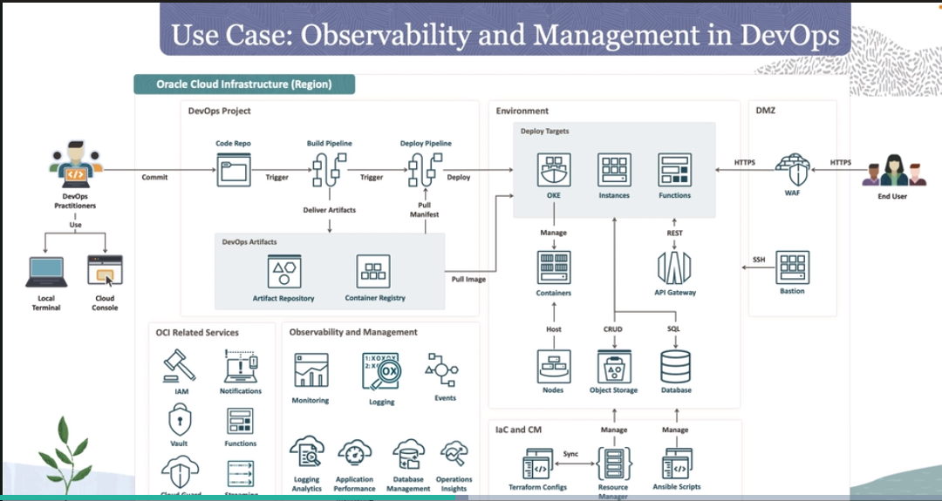

**Monitoring Service.**

We are going to look at an overview of the service, some of the fundamental capabilities, and a service workflow that integrates with the notification service.

Monitoring is one of the foundational service of OCI's Observability and Management platform. It is designed to help you actively and passively monitor cloud resources. These cloud resources can be native to Oracle Cloud Infrastructure or it could be external resources running in a different cloud infrastructure environment.

The service use a concept called metrics to monitor these resources. And these metrics are emitted by those cloud services. And then you can use alarms for notifying or alerting for any of the problems in your environment.

There are different ways you can access these metrics and alarm data. You can use OCI console, CLI or Command-Line Interface, and APIs. I would recommend you to go through some of the demos that would be highlighting how to use this service in these different ways. There are dashboards available where you can gain a single pane of glass window for monitoring your resources.

Alarms is another key concept. And it is used to publish messages into different destinations that are managed by the notification service. Let's look into some of the capabilities of monitoring service. We briefly spoke about metrics. And these metrics are standardized across Oracle and non-Oracle technologies.

And this approach would help you to reduce the need of having vendor-specific expertise for any of your requirements. Applications commonly uses a multi-tiered distributed architecture. So what this means is you're also running microservices-based applications over containers. You might be also hosting bare metal servers, databases, load balancers, and everything that support towards this architecture.

The monitoring service is designed to help you capture the status and performance summaries based on each of these service tiers and making it easy to troubleshoot when they are appearing across these tiers. The service also provides capabilities for proactive and flexible alerting. If you look at the DevOps workflow in our previous lesson, we learned about running continuous integration, continuous deployment practices. And there is always a need for proactive and continuous monitoring to capture alerts before it hits the end user. Monitoring service would help you to generate alerts and also setting up alert threshold rules which can be specific or broad for any of the resources to achieve these capabilities.

As we talk about these different metrics, getting a unified global view of infrastructure health is also important. One of the reason is to correlate metrics with other metrics, for example, correlating a performance metric with other load metrics across all entities in the tier. And this is one of the capability of the service with providing you purpose-built dashboards with a global-wide visibility. Monitoring service gives you features to define new custom metrics and integrate into your dashboards and alert rules. This is also highly important to use cases with extending monitoring to any type of resources using the service.

Here is an end-to-end workflow of OCI monitoring service. On the left, you have applications, services, and resources in a customer on-premises environment. And then you have resources in Oracle Cloud Infrastructure environment. These resources are continuously emitting metrics in the form of raw metric data, which means there are no filtering conditions defined to the data at that stage.

The next step is to transition this raw metric data into an aggregated data. And this is done with applying certain statistics at an interval. For example, you can choose to show the minimum or maximum resource utilization of an entity. You can also access this aggregated data using OCI console or using APIs is the case CLI or even using customers third-party monitoring tools like Grafana.

So once the aggregation is done, the next step is to define an alarm with a condition. And here in this example, we are choosing if the CPU utilization is greater than 80%, that should trigger an alarm. If the CPU utilization is less than 80%, the alarm status is OK.

And if it is greater than 80%, it should trigger an alarm into the firing state. Alarms are integrated with OCI's notification service, which will help you to notify different communication channels. We will be looking at the specifics and configurations in our next set of lessons.

To summarize, we looked into an overview of monitoring service, some of the capabilities of the service, and an end-to-end workflow with an example of monitoring the CPU utilization of an instance. So that's all in this lecture. We will now look into some of the key concepts of monitoring service.

**Key concepts of OCI Monitoring Service.**

Metrics is defined as a measurement related to the health capacity or performance of a resource. Metrics are logically grouped within different metric namespaces. So these namespaces are like logical containers for metrics.

You can see, in the screenshot, you have Metric Namespace dropdown. And we have selected the oci_ComputeAgent. And this namespace will provide you metrics like the CPU and memory utilization of your compute instances. We will be seeing some of these metrics and metric namespaces later in this lesson.

There are different types of metrics that can relay metric data. The service metrics are those metrics from OCI Cloud resources. Custom metrics are your own custom metrics that you can publish using an API called PostMetricData.

Dimension is another concept in the Monitoring Service. You can use dimensions as qualifiers or providing filters to the metric data. Let's say, if you want to filter the metric data by a specific resource ID of an instance or filtering by the shape used by the instance, you can add these multiple dimensions with a name value pair and then access metrics based on the selections.

The next field, as you see in the screenshot, is the time period, which you select along with the metric. You can choose a start time and an end time to filter metrics within this period. Interval and statistics are two different functions which I use to aggregate raw data points. Interval is the time window you provide within the start and end time period. And then it will aggregate the data depending on the statistic condition applied.

So statistic is another aggregation function. For example, if you want to look at the maximum reported value of CPU utilization, metric stream is defined as an individual set of aggregated data. Taking an example here, if you have 10 compute instances and then, using the metric to monitor the memory utilization, the aggregated data would represent 10 individual metric streams.

So in the screenshot here, you can refer to the different colors in the graph. And that is representing each instance. You have an option to aggregate these multiple metrics streams into a single stream of data. This capability is also referred as the grouping function, which we will be seeing later in this lesson. Let's now look into the concepts of intervals and resolutions and see how those two are related.

We saw the interval is defined as the time window used to aggregate a set of raw data points. This means you are specifying an interval within the metric query to derive multiple time windows for data aggregation. The resolution is the period between these time windows. And it could be only used through APIs. So comparing these two concepts-- interval controls the length of each window, and resolution controls the start time of each aggregation window.

So here is an example to explain these concepts. Request A is a metric query with maximum CPU utilization with an interval of five minutes. And it is used to within the last 15 minutes. This 15 minutes is represented from 0 to 15, and this is the overall time range with choosing a start time and an end time. This query is not using a specified resolution value, which means it is going to use five minutes as the default resolution value between these time windows.

So the first time window for aggregation is from 0 to the 5th minute. The second window is from 5th minute to the 10th minute. And the third window is from 10th to the 15th minute. Each time window would result in a single aggregated data point that represents the highest CPU utilization counter for that window.

In the next example, Request B has a 1-minute resolution and a 5-minute interval. This means each 5-minute aggregation window is taken from the data points emitted every single minute. And so, in this case, the aggregation starts from 0 to the 5th minute, and then the resolution will be applied after the 1st minute. So the next window would be the 1st minute to the 6th minute and then the 2nd minute to the 7th minute and resulting the highest CPU utilization counter for each window.

Statistics is another aggregation function that we use. We are going to look at some of the statistics function referred in Monitoring Query Language expression and can be used while creating queries. There are different modes where you can select when creating queries, the basic mode and the advanced mode. The statistics we are going to see here are all supported using advanced mode, which means some of these are not supported in basic mode.

Absent is a statistic which we use to see the metric is present in the whole interval. So it is used for defining alarms. Average is another statistic, and it returns the value of sum divided by count for the specified time period. Average is supported only in advanced mode, which means it is not available in basic mode. Count is the total number of observations received in the given time period. Increment is another statistic which is supported only in advanced mode.

And it returns the incremental change of each interval. Max, for maximum, is the highest value observed during the period. For example, we use maximum for reporting utilization of a resource and also defining alarms, the same way minimum is the lowest value observed during the period. Mean is similar to average, and it returns the value of sum divided by count during the time period. Percentile referred here, returns the estimated value of the specified percentile.

In basic mode, you would specify percentile in a different way. For example, P50 represents the value for the 50th percentile, or P90 returns the 90th percentile. Rate is the per-interval average rate of change in each interval. And the unit used for rate is per second. And finally, sum returns the total of all values added together.

Alarms is one another core concept that will help you to define alerts and notifications. The diagram here shows the workflow. You have OCI native services and also external services or applications emitting metrics into OCI Monitoring Service.

And in this example, you have defined an alarm for high-CPU utilization. And when the alarm is in firing state, it sends a notification message through the topic, which has got different destinations like email, Oracle functions, tools, over HTTPS, PagerDuty, Slack channels, and SMS text messages.

We have seen there are different components involved in creating an alarm query. So to define an alarm query, you must specify the metric, the statistic, interval, and the trigger rule. A trigger rule can be a threshold or looking for an absence of a metric. Alarm has different states once you have created it.

OK means the alarm is not in firing state. Firing means the alarm state has been changed from OK to firing. Reset is when the alarm is not detecting the metric firing, or the metric is no longer emitted. Repeat is referred when the alarm is maintaining a firing status, and you have also configured to repeat notifications to those destinations. Suppression is another configuration used to avoid publishing messages during a specified time range. And this is useful to suspend alarm notification during the system maintenance.

Here are some of the query components and examples. We saw, in the previous definition, and the metric used in the query for a metric namespace. And for example, the oci_computeagent provides you CpuUtilization, MemoryUtilization, total bytes written into the disk, LoadAverage. The oci_vcn namespace will give you several metrics for your VNICs. Oci_blockstore has volume read and write operations, volume read and write throughput, Oci_objectstorage with ObjectCount and the usage stored in bytes.

The next component is the interval. Always remember, the interval is specified within a time range. And this time range will have a start time and an end time. The duration of this time range could be one hour, for example. And then you specify a 5-minute interval. So the values that you provide for the interval would depend upon the specified time range. There are more interval values supported for smaller time ranges.

And for example, if you select a time range for the last one hour, then all interval values are supported. You can choose an interval of one minute or five minutes. But if you select a wider range, let's say a quick selection of last 90 days for this time range, then you could only choose intervals for one hour or one day within this range.

The interval can be specified through the basic mode or advanced mode. With basic mode, you can choose one minute, five minutes, or one hour. With advanced mode, there are further options like providing 1 minute to 60 minutes, 1 hour to 24 hours, or 1 day.

Dimensions is an optional component. You can filter data by specifying the availability domain or fault domain, the image ID of an instance, the region where you have resources, the display name of a resource, or the OCID of a resource, the shape of the instance, or a project OCID in case of a DevOps project. Grouping function is an optional component, but it is highly useful in aggregating query results.

There are two types of grouping functions. Number one is group by, which means you can aggregate query results by groups. Let's say you want to group by availability domain or grouping by specific regions or grouping based on shape of instances. Group by is not available in basic mode, and it is available only through advanced mode of the console.

The second function is referred as the grouping function itself. It means to aggregate multiple metric streams. We saw an example before, if you have 10 instances running and querying for memory utilization, this would result in 10 different metric streams. This grouping function will help you to aggregate these 10 streams into a single metric stream. This is highly useful when you have a cluster of multiple instances and have a requirement to monitor the performance of the entire cluster.

If you are referring to the OCI console, it refers to a checkbox called aggregate metric streams in basic mode. And then you can use the grouping function as shown here when you're using with advanced mode. Statistic is a component you should always specify in a query. We saw some of the statistics.

And here, for example, using absent or average for measuring the outrage, count for the total observations, max for maximum, min for minimum, sum for the values that are added together. Comparison operators are used for defining alarms. You can specify if the statistic is greater than a value or equal or not equal to a value.

So that concludes this lesson. To summarize, we looked into the key concepts and terminologies used in the Monitoring Service, the concept of metric and metric namespaces, intervals and resolutions, and how they are related, the statistics which are used to aggregate raw data points and, finally, alarms used for alerting and notifying destinations.

**Notification Service.**

In this lesson, we will look into some of the features, along with how the service work with other OCI Services like the Event Service.

The OCI Notification Service enables you to broadcast messages to distribute a component through a Publish-Subscribe pattern. It can deliver secure, highly reliable, low latency, and durable messages for applications hosted within your OCI tenancy or external applications. Topics and subscriptions are referred as communication channels for publishing messages. So when a message is published to a topic, the message is sent to all subscriptions of that topic.

And if a subscriber's end point does not acknowledge the receipt of the message, the Notification Service could be configured to retry the delivery. For example, when you're sending the notification message to an email address and the mail server could be down, the service could retry that delivery again. Notifications are integrated with other OCI Services like the Events or Monitoring where you have configured an alarm and have the message sent to those topic subscriptions.

So the first configuration step in Notification is to create a topic with one or more subscriptions. We can use the OCI Console, or Command Line Interface, APIs, or SDKs to create topics and configure subscriptions.

Once the topic is created, you must configure at least one subscription, which means the end point where you want to send those event messages. These are some of the subscriptions that you can use. The email, which is for sending an email to one or more email addresses each time the event is triggered. You can choose a Function rule action to run a specified function.

If you have a web service hosted in OCI or external that you would need to receive the event message, you can configure the HTTPS option providing the custom URL for that service. A PagerDuty subscription would create a PagerDuty incident with receiving the event message. A Slack subscription is available to be configured to send the event to the specified Slack channel. And finally, the SMS subscription option can also be chosen. However, this cannot be used for directly receiving event messages.

So once you have the topic and subscriptions added, you can configure those integrated services like the Event Service or Monitoring Service. Here in this example, you are able to edit the Rule Actions in the Event Service. After choosing Notifications as the Action Type, you can select the Compartment, and then the Topic you have created.

To wrap up, we looked into the functionalities of Notification Service, the concept of topics and subscriptions, and how it is integrated with the Event Service. So that's all in this lesson.

**Access and limits of Monitoring Service.**

We'll be looking at how to access the Monitoring Service, including the IAM policies and some of the limits that you should take and note in regards to the Monitoring Service.

There are different ways you can access the Monitoring Service. You can access using the OCI Console and navigate through the Observability and Management section, or you could use APIs, SDKs, or CLI.

In our previous lesson, we learned building queries is one of the feature with monitoring service. Metric Explorer is a section in the Monitoring Service UI and this is where you can write or build these queries. There are two modes for this Explorer, the basic mode and the advanced mode.

The basic mode is more sort of UI driven and the advanced mode is more on writing queries with Monitoring Query Language expressions. If you remember in our previous lesson, we saw some of the statistics like average and increment that is only supported in this advanced mode.

These are some of the examples on accessing Monitoring Service and some of the resources using the CLI. The CLI for monitoring starts with OCI Monitoring and then followed by the resource type in execution. And for example, OCI monitoring metric list with specifying the compartments OCID would return all the metric definitions in the compartment.

The same way, OCI monitoring alarm list with a compartment ID will show you all the alarms that are configured. To publish raw metric data points into the Monitoring Service, you would use OCI monitoring metric data post and followed by the configuring parameters.

To create an alarm, you would use OCI monitoring alarm create and then followed by the options. To delete a suspended alarm, you can run the command OCI monitoring suppression remove and followed by the alarms OCID.

The service is integrated with IAM, Identity and Access Management for authentication and authorization. You can create IAM policies depending on your organization and access requirements. Usually, when you look at cloud operations, there are multiple group levels and designated with certain roles. And these are a few examples here.

We have created a group called Alarm-Viewers. Typically they are like network operations center or the first level operations and who get notified for alarms. In most cases, you would assign policies just to see these alarms and retrieve metrics.

There are two policies that you create for this IAM group. Allow group Alarm-Viewers to read alarms in tenancy. This is a tenancy-wide rule and it gives permission to view alarms across the tenancy. The second rule is Allow group Alarm-Viewers to read metrics in tenancy. This is the permission to view and retrieve metrics at the tenancy level.

You might also have a group assigned to create and manage these alarms. And here, we have created an IAM group called Alarm-Admins and a policy has been assigned to the group. The verb used in a policy would tell you what level of permission you are providing to the group. And so in this case, we are using the verb manage and it includes all the permissions for that resource.

The policy would be Allow group Alarm-Admins to manage alarms in tenancy. You would also provide access to read and retrieve metrics with this policy. So the policy would be Allow group Alarm-Admins to read metrics in tenancy.

Alarms have an integration with notification service, so you would also need to give permissions to manage topics which are part of notification service. So the policy would look like Allow group Alarm-Admins to manage ons topics in tenancy.

So, so far, all the policies were assigned at tenancy level. So if you have a group called Metric-Readers and have them read and retrieve metrics only in a specific compartment, for example, a compartment with a name ABC, you can add this policy, Allow group Metric-Readers to read metrics in compartment ABC.

In some cases, you might also want a group with a very restricted view to metrics and have this requirement to limit the information they can see through the metrics of those resources. Let's say you have some confidential information or a user specified metadata for an instance, and you want to restrict a group called Metric-Viewers from accessing this information. You could use the verb inspect and the policy would be Allow group Metric-Viewers to inspect metrics in compartment ABC.

There are also another set of users who focus on developing metric definitions and custom metric queries. In this example, we have a group called Metric-Developers and they are assigned to create metric definitions, which would also include the ability to read and publish custom metrics.

So we are using a policy here, Allow group Metric-Developers to use metrics in tenancy. The verb used is the next level permission to the read verb and it gives you the ability to update the resource depending on the condition.

One of the use cases of using IAM policy is to reduce the scope of access to users and groups. These are some more examples here in the context of limited scope of access. You may want to allow the group Metric-Readers to read metric only at the compartment level. And then the next condition is you are allowing this group to read metrics that belong only to the OCI Compute Agent namespace.

The same way to allow Metric-Developers group to publish metric with the matching namespace, Allow group Metric-Developers to use metrics in tenancy, where target metrics namespace is equal to mycustomnamespace.

Let's see some of the limits of Monitoring Service. There are some storage limits that you need to be aware of. Metric definitions are stored only up to 14 days, and then it will be deleted. The second storage limit is the alarm history is stored only up to 90 days.

OCI Services are continuously emitting metrics. And there are no limitations on the amount of metrics posted by each OCI service. There are some dynamic limits to metric streams, and it depends on the query that you defined and the number of streams to be aggregated.

Metrics stream is an individual set of aggregated data. Let's say you have hundreds of compute instances. And each of those instance represent a metric stream. You can aggregate all of these metrics streams together using the grouping function and then create a single set of data.

In some cases, depending on the query that you use, the maximum number of metric streams you are trying to aggregate could be limited and it can throw an exception with showing how many streams it can allow. So in those cases, you would need to update the query to ensure the number of metric streams is within that reported limit.

So that concludes this lesson. To summarize, we learned the different ways to access the Monitoring Service using the OCI Console, API, SDK, and few CLI examples. We also looked into some of the IAM policies to have a secure access to the service. And finally, the limits you need to be aware of the Monitoring Service.

**Service metrics**

 emitted by some of the top OCI services, the Compute, Storage, and Networking.

We will start with a metric namespaces for compute and those type of metrics and features that are part of each namespace. OCI_compute is a metric namespace and it provides you metrics for performance characteristics of block volumes that are attached to those compute instances.

For example, you can monitor the block volume activity levels of read and write operations and also the volumes read-write throughput expressed in bytes for the given interval. The Instance Metadata Request is about providing information about a running instance, like for example, the virtual network interface cards or vNICs that are attached to the instance or any custom metadata that you have defined for the instance.

OCI_compute_infrastructure_health is another namespace for compute, and the metric for infrastructure health status would help you to monitor bare metal instances that has got hardware components, like the CPU and memory. Instant status metric is used to check the status of a running virtual machine instance or a bare metal instance, whether it is available or not.

The maintenance status metric allows you to monitor whether a VM instance is scheduled for a planned infrastructure maintenance. OCI_computeagent contains those metrics emitted by the compute instance monitoring plugin. This plugin can be enabled through the Oracle Cloud Agent UI of those instances.

You can monitor the CPU and memory utilization of those instances. Disk read and write I/O are two metrics providing the activity level from I/O reads and writes, and those are aggregated across all the storage volumes attached to the instance. Disk read and write bytes are another two metrics to monitor the throughput across the attached storage volumes.

Network receive and transmit bytes is the throughput aggregated across all the vNICs attached to the instances. Load average is the average system load calculated over a 1 minute time period. Memory allocation stall is another metric and it represents the number of times memory pages were reclaimed directly.

Let's take a look into some of the storage specific namespace and metrics. OCI_objectstorage is the namespace for object storage, and it provides you metrics to monitor the size of each bucket and also the number of objects available in each bucket.

OCI_blockstore is the namespace for block storage. The block storage volumes are attached to the instances, and so the OCI compute namespace would also report some of these metrics separately. In the blockstore namespace, the metrics are measured by volume and each represent a metric stream.

There are different types of metrics that are part of oci_blockstore. For example, the volume read and write throughput, the volume read and write operations, the throttled operations for the volume, guaranteed IOPS and throughput, and then metrics for the time elapsed from the last cross region replica was uploaded or when it was sent.

From the networking service, we have the oci_vcn Virtual Cloud Network that contains metrics for your vNICs. These vNICs are virtual network interface cards that are attached to instances and it controls how the instance communicate between internal and external endpoints of these vNICs.

There are a wide range of metrics that you can use to monitor and I'm just listing a few examples here. Metrics for monitoring packets that are received and sent through the vNIC, the total bytes received and sent through the vNIC, ingress and egress packets dropped by the security list.

Ingress means the packets that are received from the network and destined to the vNIC and egress means the packets sent by the vNIC to the network, but they both are dropped due to the rules specified in the security list. Then we have metrics for ingress egress packets that are dropped due to throttling, the packets that are dropped due to the full collection tracking table.

The next category is the oci_nat_gateway. And NAT gateway is used to give outbound connections into the internet and get responses, but they cannot receive any inbound connections that are initiated from the internet. Usually, you would use NAT gateways for updating or patching your systems.

There are a few metrics that are part of this namespace. You can monitor the traffic to and from the NAT gateway, the total bytes and packets from OCI resources to the NAT gateway, and also vice versa, the traffic from the NAT gateway back into the OCI resources. You can also monitor the packets that are dropped by the gateway which will help you to troubleshoot if there are any issues like exhausting NAT ports used for traffic flow.

To summarize, we saw the different namespaces for compute, storage, and networks, and some of the metrics and features that are part of each namespace.

**Metric queries**

We are going to learn about monitoring query language expressions, the components of queries, along with a few sample queries you can use it with a monitoring service.

One of the key features of monitoring service, it allows you to create queries. You can use these queries to search and aggregate metric data points collected from OCI resources. We have seen there are two modes you can create this query, the basic mode and the advanced mode.

The advanced mode is where you see the query in a monitoring query language expression. And this expression would validate the aggregated data return from raw data points. MQL or Monitoring Query Language uses a syntax. And this syntax would go on writing expressions that query the metrics. We will see more details of how to use the syntax later in this lesson.

An MQL query is created with a set of components. We saw the definitions of these components, but just to recap here, a metric is the measurement queried for the resource and which is part of the respective metric namespace. The interval is the time window used to convert a given set of raw data points for a specified time period.

Dimensions is an optional component. And it can be used as a filter or a qualifier with providing a name value pair. Grouping function is an optional component. Statistic is an aggregation function which is applied to the raw data points. And then the comparison operation is another optional component, and it can be used for defining alarms.

Let's now look into the query syntax and a few sample queries. The standard syntax of a query is starting with metric, followed by the interval, and then the statistic. You can see an example here, CPU utilization is the name of the metric. An interval of five minutes and using the statistic max to find the maximum reported value of CPU of compute instances reported within every 5-minute interval.

In the next query, we are introducing a dimension name and a value. So the query is metric followed by the interval. And then specifying the name of the dimension with its value. And then followed by the statistic. So if you take the previous example and then adding dimension with this example, we are looking at the maximum reported CPU utilization of compute instances, but only from the Melbourne availability domain one. And the values are reported within every 5-minute time interval.

In the third example, we are using the grouping function. The syntax is again starting with the metric, the interval, and then the grouping function, followed by the statistic. Here in this example, we are using the same metric and using the grouping function to aggregate all metric streams.

If you look at our first example, we will have multiple metric streams representing for each instance. And in this example, with adding the grouping function, you are aggregating it to report the combined maximum value of all CPU utilization across all the instances.

In the fourth example, you are using the group by function. The syntax is same as before. And here in this example, we are aggregating instances by the shape used for each instance. And then combining them together to report the maximum reported CPU utilization for each shape.

You can also create nested queries, which means creating a query inside a query. We are also using a comparison operator to define an alum. s So the syntax, the name of the metric, the interval and the statistic, and then the comparison operator with its value. And all this together becomes the first part of the query.

And then the second part of the query is where we are adding a grouping function, followed by the statistic together. Looking into the example, the CPU utilization for every 5-minute interval and looking for the maximum value reported on each interval. And then with the comparison operator greater than 80, we are specifying a condition to report the utilization that are only greater than 80%.

This is the alarm portion, which is the first part of the query. In the second part of the query, the grouping function is aggregating those metrics streams. And together, you are looking for the number of instances with a CPU utilization greater than 80%.

And then in the last example, this is another nested query. And we are nesting a group function inside the query. We use a different metric here, the success rate. And the query is returning the number of availability domain with a success rate lower than 0.99.

So to wrap up, we looked into how to build queries with MQL expressions, the different components of a monitoring query, and also the syntax with referring a few sample queries, along with nested queries.

**Manage alarms**

concept of alarms and some of the best practices to define alarms for your infrastructure.

The alarm feature enables you to set alerts when there are specific issues or values that fail the threshold condition. The diagram here shows an illustration of the alarms workflow. The resources could be native to OCI or it could be external resources that are emitting metrics.

The monitoring service would then aggregate the metric data based on functions that you apply. Along with this aggregation process, you can define alarms for each metric and using a trigger rule condition.

To create an alarm, you would always need to specify a metric, statistic interval, and a trigger condition with a comparison operator. If the alarm specified trigger is not met, the status of the alarm would be OK. Once the trigger condition is met, the alarm transitions from OK state to the firing state.

These firing alarms can be accessed through the monitoring service. One of the configuration step with defining an alarm is the integration with notification service.

Notifications use a concept called topics, which is a communication channel and it has got multiple subscriptions like email addresses, SMS, Slack channels, applications or tools over HTTPS, Oracle Functions, and PagerDuty. When the alarm is triggered, the service send notifications to these channels whichever you have configured.

We will see the best practices for setting up alarms for your infrastructure environment. The first recommendation is to create alarms for each metric based on resource behavior. Like for example those resources at risk, you would need to create alarms for metric values that indicate the resources could eventually become not functional. Giving an example, we usually refer a utilization metric which is greater than 80% and a compute instance breaching this threshold could be referred at risk and it can potentially fail.

The second category is resources that can become non-optimal. For example, the threshold is between 60% to 80%. The instance can be considered, it is about the optimal operational range. You would also need to create alarms when the resource is up or down.

The next best practice is to choose the correct alarm interval for metrics. This would depend on the frequency at which the metric is emitted. Let's say a metric which is emitted every five minutes would require a 5 minute or higher alarm interval. At the same time, it is also recommended to determine valid alarm intervals for those metrics by looking into the corresponding service documentations.

The next best practice is to suppress alarms during mitigation. Let's say when you have an alarm notified, and once a team member responds to this alarm, you can then suppress notifications while you are investigating the issue. This would also help you to avoid distractions during the investigation phase and also need to ensure you're removing the suppression when the issue is resolved.

It is highly important to run routine checks and fine tune these configured alarms. You would start with looking into the criticality of each resource and see if there are any changes. You would also need to assess the resource behavior and review if there are any fluctuations with those metric values.

And then lastly, to assess the notification methods and making sure you have added the correct recipients, and also the frequency of repeated notifications.

To wrap up, we went through the workflow of alarms, the components and configurations involved in creating alarms, and some of the best practices in defining alarms for your infrastructure.

**Logging Service.**

We will have an overview about the service, the different types of logs you can ingest into the logging service, and also we will look into an end-to-end workflow of different stages with taking actions for those collected logs.

Logging Service is defined as a highly scalable, fully managed single pane of glass window for all types of logs from your infrastructure. This could be logs from your OCI Services or it could be external logs outside of your Oracle Cloud Infrastructure. This makes Logging Service a centralized and secure log management service for all logs from your environment.

The service is highly interoperable and it is built on open standards which use the CNCF Cloud Native Computing Foundation CloudEvents and also the CNCF FluentD for log ingestions. There are different ways to use the service. You can access, search, and analyze your logs using OCI Console, CLI, SDK, or REST APIs.

One of the core feature of the Logging Service is to create rule-based actions on log events. This is done through a service called Service Connector. We will be covering a few scenarios in one of our later lesson. Logs are encrypted in flight, which means they are encrypted during the ingestion process.

There are also disk-level encryption for commercial environments. Logs are also encrypted when they are archived and when they are in the storage.

Logs are classified into mainly three different types of logs. The first one is the service logs. These are emitted by some of the OCI native services like the VCN, object storage, Oracle Functions, or the DevOps service.

You are provided with predefined logging categories for each OCI Service and which you can simply enable or disable using a single click approach. We will be seeing how to enable service logs for resources like object storage bucket in our demo.

The second type of logs are the custom logs. These are logs emitted by custom applications on OCI, which may not have the capability to enable a service log. It could also be a workload instance running outside of OCI environment. Let's say you have an on-premises environment or your workload is running with an external cloud provider.

There are two ways you can ingest custom logs. One is by using an API and the second way is using the Unified Monitoring Agent. You can also refer to this agent as the FluentD agent based on CNCF standards.

The third type is the audit logs. These are events recorded for API calls executed to all API endpoints of Oracle Cloud Infrastructure. For example, when you're uploading an object into the object storage bucket, it runs an API call to the backend API endpoint, and you can access the specific event through the service.

These events are available to you out of box through the audit section, which means you don't have to configure anything to access these type of log events in the service.

The service log and audit logs are entirely two different types. The service logs will have all generic details on what's happening with the resource and audit will have only those REST API calls executed on the resource.

So what is the end-to-end workflow of the logging service? The first stage is where you collect and manage logs. You would configure OCI Services and resources to collect these logs.

There might be also a requirement to collect custom logs. Let's say if you have an on-premises environment, you would want to collect the application level or security level logs and ingest them into the OCI Logging Service.

The next stage is where you define your search criteria. You would want to look for a specific log data from the log that you collected. You would create basic or complex queries to filter this data for a given period of time.

In the next step, and once you have filtered the log data, you would want to take an action for this data set. For example, if there is a specific error pattern seen in the log and you wanted to execute an Oracle function to remediate this problem.

One another use case could be there is a requirement to archive those legacy logs into the object storage bucket, or maybe writing those log data into the Oracle streaming service. These actions are executed using the Service Connector and we will be looking into it in a later lesson. So with these workflows, you are not just managing logs in a centralized location but you're also making use of the data with taking appropriate actions based on the data collected.

To wrap up, we looked into an overview of the Logging Service, the different types of logs, the service logs, custom logs, and audit, and also an end-to-end workflow of the service. So that's all to get started. We will now focus on specific features and concept of the Logging Service.

**Fundamental concepts of logging service.**

Log group is one of the core component in the logging service. A log group represents a collection of logs that are stored in a compartment. You would always need to create or choose a log group when you enable a log for a resource.

So the log groups are defined as logical containers for logs. One of the use case is you can segregate logs in log groups based on different purpose. For example, you can group all the write operations of the object storage bucket into one log group and all the read operations into another log group. And in this way, you can quickly navigate into the log data you are searching for and get better results.

Logs and log groups are searchable, actionable, and transportable. So what this means is you can search within the log group that have multiple logs, and you can create actions for those search criteria. You can also move log groups. Let's say you want to move from one compartment to another compartment. All the logs and that log group would move into the new compartment.

The next purpose of using log groups is you can limit the access into sensitive logs by enabling IAM policies. This means you don't have to create complex compartment hierarchies to secure your log information. Usually, there is a default log group in a compartment where you are going to store logs for the entire tenancy. You would then grant access to all log administrators using IAM policies.

But let's say some logs contain personal identifiable information or you call it a SPII. And those logs needs to be accessed only by a selective group of log administrators. So by using log groups, you can put those sensitive logs in a separate log group and then use IAM policies to restrict access and give access only to a few log administrators.

Let's look into some of the key concepts of logging service. Service Log Category. OCI services give you different log categories for different types of logs. This categorizes the type of events logged by different services.

Taking an example here, the load balancer service gives you log categories like the access log and error log. The object storage service gives you log categories like the read and access events for storage buckets. The read access category captures all the download events. And the write access category captures all the upload events to that bucket.

The Service Connector Hub is a feature that would help you move logging data into other services of Oracle Cloud Infrastructure. For example, if you want to set up an alarm for a specific log pattern, you can create a search condition for that pattern and then use Service Connector to move that data into the monitoring service. There are a wide range of use cases for Service Connector. You can send log data into databases or archiving log data into the object storage. We will look into these scenarios later in one of our Service Connector lesson.

The Unified Monitoring Agent is also known as the Fluentd agent. And it is a fully managed agent on OCI instances. This agent is used to ingest custom events from your applications running on OCI instances. Or if you are running external instances, which is outside of OCI environment, you could install this agent manually and collect custom logs.

The Agent Configuration is a section of logging service. And it will provide you the configuration for this Unified Monitoring Agent. The configuration is where you would define how the custom logs are ingested into the logging service. The Audit section of logging service is the newer version of audit service. This is where you would locate all the audit log events with those recorded API calls executed to OCI's public API endpoints.

To wrap up, we learned the concepts of log groups. We also went through the concept of service log categories, the Service Connector for log transition, Unified Agent and the agent configuration for custom blocks, and then the audit section to see the audit log events. So that's all in this lesson.

**Access, search and explore  Logging Service**

So first of all, IAM policies are always required to grant access or restrict access to logging service based on your requirement. Usually, you will have multiple levels of user roles and a hierarchy that defines the permission level. A basic way of choosing access level could be you have two categories of user groups.

One would be the log administrators who can decide which logs have to be enabled, what log groups are to be managed. The second type of role would be log viewers who would just have read permissions to search and view logs. You can choose to provide policies at the tenancy or compartment level.

And in addition to these IAM policies, you would also need policies for those corresponding OCI resources of the service. For example, if it is a VCN floor log, you would also need policies to manage subnets or the virtual network family in the tenancy.

So here in this example, I'm listing a few IAM policies that you may use for a group called log admins. The first level of access is inspect, and the policy would look Allow group Log-Admins-A to inspect log groups in compartment XYZ. This would allow the Log-Admin-A group to view the log groups in XYZ compartment.

The second level permission is the read level. So the policy Allow group Log-Admins-B to read log groups in compartment XYZ. This policy allows the group to read the metadata of logs and log groups. The third level of access is the use level. Allow group Log-Admins-C to use log groups in compartment XYZ. This would allow the group to update the log groups or logs within that log group.

The highest level permission is with using the word manage. So the policy would be Allow group Log-Admins-D to manage log groups in compartment XYZ. This would give all permissions including to create and delete log groups and the logs that are part of the log group in that compartment.

The next rule is applied to a group called log viewers. And if you would like to give a permission only to search log content, the policy would be Allow group Log-Viewers-A to read log content in compartment XYZ.

To allow the group to read the contents of index logs, you would need two policies. So one policy with Allow group Log-Viewers-B to read log groups in tenancy. The next policy with Allow group Log-Viewers-B to read log content in tenancy.

Agent configuration is a step involved with custom log ingestion. And to have the group to provision agent configuration, you would need to use this policy, Allow group Log-Admins-E to use unified configuration in compartment XYZ. Along with the agent configuration, the instances also need to access this configuration to push the logs.

So you would need a policy with the dynamic group that includes those instances, and for example, a policy would look like, Allow dynamic group, the name of the group is production-fleet to use log-content in compartment XYZ.

OCI Logging Service provide you a powerful search engine tool to filter log through the console, CLI, or APIs. You can search logs based on custom queries. There are two modes in the OCI Console, the basic mode and the advanced mode. You can create basic queries using the basic mode. And to create complex queries, you would need to use the advanced mode.

There are multiple filtering options you could add to the search criteria. You can filter values by log fields or searching by a string or a keyword or filtering by time intervals. Each log entry can be exported in detail. You can find these details with expanding the logline section and you can view the entire payload structure in JSON format.

You can also access the previous and after log view, which shows the exact proceeding of log entries along with the successive log lines in the log object. The search results can be exported into JSON file. And finally, the log retention period for service and custom logs is maximum up to six months.

The logging service also provides features to view the filtered log data. You can visualize data with chart widgets. You can choose stacked bar chart or a pie chart, donor type or line chart.

The chart can be updated with choosing a specific data for the x-axis, a time interval, and also selecting a log field to group the results. The log data that is searched, filtered, or visualized can be auto-refreshed for every 5 minutes or 15 minutes to view the most recent logs in real time.

So to wrap up, we looked into the IAM policies required to manage and view log groups and logs, the capabilities to explore logs with searching and visualizing logs using different chart options.

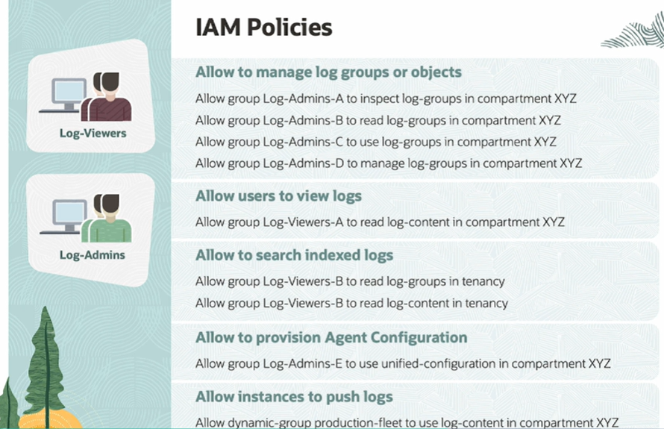

**Logging query language and  how to write logging queries to search data from collected logs.**

You can perform log searches using the Basic mode that gives you options to filter through a graphical UI or you can use the Advanced mode where you can create custom and complex queries through the logging query language interface. The Advanced mode search would also provide you more comprehensive search options which are not available in the Basic mode.

You have options to search multiple logs and data sources and also include multiple regions into the search criteria. This means you're not only searching in the initial chosen region but also searching in multiple regions based on a selected list. Logs can be filtered using log fields or you can provide a keyword or a text search and then choosing a time interval period.

Apart from using the console, you can also use the API called SearchLogs to run a log search. The next way of searching logs is using the CLI or command line interface.

Here is an example here on how to use the CLI and the syntax. So the command is oci logging-search followed by search-logs. Then we use the parameter search query and the actual query, and then followed by the time period with the time start and time end for the query.

Here is an example of the command. We have created a search criteria to search within the entire tenancy and for the chosen time period with a start time and an end time.

Logging queries are created and processed based on a data flow model. So what this means, each query can reference to one or more multiple logs. You can then add different criterias to filter this data. And then as a result, it produces the final data set table.

The logging query language provides you different operators which are used for searching, filtering, and aggregating both structured and unstructured logs. The logging query is the most important part to define a search criteria. We saw the CLI parameter search query and a value in our previous slide, and this is referred as a section where you specify the query condition.

So the logging query can include a few components like the log streams, log fields, data types, operators, and expressions. We will look into each of these components in our next set of slides.

Log streams are used to define what set of logs that you need to search using the query. Here is a syntax. And to make it clear, let's take our first example. You are defining a search within the entire compartment, so you would specify search by the compartment's OCID.

Each stream should be mentioned within double quotes, so we have added the compartment's OCID also in double quotes. In the second example, you're searching within a log group of the compartment. So you would say search, followed by compartmentOcid, and then we would use the forward slash, the log group name or the OCID of that log group.

The same way, if you want to search a log object, you would use search compartmentOcid/logGroup, and then using another forward slash, followed by the OCID or name of that log object. You can search multiple compartments or multiple log groups or multiple log objects.

And here, you would use a comma to define multiple streams and which is used in between each section of the stream. And here in this example, there are two sections. In the first section, you are searching within a log object of a log group of the compartment. And in the second section, we are also adding another log group of another compartment where you want to run the search query.

Fields represent specific field of each log line, and this can be used to search within log streams. Fields are also case sensitive. Let's take a few examples here. If you remember the structure of a service log, this has got a unique envelope with some key value pairs.

You could see the spec version, the ID of each log, the type of that emitted log. We could use these fields to filter on provided values. An example here with specifying the type and value of VCN flow logs data event, it will show all the logs that belongs to the specific type.

The same way, you could filter data fields. The data section is the most important section in a log. And you can filter like data.action not equal to ACCEPT, and this will show all the actions that are rejected. In the next example, you are looking for data.message with the message body as the condition. Data.resourceId will show all the logs for that specific resource.

Data types are about searching with strings, numbers, or arrays, Booleans, timestamps, and intervals. A few examples here. You could search with a string. We saw in our previous slide, we used a string accept, which was mentioned in single quotes. The single quotes would take the entire value just as it is.

You can also specify wild cards with tar or asterisk sign to search strings that are starting with a word or letters. Integers are another data types. And it is usually used to mention timestamps like the start time and end time.

Tabular operators are one of the common operators used in a query. For example, you could use the search operator to construct a log stream from actual log objects. The where operator filters the log stream using scalar or Boolean operators. We will be seeing these scalar operators later in this lesson.

Top would fetch only the specified number of rows from the log stream. Sort would sort the log stream by columns in ascending or descending order. The dedup operator would process the log stream by filtering all duplicates by specified columns.

Select applies a series of named scalar expressions to the log stream. And the extend operator is used to extend the log stream with a computed column. Here are some of the examples.

You are searching the application object to filter by logs with level is equal to error. The pipe symbol is an expression used between these operators. In the second example, you are returning the last three rows from the search application log stream.

In the next one, you are sorting based on values returned from the query. And in the last example, you are defining to show only the selected fields from the log stream.

Scalar operators are another type of operators. And it is usually used in calculations or matching conditions or comparing between values. The arithmetic operators are used for addition or subtraction, multiplying or dividing values. Boolean operators are used with an add operator, which is defining multiple conditions together.

The or operator is for matching one of the condition. Comparison operators are used for comparing values greater than or less than, matching to the exact value with using the equal to sign or not matching a value with not equal to sign.

Two more examples here. The first one is searching all log objects within a compartment and the log content that contains a specific IP address 10.50.0.220, which is mentioned with the wild card and within single quote. And finally, sorted by date time in descending order.

In the second example, you are searching all logs within a compartment. You are then looking for either of these request action. One could be a delete or the other could be a put action. Then using the Boolean operator and, you would only want to look into an object storage bucket that is named production bucket. And then sorting the log data by date and time in ascending order.

To wrap up, we learned the structure of a logging query, the different components of logging query language, and using some of the data types, operators, and expressions to write a query. So that's all in this lesson.

1. You are tasked to review and run routine checks for alarms configured in the Oracle Cloud Infrastructure environment.  
  
To choose notification methods, which configuration should be updated?

Streaming

Oracle Function

Notification Topic (*)

Grouping Function

Correct. Notification Topic is the communication channel for sending messages to subscriptions.

2. Which three types of logs are found in the Logging service?

Service logs (*)

Audit logs (*)

Trace logs

Alert logs

Archive logs

Custom logs (*)

Correct. The OCI Logging service enables, manages, and searches the following logs: Audit logs, Services logs, and Custom logs.

3. Which component controls the length of each time window in a metric query?

Namespace

Dimension

Interval (*)

Statistic

Resolution

Correct. Interval is the time window used to convert the set of raw data points.

4. Which three mandatory components are required to define a metric query?

Metric (*)

Dimension

Interval (*)

Grouping

Statistic (*)

Correct. A metric query is an expression and associated information to evaluate aggregated data. In order to run a metric query, you need to specify the metric, statistic, and interval.

5. Which is the correct way of using the search query to search from a log object?

search "compartmentOCID/logGroupOCID/*"

search "compartmentOCID/logGroupOCID/logOCID" (*)

search "logOCID"

search "compartmentOCID/logOCID"

Incorrect. Filter on values in logs, whether by log fields, text search, or time intervals, all in terms of chosen compartments or log groups. In order to query just one log, you will need to inform the compartment, the log group and the log, in that order.

6. You want to filter aggregated data by a specific resource ID.  
  
What is used in Basic and Advanced Modes to achieve this?

Statistic

PostMetricData API

Dimension (*)

Resolution

Comparison Operator

Correct. Dimension is a qualifier provided in a metric definition. Use dimensions to filter or group metric data.

7. What is the maximum duration of Alarm history stored for the Monitoring service?

60 days

30 days

1 year

6 months

90 days (*)

Incorrect. Alarm history is retained for 90 days.

**Test: Practice Exam: Oracle Cloud Infrastructure Operations Professional**

1. Which three algorithms are supported by Vault?

ECDSA (*)

DES

OWASP

RSA (*)

AES (*)

Correct. OCI Vault supports three algorithms:

* **Advanced Encryption Standard (AES):** AES is a symmetric encryption algorithm that is used to encrypt and decrypt data. AES is a strong encryption algorithm that is considered to be secure.
* **Rivest-Shamir-Adleman (RSA):** RSA is an asymmetric encryption algorithm that is used to encrypt and decrypt data. RSA is a strong encryption algorithm that is considered to be secure.
* **Elliptic Curve Digital Signature Algorithm (ECDSA):** ECDSA is an elliptic curve cryptography algorithm that is used to sign and verify digital signatures. ECDSA is a strong encryption algorithm that is considered to be secure.
* 2. A working Linux instance stops responding. Which is the correct way to troubleshoot the issue?
* Check the Console history for errors. (*)
* Change the ssh keys.
* Check query performance.
* Terminate the instance.
* Correct. Using the Console history, it is possible to see the latest messages displayed in the Console and start troubleshooting.

3. A user is unable to mount a file system to access the data from a local data center via VPN.  
  
What is causing the issue?

A mount point has been created.

The instance is in a different region. (*)

The NFS client is installed.

Port 111 is allowed as a stateful ingress rule.

Incorrect. Transit routing allows on-premises to communicate with multiple VCNs using a single FastConnect or VPN, but all those VCNs should be in the same region.

4. What is the most secure place to store secret keys on Oracle Cloud Infrastructure?

Config files

Code files

Cloud Guard

Vault (*)

Correct. OCI Vault is a cloud-based key management service that helps you protect your sensitive data. OCI Vault provides a secure and centralized repository for storing and managing encryption keys and secrets.

5. You are using Terraform to create a sandbox environment for the development team. This environment consists of an Oracle Cloud Infrastructure virtual cloud network, two compute resources, and a database instance. As part of the Terraform configuration, you need to run a script on the two compute instances that will configure the connection to the database. Which Terraform feature should you leverage to accomplish this task?

The local-exec provisioner

The Oracle Cloud Infrastructure provider

The instance data source

The remote-exec provisioner (*)

Incorrect. To run a script on the two compute instances to configure the connection to the database, you can use the remote-exec provisioner in Terraform.  
  
The remote-exec provisioner is a built-in provisioner that can execute commands on a remote resource over SSH or WinRM. In this case, you can use the remote-exec provisioner to run a script on each compute instance after it has been provisioned.

6. What is used to automate copying block volume backups seamlessly from one region to another?

Silver backup policy

Bronze backup policy

User-defined backup policy (*)

Gold backup policy

Incorrect. You can copy volume backups and volume group backups from one region to another region using the Oracle Cloud Infrastructure Block Volume service. You can also enable scheduled cross-region automated backups with user-defined policies.

7. Which service intercepts HTTP/S traffic and passes them through a set of filters and rules to protect against attack streams?

Cloud Guard

WAF (*)

Vault

IAM

Incorrect. A web application firewall (WAF) is a security device that monitors, filters, and blocks HTTP traffic between a web application and the internet. WAFs are designed to protect web applications from a variety of attacks, including cross-site scripting (XSS), SQL injection, and denial-of-service (DoS) attacks.  
  
WAFs work by inspecting HTTP traffic and looking for patterns that match known attack signatures. If a WAF finds a match, it can block the traffic or take other action, such as logging the event or sending an alert.

8. Which three Terraform actions can be executed against a stack in the Resource Manager?

Import

Create

Apply (*)

Plan (*)

Destroy (*)

Correct. In Terraform Resource Manager, you can perform three actions on a stack:

* **Plan:** Generates an execution plan showing changes to be made, including resource creation, update, or deletion. It's a preview without applying changes.
* **Apply:** Applies changes from the execution plan to the stack's resources. It creates, updates, or deletes resources to match the desired state.
* **Destroy:** Removes all resources in the stack. It's irreversible, so review the plan carefully before executing it.

9. Where are the Oracle Cloud Infrastructure block volume backups stored?

In another block volume in a different region

In Object Storage (*)

In another block volume in the same region

In File Storage

Incorrect. Backups are encrypted and stored in Oracle Cloud Infrastructure Object Storage, and can be restored as new volumes to any availability domain within the same region where they are stored.

10. Which three are valid use cases for using Oracle Cloud Infrastructure cost-tracking tags?

Set up budgets based on resources grouped by tags. (*)

Filter projected costs based on tags. (*)

Set up autoscaling policies based on tags.

Track resource usage based on tags. (*)

Apply discount to cost of the resource

Incorrect. OCI cost-tracking tags are a feature in Oracle Cloud Infrastructure (OCI) that allow you to assign metadata to resources to track and categorize costs. By adding tags to resources such as compute instances, storage volumes, or networking components, you can easily monitor and analyze spending based on specific attributes or criteria.  
Except for the autoscaling policy statement, all other options match the intended use.

11. Which three tasks can be done using Ansible?

Analytics

Audit (*)

Workflow automation (*)

Application deployment (*)

Correct. Ansible is an open-source IT automation tool used for configuring, deploying, and managing IT infrastructure and applications. It simplifies complex tasks and saves time by automating repetitive tasks. Analytics is not among the use cases.

11. Which three tasks can be done using Ansible?

Analytics

Audit (*)

Workflow automation (*)

Application deployment (*)

Correct. Ansible is an open-source IT automation tool used for configuring, deploying, and managing IT infrastructure and applications. It simplifies complex tasks and saves time by automating repetitive tasks. Analytics is not among the use cases.

13. Which three SDKs are supported on Oracle Cloud Infrastructure?

Rust

Go (*)

Java (*)

FORTRAN

TypeScript (*)

Incorrect. The current supported SDKs are:

* SDK for Java
* SDK for Python
* SDK for TypeScript and JavaScript
* SDK for .NET
* SDK for Go
* SDK for Ruby

14. You have created the following JSON file to implement a lifecycle policy for one of your Oracle Cloud Infrastructure Object Storage buckets:

oci os object-lifecycle-policy put -ns MyNamespace -bn MyBucket --items '[  
""action"": ""ARCHIVE"",  
""is-enabled"": true,  
""name"": ""ArchiveAfter30Days"",  
""object-name-filter"": {  
""inclusion-prefixes"": [  
""documents""  
]  
},   
""time-amount"": 30,  
""time-unit"": ""DAYS""  
},   
{  
""action"": ""DELETE"",   
""is-enabled"": true,   
""name"": ""DeleteAfter180Days"",   
""object-name-filter"": {  
""inclusion-prefixes"": null  
},   
""time-amount"": 180,   
""time-unit"": ""DAYS""  
}  
]'

How will this policy affect the objects that are stored in the bucket?

Objects containing the name prefix "documents" will automatically be moved from Standard Object Storage to Archive Storage 30 days after the date of creation, but because of policy error will have to be manually deleted after 180 days.

Objects containing the name prefix "documents" will automatically be moved from Standard Object Storage to Archive Storage 30 days after the date of creation.

Objects containing the name prefix "documents" will automatically be moved from Standard Object Storage to Archive Storage after 30 days and then deleted 180 days after the date of creation. (*)

Objects containing the name prefix "documents" will automatically be moved from Standard Object Storage to Archive Storage 30 days after the date of creation. Other objects will be deleted after 180 days.

Incorrect. The JSON file contain two active policies:

* Archive (change tier) objects named with the prefix "documents" after creation or last update.
* Delete objects after 180 days of creation.

15. What is the difference between service limits and compartment quotas?

Service limits are set by Oracle, while compartment quotas are set by administrators. (*)

Service limits can be increased by administrators, while compartment quotas cannot.

Both service limits and compartment quotas are identical.

Service limits are the limits on the overall billing, while compartment quotas are limits for a specific resource.

Incorrect. Defined by Oracle, Service limits restrict the usage of resources or operations within a specific service and apply to all users in a tenancy, while compartment quotas restrict the usage of resources within a specific compartment and apply only to that compartment and are set by the tenancy administrators.

16. Which two statements about Object Storage replication are true?

After a replication policy is created, the destination bucket is read/write by default.

Replication overwrites any object in the destination bucket that has the same name as an object in the source bucket. (*)

It protects from regional outages and helps in disaster recovery. (*)

Objects uploaded to a source are synchronously replicated to the destination bucket.

Incorrect. After a replication policy is created, the destination bucket is set to ready-only and this cannot be changed.  
  
Objects uploaded to a source are asynchronously replicated to the destination bucket.

17. Which two statements about the Oracle Cloud Infrastructure Cost Analysis Tool are true?

Costs can be filtered by Date, Tags, and Compartments. (*)

The tool can be accessed by all users.

The tool can only be accessed by members of the ADMINISTRATOR group. (*)

Costs can be filtered by Compartments, Date, and Service Limit.

Incorrect. The Oracle Cloud Infrastructure Cost Analysis Tool is restricted to members of the ADMINISTRATOR group. It allows users with the necessary privileges to access and analyze cost-related information. The tool provides filtering capabilities based on date, tags, and compartments, enabling users to focus on specific time periods, resource attributes, and organizational structures when analyzing costs.

18. Which three can leverage the Oracle Cloud Infrastructure Traffic Management service?

Steering traffic to other cloud providers and enterprise data centers (*)

Controlled migration from a data center to Oracle Cloud Infrastructure (*)

Steering internal traffic between two Virtual Cloud Networks

Serving different responses for internal users and external users (*)

Incorrect. The Oracle Cloud Infrastructure Traffic Management service operates only with public zones, so is unable to steer internal traffic.

19. Which two options show the correct scope for setting up Oracle Cloud Infrastructure budgets?

Cost-tracking tag (*)

Namespace

User-defined tag

Tenancy

Compartment (*)

Incorrect. In Oracle Cloud Infrastructure, budgets can be set up at two different scopes:

* **Compartment:** A budget set up at the compartment level applies to all the resources within that compartment and its subcompartments.
* **Cost-tracking tag:** A budget set up at the tag level applies to all the resources that are tagged with a specific tag key-value pair.

20. Which statement about multipart uploads is FALSE?

Multipart uploads are initiated by making a CreateMultipart Upload REST API call.

A commit is performed after all object parts are uploaded.

Multipart uploads are performed to upload objects larger than 100 MiB.

Uploads cannot be restarted if they fail due to a network issue. (*)

Incorrect. Uploads can be restarted if they fail due to a network issue.

21. To better manage resource utilization in your environment, you have decided to create alerts that notify your team each time a new compute instance is created. Which two resources do you need to create to accomplish this task?

Create a new subscription in the Notification Service to subscribe to all Event Service rules.

Create a new instance pool and assign an autoscaling policy to create additional instances when the aggregate CPU utilization exceeds 80%.

Create a rule in the Event Service that is activated by the Instance – Launch End event type. (*)

Create a new topic in the Notifications Service and subscribe your email address to the topic. (*)

Create a new metrics query in the Monitoring Service with the metric namespace "oci_computeagent" and the dimension name "resourceId".

Incorrect. To create alerts that notify your team each time a new compute instance is created, you need to create two resources:

* A rule in the Event Service that is activated by the Instance – Launch End event type
* A subscription in the Notification Service to subscribe to the rule

The rule will be triggered when a new compute instance is created. The subscription will send an alert to your team when the rule is triggered.

22. If the traffic does not flow correctly, which three might cause issues in the IPSec connection?

Incorrect CPE IP address

Overlapping CIDRs (*)

Improper routing (*)

Incorrect protocol configured for the listener

Multiple SPIs with policy-based tunnels (*)

Incorrect. If the incorrect protocol or IP Address are configured on the CPE, the tunnel will not even be established. All other three options will have the tunnel up but no traffic through.

23. Which action do you need to perform to push a new image to the Oracle Cloud Infrastructure (OCI) Registry?

Assign an OCI-defined tag via OCI CLI to the image.

Generate an auth token to complete the authentication via Docker CLI. (*)

Generate an API signing key to complete the authentication via Docker CLI.

Generate a public private key pair to authenticate via Docker CLI.

Incorrect. Docker CLI authentication methods are username/password, service account, or auth token.

24. Which Oracle Cloud Infrastructure service monitors endpoints across a hybrid infrastructure?

Health Checks (*)

Notifications

Monitoring

Logging

Incorrect. Logging and Notification services are not used for monitoring. The Monitoring service is used to monitor only OCI resources. Using Health Checks it is possible to specify internal and external endpoints for monitoring.

25. Which statement about block volume backups is true?

Block volumes backups are global resources.

It is possible to retrieve an individual file from the block volume backup.

Block volume backups meet compliance and regulatory requirements, because the data in a backup remains unchanged over time. (*)

Block volume backups always have the same size as the block volume.

Incorrect. As it is a point-in-time backup of data on a volume and immutable, a block volume backup can be used to meet compliance requirements.

26. Which Traffic Management Steering Policy dynamically routes traffic requests based on the originating IP prefix?

Geolocation

IP Prefix Steering (*)

DNS Steering

Failover

Incorrect. Traffic Management Steering Policies offers several policies to guide traffic. IP Prefix Steering Policies enable customers to steer DNS traffic based on the IP prefix of the originating query.

27. What is the Oracle Cloud Infrastructure Command Line Interface used for?

Managing application configuration

Managing application deployment

Automating simple, repeatable actions (*)

Creating complex application architecture

Correct. OCI CLI is a command-line tool that allows you to manage and interact with Oracle Cloud Infrastructure resources and services from your local machine or server. You can perform a variety of tasks such as creating and managing compute instances, storage volumes, and other infrastructure resources, through single line commands, allowing creation of reusable scripts to automate tasks.

28. Which statement about the Monitoring service is true?

You cannot create alarms with nested queries.

The Monitoring service uses metrics to monitor resources and alarms to notify about metrics. (*)

Metric and alarm data are accessible only via the Console.

You can publish only default metrics to the Monitoring service and not the custom metrics.

Incorrect. The Monitoring service in OCI uses metrics to monitor resources and alarms to notify about metric breaches. Alarms can include nested queries, and metric and alarm data are accessible not only via the Console but also through APIs and SDKs. Both default and custom metrics can be published to the Monitoring service.

29. Which three are typical responses from WAF?

An error page due to a blocked request (*)

Provided a detail description why the request was blocked

Redirect the request

Audit log the request (*)

Allow the request to pass (*)

Incorrect. There are three typical responses from a web application firewall (WAF):

* **Allow:** The WAF allows the request to pass through. This is the most common response.
* **Block:** The WAF blocks the request and sends an error message to the client.
* **Audit:** The WAF logs the request and sends an alert to the administrator.

30. Which alarm state is seen if the alarm metric is no longer being emitted?

Suspended

Cancelled

Firing

Reset (*)

Correct. Here are the possible states of an alarm:

* **OK:**The alarm is not detecting any problems.
* **WARNING:** The alarm is detecting a problem that is not yet serious.
* **ALARM:** The alarm is detecting a serious problem.
* **RESET:** The alarm is not detecting the metric that it is configured to monitor.

31. Which three are components of a Monitoring Query Language expression?

Statistic (*)

Alarm

Metric (*)

Interval (*)

Filter

Correct. The three components of a Monitoring Query Language (MQL) expression are:

* **Metric:** The metric is the value that you want to query.
* **Interval:** The interval is the time period that you want to query.
* **Statistic:** The statistic is the calculation that you want to perform on the metric.

32. Which Oracle Cloud Infrastructure service enables you to set up communication channels to publish messages using topics and subscriptions?

OCI Notifications Service (*)

OCI Audit Service

OCI Events Service

OCI Email Delivery Service

Correct. The Oracle Cloud Infrastructure Notifications service enables you to set up communication channels to publish messages using topics and subscriptions.  
  
A topic is a communication channel for sending messages to the subscriptions in the topic. A subscription is an endpoint for a topic. Published messages are sent to each subscription for a topic. Message: The content that is published to a topic. Each message is delivered at least once per subscription.

33. What is the measurement related to the health, capacity, or performance of a given resource called?

Dimension

Metric (*)

Namespace

Metadata

Correct.

* **Namespace:** Indicator of the resource, service, or application that emits the metric
* **Metadata:** A reference provided in a metric definition
* **Metric:** A measurement related to the health, capacity, or performance of a resource
* **Dimension:** A qualifier provided in a metric definition

34. Which statement about the Oracle Cloud Infrastructure audit logs retention period is true?

You can configure log retention for up to 365 days.

The log retention duration cannot be changed. (*)

You can configure log retention for 60 days.

You can configure log retention for any duration of time.

Incorrect. By default, audit logs are retained for 365 days. Retention period is a tenancy-level setting. The value of the retention period setting affects all regions and all compartments. The retention period cannot be changed.

35. What is the default location of the file created to organize the servers managed by Ansible?

/etc/ansible/hosts (*)

/etc/ansible/config/hosts

/etc/hosts

/etc/ansible/systems

Incorrect. The file created to organize the servers managed by Ansible is called the "inventory file." By default, Ansible looks for the inventory file in the location /etc/ansible/hosts on the control node.

36. When would you use a load balancer instead of a Network Load Balancer in Oracle Cloud Infrastructure (OCI)?

When you need source and destination IP addresses, and port preservation

When you are working with latency-sensitive applications

When you require SSL/TLS termination and HTTP/HTTPS load balancing (*)

When the backend is located in different availability domains

Incorrect. OCI load balancers operate on OSI layers 3, 4, and 7. The network load balancer operates on OSI layers 3 and 4. SSL termination/offloading is done on Layer 7, hence why you would choose a LB instead of a NLB

37. How can you provide user access to an existing compartment in Oracle Cloud Infrastructure?

By adding users to a compartment. All users in the compartment will have access to the resources in the compartment.

By adding users to a group and defining a policy to provide group access to the compartment (*)

By granting access directly to the user when the user is created

By granting users access to the compartment when the compartment is created

Correct. To provide user access to an existing compartment in Oracle Cloud Infrastructure (OCI), you can grant permissions and assign policies to a group and then add the user to the group.

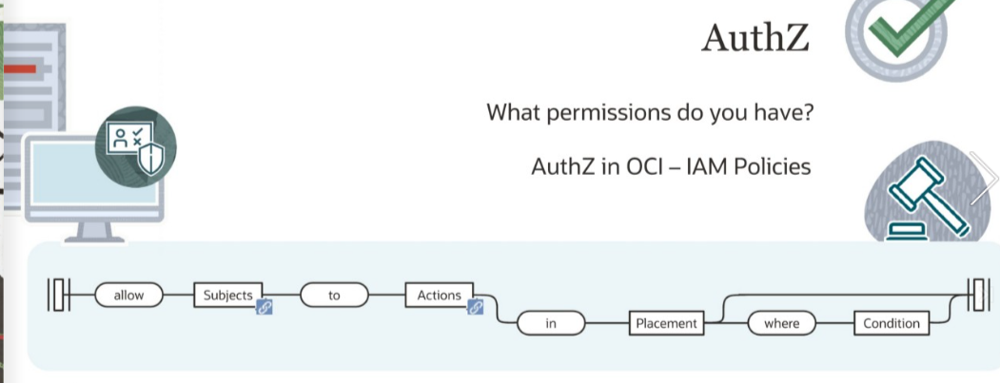

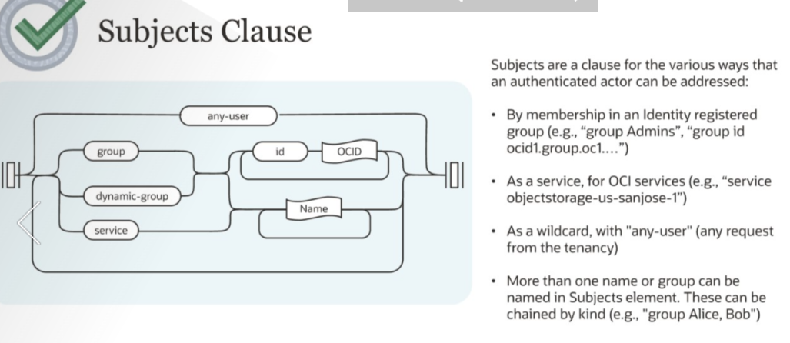

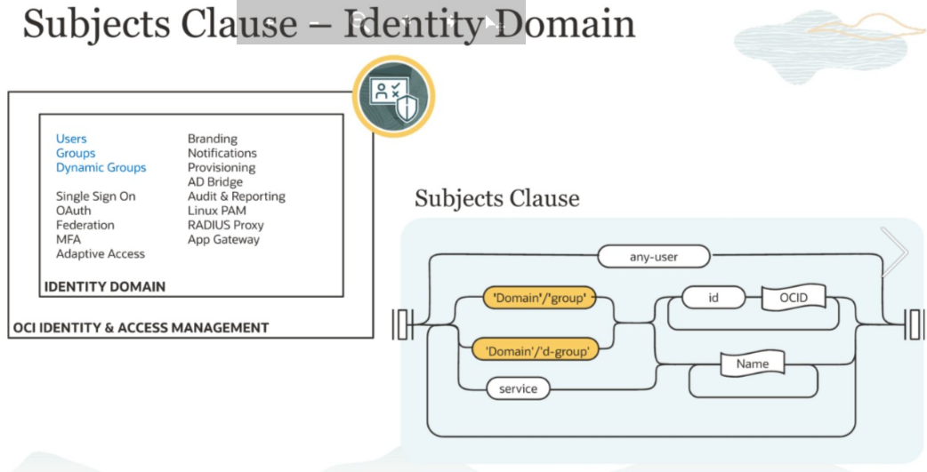

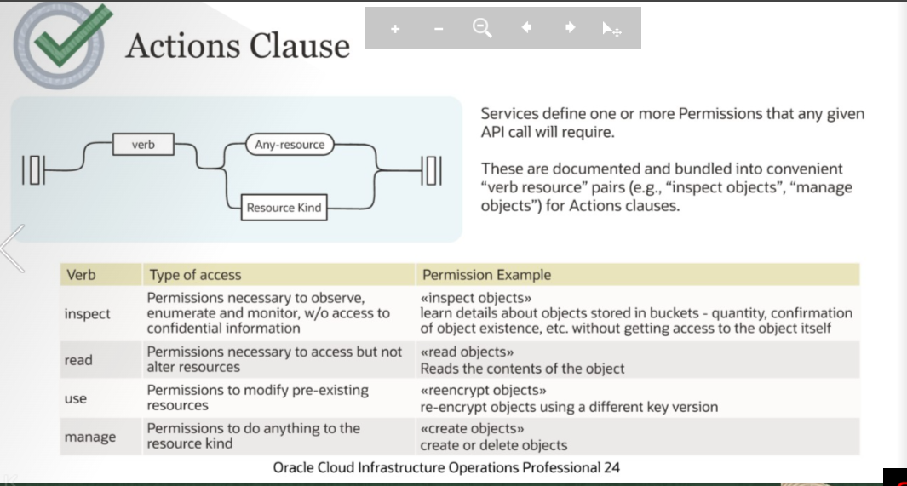

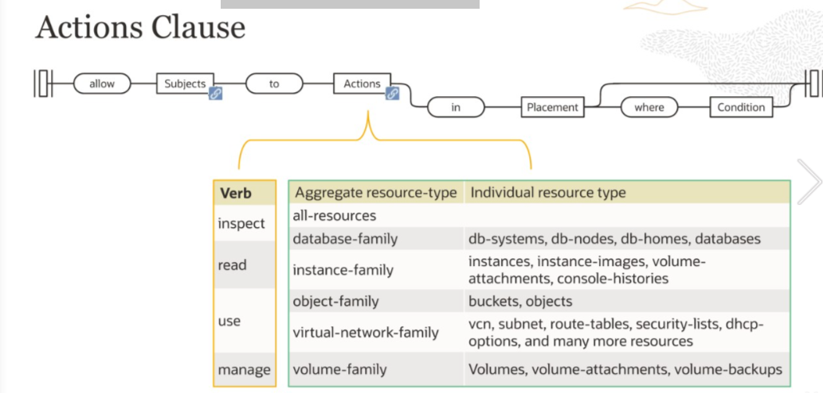

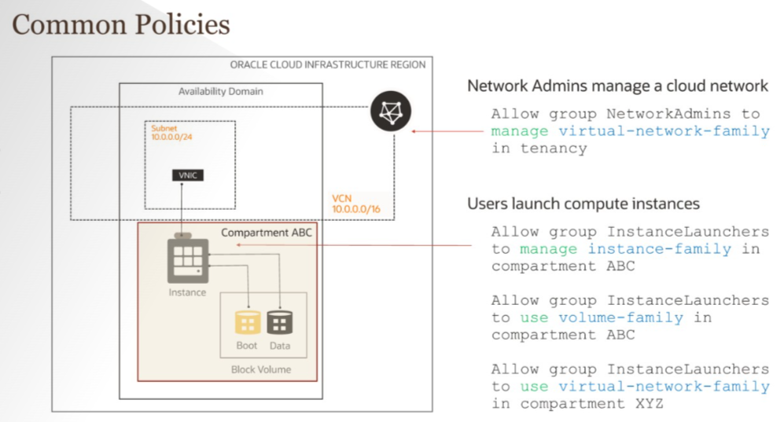

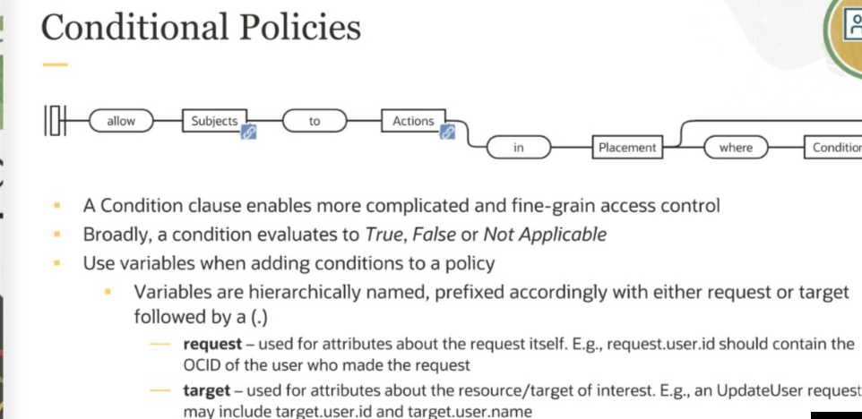

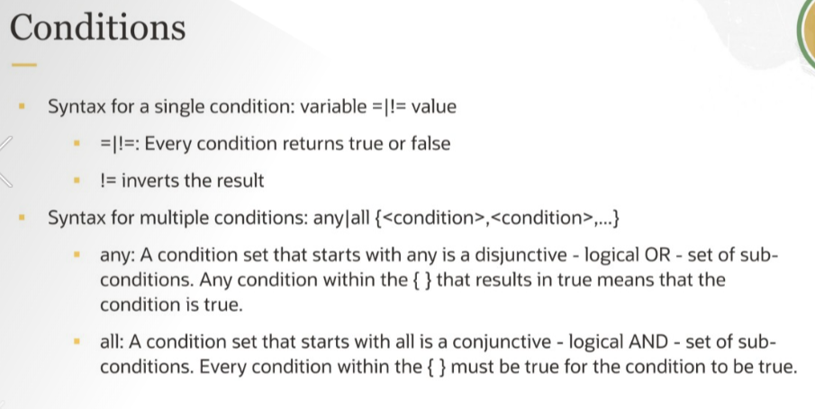

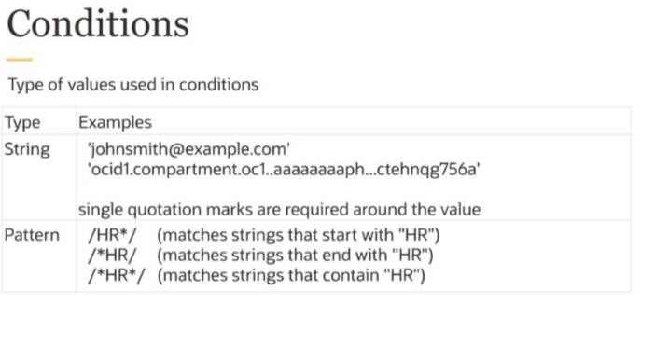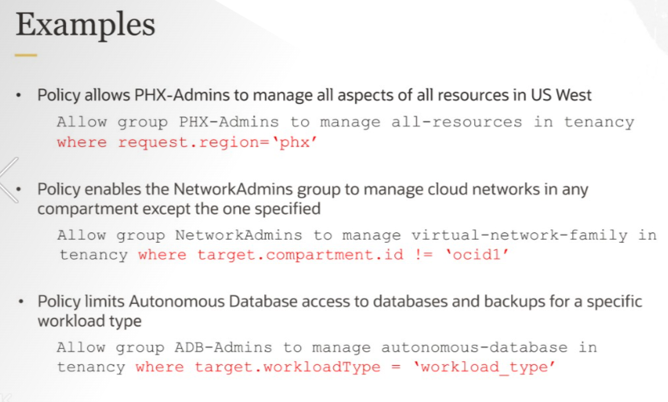

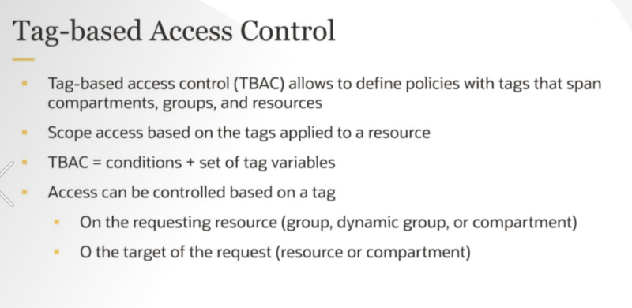

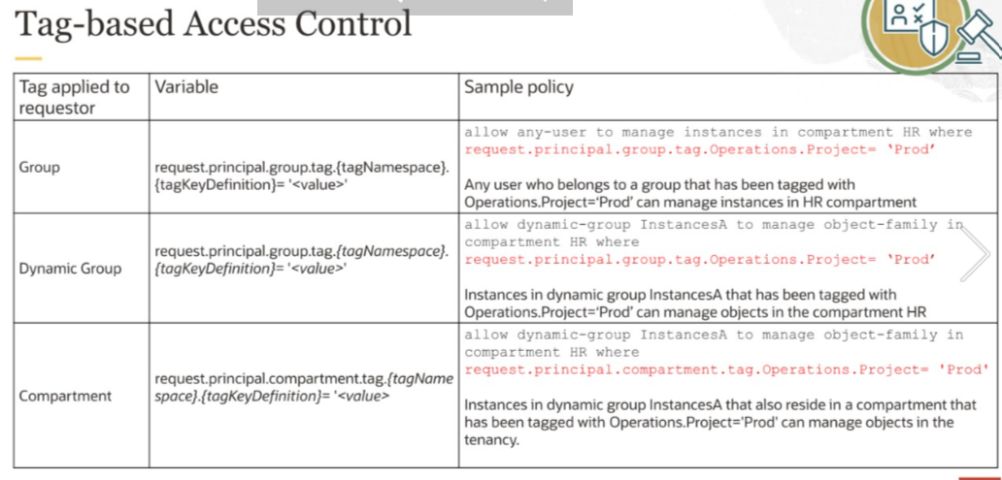

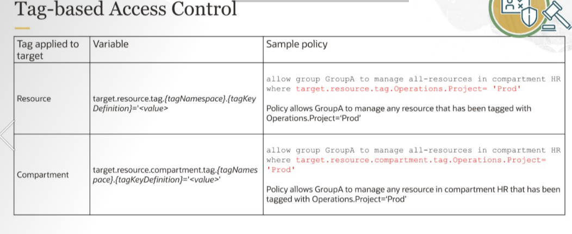

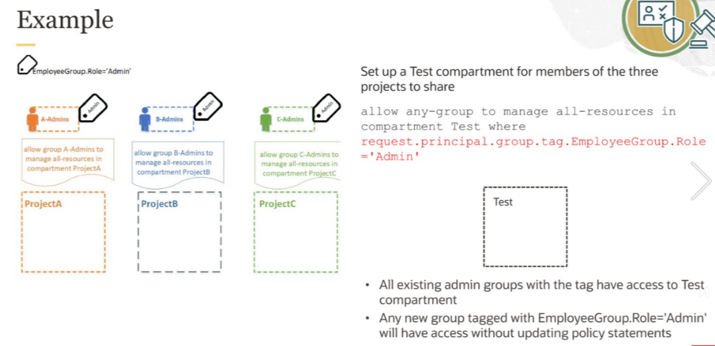

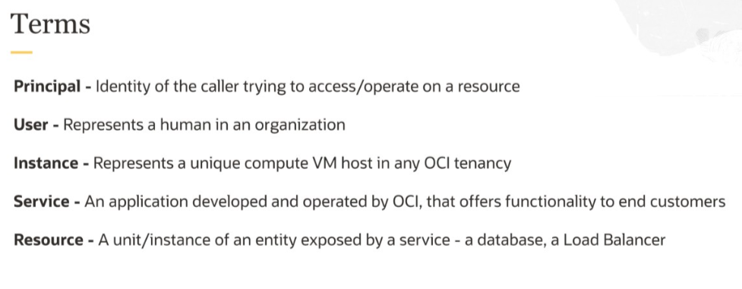

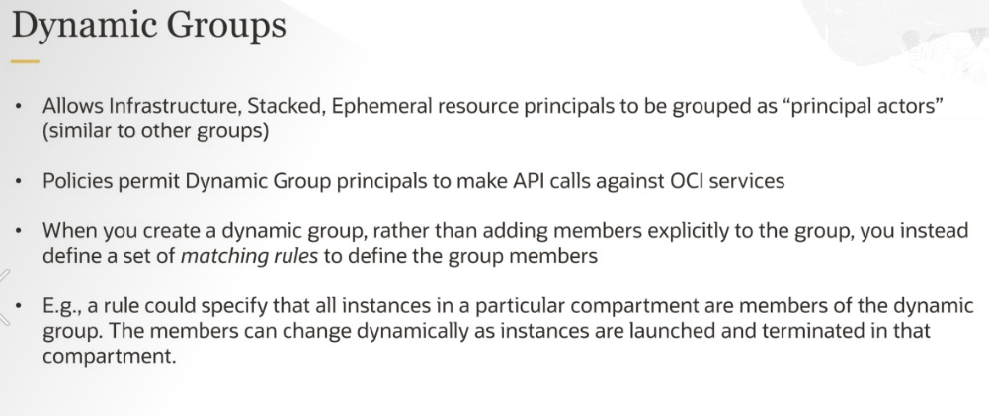

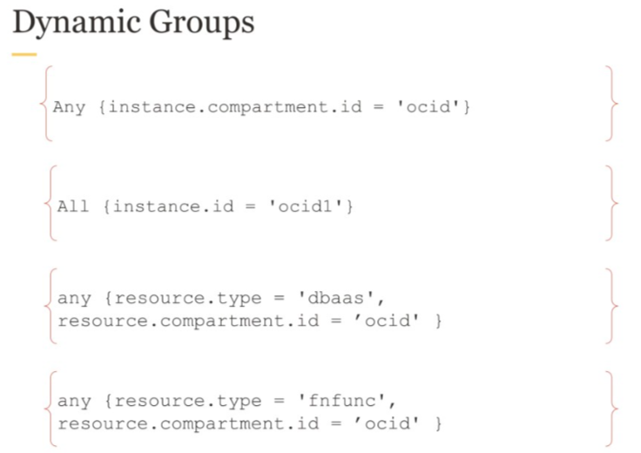

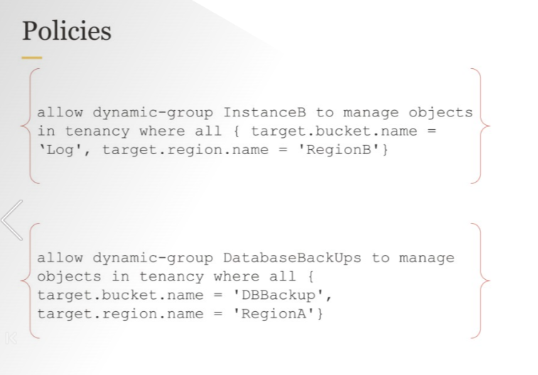

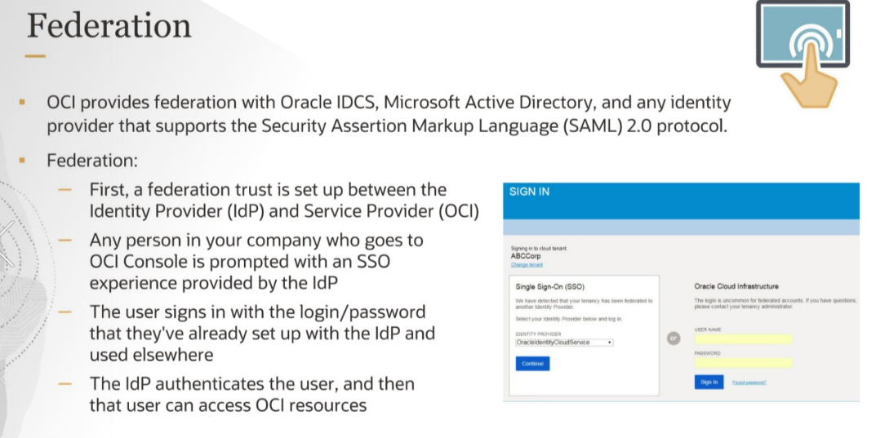

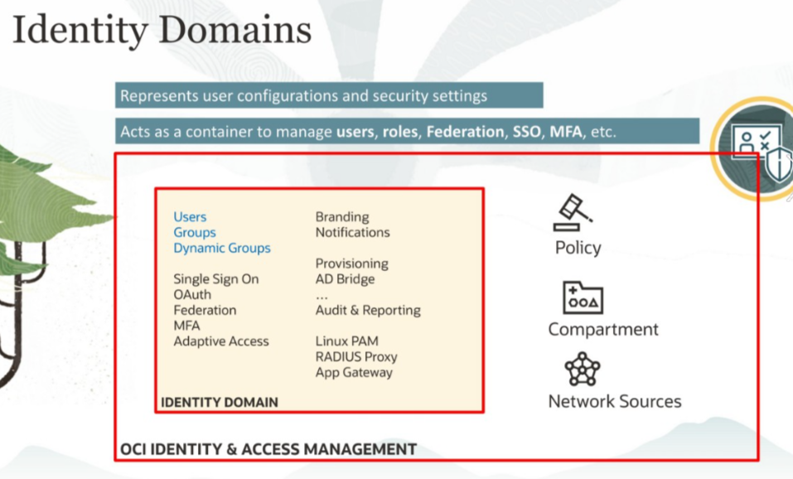

IAM

1. Which three components are part of the OCI Identity and Access Management service?

Policies (*)

Roles

Regional subnets

Virtual cloud networks

Users (*)

Compute instances

Dynamic groups (*)

Correct. Users, dynamic groups, and policies are security constructs used by OCI Identity and Access Management. Regional subnets, VCNs and compute instances are resources. Roles are not used within OCI IAM

2. Which of the following statements about IAM compartments are true?

Resources can be moved from one compartment to another. (*)

Compartments span all regions that you are subscribed to. (*)

Compartments can be nested within one another. (*)

Compartments are used to limit interactions between resources.

Incorrect. Compartments are logical global containers to limit user permissions. Resources in different compartments can still interact with one another.

3. What would you use from Oracle Cloud Infrastructure Identity and Access Management to govern resources in a tenancy?

Dynamic groups

Policies (*)

Users

Groups

Correct. OCI permissions are granted using policies.

4. You have created a new compartment – "apps" – to host some production apps, and you have created an apps_group and added users to it.  
  
What would you do to ensure the users have access to the apps compartment?

No action required

Add an IAM policy for the individual users to access the apps compartment.

Add an IAM policy for the apps_group granting access to the apps compartment. (*)

Add an IAM policy to attach tenancy to the apps group.

Correct. IAM policies grant permissions on compartments to user groups.

5. You want to make API calls against other OCI services from your instance without configuring user credentials.  
  
How would you achieve this?

Create a dynamic group and add a policy. (*)

No configuration required for making API calls

Create a group and add a policy.

Create a dynamic group and add your instance.

Correct. Using instance principals, one instance can access the OCI API. In order to set up this, you need to create a dynamic group that contains the instance and assign a policy to that group.

